Some of Arab and Muslim Physicians Achievements Attributed to Western Physicians

By:

Abdul Nasser Kaadan, MD, Ph D*

بعض الإنجازات لأطباء عرب ومسلمين تعزى لأطباء غربيين

إعداد

الدكتور عبد الناصركعدان*

Key words: History of Medicine, Arabic Medical Heritage, Islamic Medicine
Abstract
Al-Razi is considered the first who described what is called now Baker’s cyst, which is attributed to the English surgeon William Baker (1839-1896) who described it in 1877. He mentioned to the necessity of removing the patella (patellectomy) in the cases of comminuted fracture of the patella, which is attributed to Brooke who described it in 1937, and is called Brooke method. Avicenna drew attention to the necessity of not splinting the fracture immediately, advising postponing it beyond the fifth day. Today, this is called the Theory of Delayed Splintage; now Professor George Perkins is considered the pioneer of this theory. The aim of this paper is to shed lights on some of Arab and Muslim physician's achievements or contributions, and still some of them attributed to some Western physicians.

Introduction
Between the ancient civilizations, namely the Egyptians, Greek, Roman, Persian, Indian, and Chinese, and the Renaissance era in Europe, there was a gap, commonly called "the dark ages", during which the flame was hosted, not by the West, but by another culture and people called the Arabs or the Moslems. The nomenclature, "the dark ages" reflects the civilization in Europe between the 7th and 13th centuries, but by no means it expresses the state of affairs in the Arab world or the Islamic Empire at that time when an and science were as bright as the midday sun. That era, unjustifiably, has been commonly neglected and overpassed, as if nothing happened. The aim of this paper is to shed lights on some of Arab and Muslim physicians achievements or contributions, and still attributed to some Western physicians.

Islamic Physicians:
History of a nation is the sum total of the history of a few of its individuals. This is particularly true in the history of medicine during the Arab or Islamic period. In every stage of its development we find men of outstanding repute, the sum total of whose efforts has constituted this magnificent chapter. It is impossible to give an account of all the important physicians of Islam. We thus are going to discuss some of those who were known to Medieval Europe and whose books affected its thinking and practice for centuries, I chose an internist, Al-Razi (Razes); the physician-philosopher of Islam, Ibn-Sina (Avicenna); a surgeon, Al-Zahrawi (Abulcasis).

Al-Razi (Razes), 841-926 A.D.
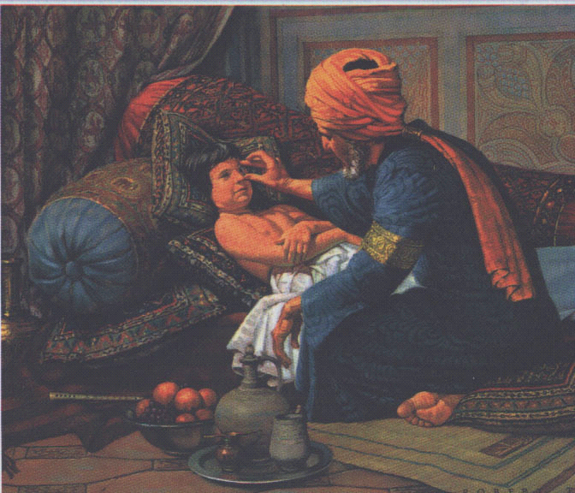

His full name is Abu-Bakr Mohammaed Ibn-Zakaria Al-Razi, known to the Western World as Razes. He was born in Ray, a suburb of Tehran, the capital of modern Persia (Profile of Iran 1977, Sarton 1950). He first studied music which was his main interest in his early life. He was a skillful player on the lute. He then studied philosophy, and later medicine. But he was a better physician than a philosopher.
The most important books of Al-Razi is "Al-Hawi book", which means the complete text. It was composed of 22 volumes. It was one of the main text books in the medical school in Paris, especially its 9th volume on pharmacology.
He wrote a treatise on measles and smallpox called "de Peste or de Pestilentia" which was translated to Latin in 1565 A.D. It is a masterpiece in clinical medicine. It describes the clinical difference between the two diseases so vividly that nothing since has been added.
Some of Al-Razi most important achievements and attributed to western physicians:
1- Al-Razi played an important role in keeping the medical heritage that developed over thousands of years, for al-Hawi book represents a unique reference or document containing medical knowledge as it accumulated throw many civilizations until his period.

2- Al-Razi is considered the first who described what is called now Baker’s cyst. Which is attributed to the English surgeon William Baker (1839-1896) who described it in 1877.

3- He mentioned to the necessity of removing the patella (patellectomy) in the cases of comminuted fracture of the patella, which is attributed to Brooke who described it in 1937, and is called Brooke method.
4- He described the recurrent dislocation of the shoulder Joint and determined the predisposing factors with two methods of treatment.
Ibn-Sina (Avicenna) 980-1037 A.D.

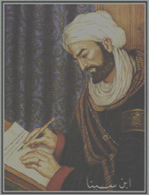

In 980 A.D. Ibn-Sina was born in Bukhara which is now part of Uzbekistan. By the age of 10, he was already proficient in the Qur'an and Arabic classics. By the age of 16, he finished Islamic law studies, geometry, anatomy, logic and philosophy. By the age of 18, he completed the study of medicine.
Ibn-Sina wrote I00 treatises, 21 of them were major of which 16 were in medicine. He wrote in philosophy, medicine, named Al-Qanon fi Al- Tibb (Canon of Medicine). It was an encyclopedia containing more than one million words. It was composed of 5 volumes:
Volume I- described the principles and theories of medicine.
Volume II- contained the simple drugs arranged alphabetically.
Volume III- described localized diseases of the body from the head to the toes.
Volume IV- was addressed to generalized diseases of the body e.g. fevers.
Volume V- explained compound drugs.
The Canon contained all medical knowledge up to the 1Oth century. It was translated to many languages and was the reference for medical schools in Europe up to the 17th century. Although the Canon was a great book, it overshadowed the important works prior to it by Al-Razi and Al-Zahrawi, and subsequent to it by Ibn-Al-Nafis and Ali Ibn-Abbas, Halle Abbas, (Haddad 1942).
Ibn-Sina is considered a great philosopher, and his writings affected the thinkers and influenced many of those who appeared after him. He was a unique phenomenon, not only because of this encyclopedic accomplishments in medicine, but also because of the versatility of his genius.
Some of Ibn-Sina most important achievements and attributed to western physicians:
- Avicenna drew attention to the necessity of not splinting the fracture immediately, advising postponing it beyond the fifth day. Today, this is called the Theory of Delayed Splintage; now Professor George Perkins is considered the pioneer of this theory.

- Ibn-Sina talked about what is called now “Bennett’s fracture 1882” Described by Edward H. Bennett, Dublin surgeon (1837-1907).We know that neither al-Razi before him, nor ibn al-Quf after him, had described this type of fracture, this means that ibn-Sina is considered the first who described this fracture nearly one thousand year before Bennet.

Al-Zahrawi (Albucasis) 930-1013 A.D.
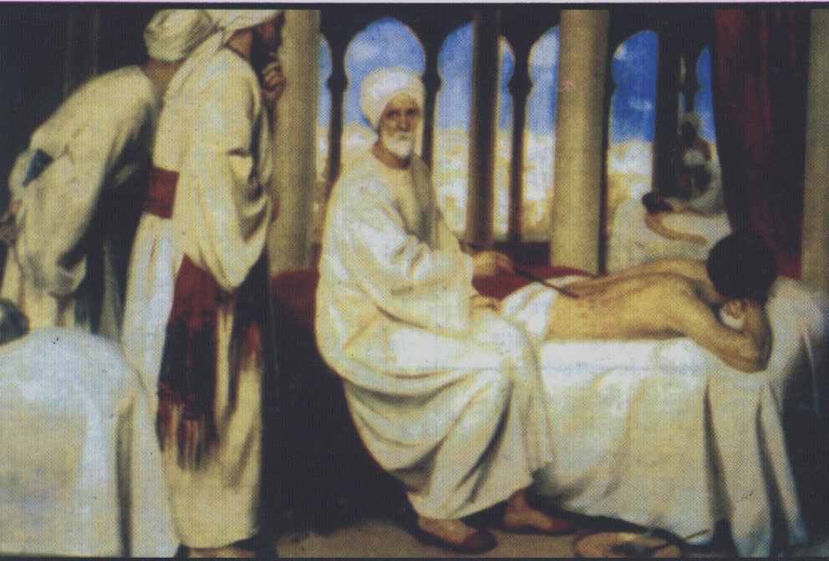

His full name is Abu-Al-Qasim Khalaf Ibn'Abbas Al-Zahrawi. He had been known in the Western World as Abulcasis. He is the famous surgeon of the Arabs. In 930 A.D., he was born in Al-Zahra, a suburb of Cordova.
Al-Zahrawi wrote only one book "Al-Tastif Liman Ajiz'an Al-Ta'lif' which is the best medieval surgical encyclopedia. It was used in Europe until the 17th century. He stressed the importance of basic sciences: "... Before practicing, one should be familiar with the science of anatomy and the functions of organs so that he will understand them, recognize their shape, understand their connections, and know their borders. Also he should know the bones, nerves, and muscles, their numbers, their origin and insertions, the arteries and the veins, their start and end. These anatomical and physiological bases are important, and as said by Hippocrates: 'These are many physicians by title and a few by practice.' ... During the time of Al-Zahrawi, surgery in the Islamic world became a respected specialty practiced by reputable physicians. On the contrary in Europe, surgery was belittled and practiced by barbers and butchers. In 1163 A.D., the Council of Tours declared the following resolution "Surgery is to be abandoned by the schools of medicine and by all decent physicians."
Some of Al-Zahrawi most important achievements and attributed to western physicians:
1-Al-Zahrawi is mentioning to three methods for stopping Haemorrhage: by ligation, cauterization and by compressing the artery, so he has advised for stopping hemorrhage, by using ligation of the vessels before Ambroise Pare in 1552.
2- Al-Zahrawi mentioned to what is called now Trendelenburg Position, Which described by German Surgeon Freidrich Trendelenburg (1844-1924).
3- He differentiated between different types of fractures: avulsion, crushing, penetrating reaching the membrane or superficial, hairline fracture. And he described in detail how to remove the depression fracture.

Conclusion:
The concept that medicine is exclusively the products of Western minds, remains unquestioned by most individuals. A review of any of the standard texts or encyclopedias regarding the history of medicine would support this view. Most modern medical textbooks give little or no mention of the advancements made by ancient Indian, Chinese or, particularly, Arab and Muslim physicians. The British surgeon, George Perkins, is considered now the pioneer of what is called the delayed splintage theory, while we can see that Ibn-Sina talked about this theory in his book Al-Qanunn one thousand year before Perkins. George Sarton states that modern Western medicine did not originate from Europe and that it actually arose from the (Arabic and Islamic) orient. This paper reviewed some of Arab and Muslim physicians achievements, which are still attributed to Western physicians.

References:
- Al-BABA MZ: some of medical books edited by Ibn Sina. Institute for History of Arabic Science-Aleppo University, Aleppo-Syria, 1984.
- APLEY AG, SOLOMON L: Apley’s system of orthopedic and fractures, p. 344, 6th ed., Butterworth & Co.,Ltd., London, 1982.
- BROAWE, E.G.: Arabian Medicine: Cambridge at the University Press, 1962.
- CAWBELL, DAVID: Arabian Medicine and its influence on the middle ages. Kegon Paul. French, Frubner & Co. London, 1926, Vol. 1, pp. 69-77.
- GARRISON, FIELDING A: An Introduction to the History of Medicine with Medical Chronology, Suggestions for Study and Bibliographic Data. W.B. Saunders Co., Philadelphia, 1929.
- GRUNER, O.C.: A treatise on the Canon of Medicine of Avicenna, Incorporating a Translation of the First Book, London, Luzac & Co. 1930.
- HADDAD, S.I.: Arabian Contribution to Medicine. Anna Med. Hist. 3:60-72, 1942.
- HAMARNEH S: The Physician and the Health Profcssions in Medeival Islam. Bull. N.Y. Acad. Med. 47.1088-1110, 1971.
- HAMARNEH, S.: Development of Hospitals in Islam. J. History of Med. and Allied Sciences 17: 366-84, 1962.
- Ibn-Sina: Al-Qanun fit-Tibb. Vol. 3, P. 197, Dar Sader, Lebanon, 1980.
- KAADAN, A. N., Al-Razi Book on Smallpox and Measles. Hikmah Journal of Muslim Doctors & Dentists Association (U.K.), P. 20-24, June 1999.
- KAADAN, A. N., Bone Fractures in Ibn-Sina Medicine. The Pan Arab Journal of Orthopaedic and Trauma. P. 151-155, Vol. 4, No. 2, July 2000. ISSN 1607-4912.
- KAADAN, A. N., The Surgery of al-Zahrawi. Dar al-Qalam al-Arabi, Aleppo-Syria, 1999, 357 pages.
- KAADAN, A. N., Bone Fractures in Arab Islamic Medicine. Dar al-Qalam al-Arabi, Aleppo-Syria, 1999, 210 pages.
- KEYS, T.E., WAKIM, K.G.: Contributions of the Arabs to Medicine Staff Meetins of the Mayo Clinic 28: 42-437, 1971.
- MEYERHOF, M.: Ibn-El-Nafis (Xlllth Cent) and His. Theory of the Lesser Circulation. Isis 23: 100-120, 1935.
- MIN-KIN, J.S.: The World of Moses maimonides: Thomas Yoseloff Inc. New York, 1968.
- PARENTE, P. The Medical School of Salemo in the Regimen of Health of the Medical School of Salcmo. N.Y. Vantage Press, 1967, pp. 15-20. Profile of Iran. Health Care in Iran. May 1977, 2536, Vol. 11, No. 5.
- ROCKWOOD CA, GREEN DP: Fractures. P.305, vol. 1, H. K. Lewis and Co. Ltd., London, 1975.
- SARTON, G.: Introduction of the history of Science. Vol. I Baltimore, Camegic Inst. of Wash. 1950.
***

*Chairman, History of Medicine Department, Aleppo University* The President of ISHIM (www.ishim.net) P.O. Box: 7581, Aleppo, Syria e-mail: a.kaadan@scs-net.org Phone 963 944 300030, Fax 963 21 2236526
* أستاذ ورئيس قسم تاريخ الطب - معهد التراث العلمي العربي – جامعة حلب. رئيس الجمعية الدولية لتاريخ الطب الإسلامي (www.ishim.net) دكتوراه في تاريخ الطب العربي الإسلامي – طبيب استشاري في جراحة العظام. هاتف 300030 944 963 ، بريد إلكتروني: a.kaadan@scs-net.org

