Recommendations Mentioned by Hippocrates and Other Ancient Medical Practitioners and Scholars (from Kaamal Al Sanaa’ah Al Tibbiyah, by ‘Ali Ibn Al Abbaas Al Majusi)
Original Arabic Text¹ & English Translation and Commentary
by Eugene L. Mahmoud, MD*

*Board Certified in Neonatal-Perinatal Medicine
Expert Medical Reviewer Medical Board of California
email: eugene.mahmoud@gmail.com

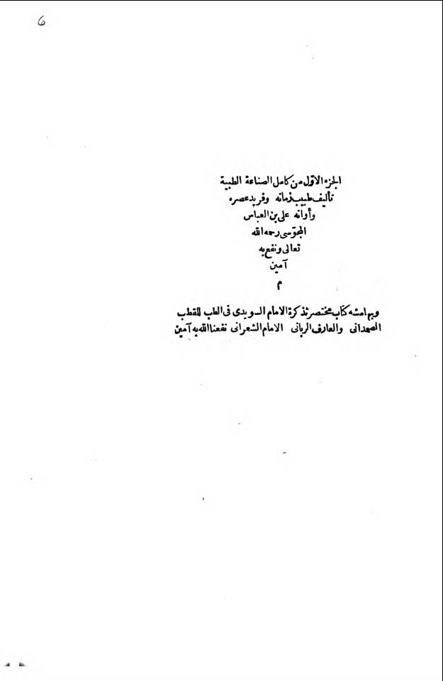
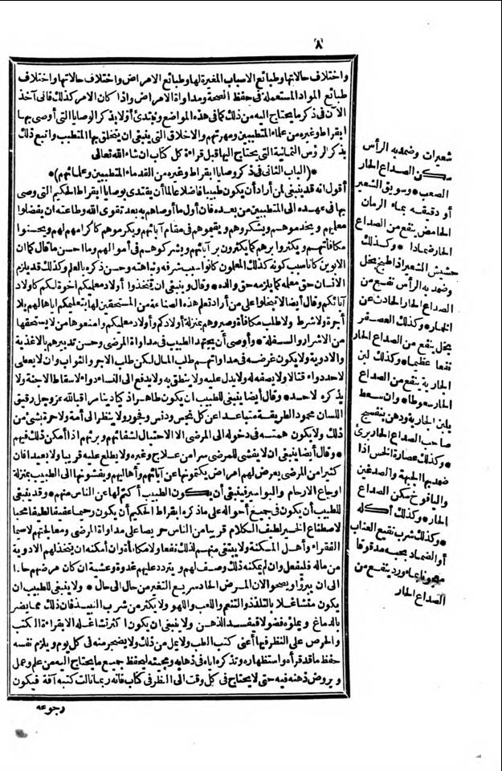
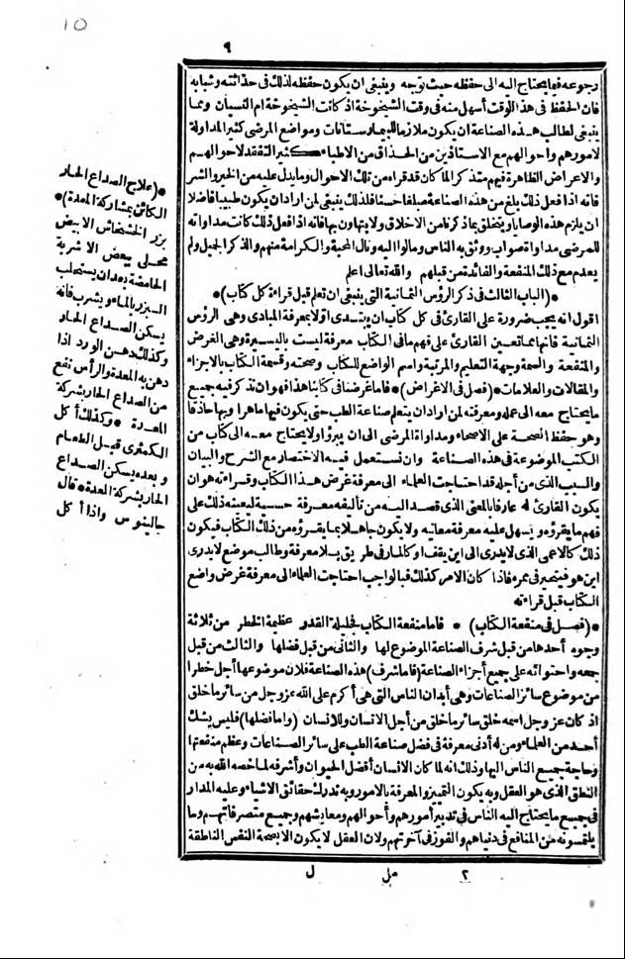
Chapter Two: Recommendations Mentioned by Hippocrates and Other Ancient Medical Practitioners and Scholars
I would say to whoever wanted to be a virtuous learned doctor to follow the recommendations of the wise Hippocrates, which he recommended by his oath to the Medical Practitioners after him. First what he recommends to them after duty to God and obeying His Commandments, that they favored their teachers with their service and gratitude. Also care for them in comparison the care of your parents, by honoring them as they were honorable to them, with their good returned by sharing much of your possessions with them. What was best as much said as if the parents were the reason they are. Likewise the teachers were the reason they were distinguished by astonishing them with good report for science. Likewise human rights had belonged to their teacher, as belonged to them the rights of their parents.
* He said that you should take your teachers children as brothers you have like sons of your fathers. Also he said do not let go any of those who wanted study this Art from the eligible for its education without wages, or requirement. Nor request a reward with their provision of hospitality, until you or your teachers were afflicted from the wicked and foolish, as offering greater resistance to who did not deserve it.
* He recommended that the doctor strived in treatment of patients by their good management with food and medicine. It was not their purpose with treatment to seek money, but to seek the reward of hire. And he did not give to anyone a lethal drug, while not it was described by indications for it. Also he would not hand over to any women the abortion medicine of embryos/fetuses and not mention it.
* Also it was said for the doctor that he should be clean, when the fine commendable tongue of God’s Might and Glory had drawn up a clean arrangement, separating for all impurity and debauchery. He does not look to the nation or the devotion with things from that. It would not be his intention of entry to the patients, except to heal their conditions, if he has the ability with them.
* Also he should not disclose of the patients secrets with others, by not informing about it the near or the far away. Because much of the sickness presented to them was the diseases hidden from their parents and families, they revealed to the doctor manifestation of pain in uterus and hemorrhoids. It should be that the doctor concealed it from the people among them.
* It must be for the doctor in all conditions for what the wise Hippocrates had said: that he had been merciful, decent, with gentle modesty to choose favorable nice talk near people, keen for the patients treatment by their medical treatment, especially the poor and people of poverty. He would not seek among them therefore to profit, but to be given the ability. And if he was able to set up the medicine from his possessions, let him do that. Then if he was not able for that, he accomplished for them by coming and going evening and morning until their illness was cured and they were healthy, because the acute illness rapidly changes from one condition to another.
* It should not be for the doctor to be busy with pleasures and enjoy diversion of playing. He is not to be among much to drink filth, because that injures the brain. But infused with curiosity of a kind mind, he must be more busy only for the reading of medical books, with careful consideration and not tired nor angry of that every day. He will commit himself to preserve all he had read with its presentation needed from the knowledge, by remembering it in going and coming. Then he works and accustoms his mind until it does not need the book ends at all times, while he probably receives the books affliction. Then returning to them as what is needed where it was preserved. As he should have preserved it therefore in its novelty as a youth, because preservation at this time easier than making a mistake at the time of aging, when he was aged or forgetting. And such a student of this Art should be attending the many places of disease as the Bimaristans (hospitals) for deliberation of care and their situation, with the well-versed professors among many doctors. The review of their conditions and apparent symptoms in them recalling what students had read as evidenced by good and bad about them. Because if the work was done by this Art amounted as good, you should be so delighted for those who wanted to be a virtuous doctor to commit these commandments and seek to acquire what we have of morality. And do not take it lightly. For if he did what was right treatment for patients, people trusted him and he obtained riches. Also by beautiful mention, he attained love and dignity among them, as he was not deprived with that benefit and the hearts before them. And God, high above, knows best.

Commentary: Recommendations Mentioned by Hippocrates and Other Ancient Medical Practitioners and Scholars
- History
‘Ali Ibn Al ‘Abbaas Al Majusi was the second of three great Persian (Iranian) Physicians, following Abu Bakr Mohammad Bin Yahia Bin Zakaria Al-Razi (Al Razi). Abu ʿAli Al-Husayn ibn ʿAbd Allah ibn Sina (Avicenna) was the third Persian Physician. Their encyclopedic Medical Textbooks were studied in European Medical Schools until the end of the seventeenth century. These physicians had inherited the development of academic medicine and medical centers that required graduates to pass an examination in order to practice medicine during the flourishing of Gondi-Shapur (370 AD- 638 AD). Gondi-Shapur became known as the ‘City of Hippocrates’, as manuscripts of Hippocrates and Galen, as well as Indian and Syriac civilizations were translated and practiced. After the Arab conquest of Persia, the academic tradition developed in Gondi-Shapur was gradually then transferred to Bagdhad, the capital of Abbasid Caliphate, and later to Spain ushering in the birth of the ‘Golden Age of Islam’². Al Majusi was born in the city called Al-Ahwaz. His ancestors were Zoroastrians, but he was a Muslim. He learned medicine from the madrassa teacher Abi Maher Moussa Ibn Yousef Ibn Sayyar. A number of important books for medical practitioners are attributed to Al Majusi. However, his last and best book, ‘Kaamal Al Sanaa’ah Al Tibbiyyah’, was widely appreciated for giving a good picture of the theoretical and practical medicine used during this time. He presented the book to the Amir Adhodd Al-Dawla Al-Bouwayhi, and it was called the Royal Book. Even though the book was translated into Latin, by Constantine the African, in 1087 AD, without acknowledging Al Majusi as the true author, it was subsequently translated more completely in Latin, by Stephan of Antioch, where Al Majusi was acknowledged as the true author of the book³.
- Importance of Hippocrates
Hippocrates is known as the ‘Father of Medicine’ and the central figure in Western Medicine. Al Majusi recognized Hippocrates in the previous chapter as a leader of this Art and the first of those superior with an abundance of books, he produced in each type of the science, when he had not found anyone book complete from the ancient and recent doctors containing all they needed to achieve the purpose of this art by exact performance. Medicine has been required since the beginning of mankind to maintain the health of humans. Since prehistoric times, it is believed that the animistic philosophy must have been that which was earliest developed among the prehistoric societies of mankind. The German physician Stahl explained animism as a theory of Biology, ‘the soul (anima) as the vital principle, cause of the normal phenomena of life, or of the abnormal phenomena of disease’⁴. The ancient world records Shamans as the oldest of the medical healers. Trances and prayers were among the treatments used for various illnesses. As healers Shamans were accorded a high place socially and politically, and considered learned in tribal lore and traditions, even as they still exist today⁵. There were male and female Shamans, who were originally looked to as the healers and priests. The medical tradition of the Babylonians and Egyptians was based on study of medical practices which preceded them. Babylonian medical texts on clay tablets recorded first symptoms of illness, prescription and directions for compounding, then an invocation to the gods about the time of 2400 BC. Sir William Osler⁶ tells us about the ancient Egyptian physician Imhotep:
"..first figure of a physician to stand out clearly from the mists of antiquity." Imhotep diagnosed and treated over 200 diseases, 15 diseases of the abdomen, 11 of the bladder, 10 of the rectum, 29 of the eyes, and 18 of the skin, hair, nails and tongue. Imhotep treated tuberculosis, gallstones, appendicitis, gout and arthritis. He also performed surgery and practiced some dentistry. Imhotep extracted medicine from plants. He also knew the position and function of the vital organs and circulation of the blood system. The Encyclopedia Britannica⁷ says, "The evidence afforded by Egyptian and Greek texts support the view that Imhotep's reputation was very respected in early times. His prestige increased with the lapse of centuries and his temples in Greek times were the centers of medical teachings." Imhotep's best known writings were medical texts. As a physician, Imhotep is believed to have been the author of the Edwin Smith Papyrus in which more than 90 anatomical terms and 48 injuries are described. He may have also founded a school of medicine in Memphis, as part of his cult center possibly known as "Asclepion”, where he was revered as the ‘God of Medicine’. It remained famous for two thousand years. This cult center was transferred to Greece, where a number of well-organized sanctuaries were developed. When patients arrived at the sanctuary, they were made to fast, bathe and purify themselves before sacrificing. All of this occurred some 2,200 years before Hippocrates was born. Hippocrates of Cos was among the most famous Greek physicians who followed Asclepius⁸.

Hipporcrates is credited with the establishment of rational systems of medicine free from magical and religious elements and based upon natural causes⁹. So at the time of Prophet Muhammad (Prayers of Peace be upon him) medical systems were based on the philosophy derived from the Greeks. Illnesses of any kind were, in general, due to disturbances of the four body humors (akhalaat), blood, bile, black bile, and phlegm¹⁰. With the spread of Islam, the ‘Abbasid Dynasty established the House of Wisdom (Bayt Al Hikma), in Baghdad, for the study and translation of the Greek works of philosophy, science, and medicine. A Nestorian Christian, Hunayn Ibn Ishaq, was the chief translator. Although he was not a Muslim, Al Razi was noted for his chief manuscripts, which included ‘Al Mansouri’ and ‘Al Haawi Fiy Al Tibb’ (The Comprehensive), as well as his clinical observations. He became the personal physician to the Caliph of Baghdad, Al Muqtadir. Islamic colleges of Al Andulusia were characterized by an inscription based on ‘the learning of the wise’ as one of four principles that supports the world¹¹. Even though he departed from some of the religious elements, Hippocrates recommendation of duty to God and obedience to His Commandments is consistent with the Medical Practitioners before his time. The preparation of the physician for the medical practice requires rigorous learning and preceptorship, as supervision by the experts of medical practice. Al Majusi recognized Abi Maher Musa Ibn Sayyer as his preceptor, as well as Imams Al Sawaidi and Al Sh’araani, by allowing their comments throughout the book ‘Kaamal Al Sanaa’ah Al Tibbiyyah’. Those who did not deserve to study the Art of Medicine from the wicked and foolish were offered greater resistance to its study and practice. The high social and political positions that were afforded does not permit ill will toward patients. Al Razi had noted if the patient can be cured by dietary means, do not use drugs. Physicians at this period of time were more interested in being hired by their patients as personal physicians, than hired for monetary gain. During this time, however many of the physicians were hired by Kings, including Al Razi, the family of Bukhtishu physicians, and Moses Maimonides. Medications were mostly from plants, with some mineral and animal items. Physicians were encouraged not to be enthusiastic for the administration of medications. It was said that the Holy Qur’an was the primary inspiration for Muslim administrators to ensure emphatic care for the sick regardless of social status, race, or color¹¹. Patients understood that the medical conditions from which they suffered from would be held in confidence with the doctor, not to be discussed with any family member. With all medical conditions of the patients, physicians showed mercy and were keen to heal their suffering. Also physicians were advised to avoid too much diversion of pleasures and drinking of alcohol. But with much deliberation and care of their patients, seek their delight by determining the good or bad of their medical conditions. By not taking the position of the medical profession lightly, physicians would attain the trust and love that was accorded to them.

- Relationship to Medicine of Today
Though we no longer formerly subscribe to the Hippocratic Oath, much of the practice has remained unchanged. It is not only enough to know what Hippocrates did, as it should be to know how Hippocrates was connected with those who came before him. We know enough today to give an accurate account of medicine from the beginning time. This should be the foundation of teaching in all Medical Schools. This book gives a much needed picture of the practice of medicine during the time of Al Majusi. The language barrier had made it difficult to lend it to the overall picture of Medical History. This should change, as the human spirit is one and the accurate and intended translations are able to be attained. Despite of the possibilities for wealth, most doctors caring for patients are not seeking wealth. There are many organizations today that provide free medical services to underdeveloped countries, which may include heart surgery. Much of the dissatisfaction with Medical Care today involves roles of the management of Health Maintenance Organizations and Insurance Companies with organization restrictions by limiting the physician’s autonomy¹². In spite of the advancement of progression of the health delivery today, most births of newborns in the world occur outside of a hospital. What may help all of us is to remember our true roles to acknowledge we owe our existence to God, our parents, teachers, and country. And that our value lies not in who we are, but in what we do for humanity.

REFERENCES:
- Islamic Medicine Volume 41 ‘Ali Ibn Al Abbaas Al Majusi Kaamil As Sinaa’a At Tibbiya Part 1. 1996. Institute for the History of Arabic-Islamic Science at the Johann Wolfgang Goethe University, Frankfurt am Main
- Modanlou HD Historical evidence for the origin of the teaching hospital, medical school and rise of academic medicine Journal of Perinatology (2011) 31: 236-39.
- Shayeb M Causes of obstructed labor as written in The Complete Medical Art “Kamil Al-Sinaa Al Tibbiya” by Ali Ibn Al-Abbas Al-Majusi Journal of the International Society of the History of Islamic Medicine 2009-2010, 8-9: 82-5.
- Stahl and Hoffman: A study in eighteenth century animism J Hist Med Allied Sci (1964) XIX(2): 118-130
- In MEDICINE- An Illustrated History; 1987
- Osler W, The Evolution of Modern Medicine, Kessinger Publishing, 2004, p. 12
- Imhotep Encyclopedia Britannica Online 2013
- Greek Mythology and Religion Editions Ha’i’talis, Athens. 1997. Page 112.
- Loundon I Western Medicine: An Illustrated History, Oxford University Press, Oxford. 1997. Page 25
- Al-Jawziyya I Medicine of the Prophet The Islamic Texts Society, Cambridge, UK. 1998. Page xxv
- Ajram K Incredible Islamic Scientists Volumes 1 and 2 Knowledge House Publishers, Cedar Rapids, IA, 1992
- Zuger A Dissatisfaction with Medical Practice N Engl J Med 2004; 350:69-75

