The Story of Blood Group Discovery
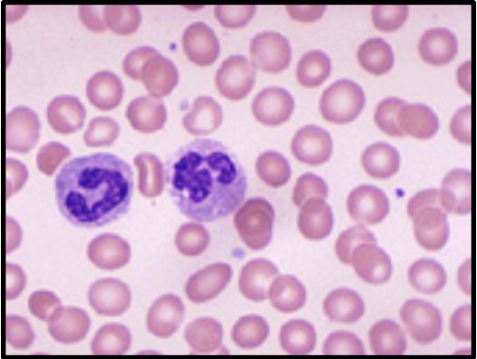

Submitted by
Abdul Nasser Kaadan, MD, PhD*
** Muhammad Alkhatib

Contents:
- Introduction
- Definition:
- ABO Blood Grouping System
- Rh Factor Blood Grouping System
- Blood Group Notation
- Antigens and Antibodies
- Importance of The ABO System
- Indications for The ABO Grouping
- Dicovery of The ABO System
- ABO Typing
- Characteristics of ABO Antigens
- Characteristics of ABO Antibodies
- ABO Inheritance
- Biochemistry of The ABO System
- Rarest Blood Type:
- Rarest Blood Type in Humans
- Rarest Blood Type in The World
- Early Practices
- Blood Banks
- Clinical Trials
- New Hemoglubin Type Found
- Blood Type Discovery May Lead To New Tools In
HIV Fight
Biography:
- Karl Landsteiner
- Emil Fischer
- James Blundelle
- William Harvey
- Jan Jansky

Introduction:

An adult human has about 4–6 liters of blood circulating in the body. Among other things, blood transports oxygen to various parts of the body. Blood consists of several types of cells floatingaround in a fluid called plasma.

The red blood cells contain hemoglobin, a protein that binds oxygen. Red blood cells transport oxygen to, and remove carbon dioxide from, the body tissues.

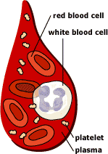

The white blood cells fight infection.
The platelets help the blood to clot, if you get a wound for example.
The plasma contains salts and various kinds of proteins.

Definition:
The differences in human blood are due to the presence or absence of certain protein molecules called antigens and antibodies. The antigens are located on the surface of the red blood cells and the antibodies are in the blood plasma. Individuals have different types and combinations of these molecules. The blood group you belong to depends on what you have inherited from your parents.

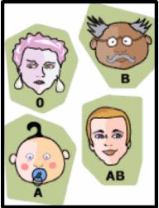

There are more than 20 genetically determined blood group systems known today, but the AB0 and Rh systems are the most important ones used for blood transfusions. Not all blood groups are compatible with each other. Mixing incompatible blood groups leads to blood clumping or agglutination, which is dangerous for individuals.

AB0 blood grouping system
According to the AB0 blood group system there are four different kinds of blood groups: A, B, AB or 0 (null).

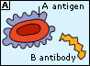 | Blood group A  If you belong to the blood group A, you have A antigens on the surface of your red blood cells and B antibodies in your blood plasma.
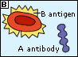 | Blood group B  If you belong to the blood group B, you have B antigens on the surface of your red blood cells and A antibodies in your blood plasma.
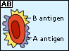 | Blood group AB  If you belong to the blood group AB, you have both A and B antigens on the surface of your red blood cells and no A or B antibodies at all in your blood plasma.
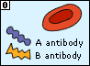 | Blood group 0  If you belong to the blood group 0 (null), you have neither A or B antigens on the surface of your red blood cells but you have both A and B antibodies in your blood plasma.

Rh factor blood grouping system
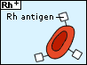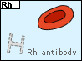

Many people also have a so called Rh factor on the red blood cell's surface. This is also an antigen and those who have it are called Rh+. Those who haven't are called Rh-. A person with Rh- blood does not have Rh antibodies naturally in the blood plasma (as one can have A or B antibodies, for instance). But a person with Rh- blood can develop Rh antibodies in the blood plasma if he or she receives blood from a person with Rh+ blood, whose Rh antigens can trigger the production of Rh antibodies. A person with Rh+ blood can receive blood from a person with Rh- blood without any problems.

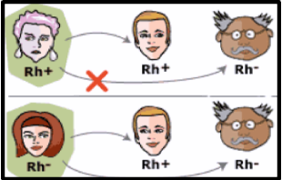

Blood group notation:
According to above blood grouping systems, you can belong to either of following 8 blood groups:

A Rh+ | B Rh+ | AB Rh+ | 0 Rh+
A Rh- | B Rh- | AB Rh- | 0 Rh-

Blood typing:

how do you find out to which blood group soeone belongs?
1.
You mix the blood with three different reagents including either of the three different antibodies, A, B or Rh antibodies.
2.
Then you take a look at what has happened. In which mixtures has agglutination occurred? The agglutination indicates that the blood has reacted with a certain antibody and therefore is not compatible with blood containing that kind of antibody. If the blood does not agglutinate, it indicates that the blood does not have the antigens binding the special antibody in the reagent.
3.
If you know which antigens are in the person's blood, it's easy to figure out which blood group he or she belongs to!
What happens when blood clumps or agglutinates?
For a blood transfusion to be successful, AB0 and Rh blood groups must be compatible between the donor blood and the patient blood. If they are not, the red blood cells from the donated blood will clump or agglutinate. The agglutinated red cells can clog blood vessels and stop the circulation of the blood to various parts of the body. The agglutinated red blood cells also crack and its contents leak out in the body. The red blood cells contain hemoglobin which becomes toxic when outside the cell. This can have fatal consequences for the patient.The A antigen and the A antibodies can bind to each other in the same way that the B antigens can bind to the B antibodies. This is what would happen if, for instance, a B blood person receives blood from an A blood person. The red blood cells will be linked together, like bunches of grapes, by the antibodies. As mentioned earlier, this clumping could lead to death.

Blood transfusions: who can receive blood from whom?
Of course you can always give A blood to persons with blood group A, B blood to a person with blood group B and so on. But in some cases you can receive blood with another type of blood group, or donate blood to a person with another kind of blood group.

The transfusion will work if a person who is going to receive blood has a blood group that doesn't have any antibodies against the donor blood's antigens. But if a person who is going to receive blood has antibodies matching the donor blood's antigens, the red blood cells in the donated blood will clump.
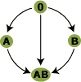

People with blood group 0 Rh - are called "universal donors" and people with blood group AB Rh+ are called "universal receivers."

Rh+ blood can never be given to someone with Rh - blood, but the other way around works. For example, 0 Rh+ bloodcan not be given to someone with the blood type AB Rh -.
Blood Group | Antigens | Antibodies | Can give blood to | Can receive blood from
AB Rh⁺ | A, B and Rh | None | AB Rh⁺ | AB Rh⁺  AB Rh ⁻  A Rh⁺  A Rh ⁻  B Rh⁺  B Rh ⁻  0 Rh⁺  0 Rh ⁻
AB Rh ⁻ | A and B | None  (Can develop Rh antibodies) | AB Rh ⁻  AB Rh⁺ | AB Rh ⁻  A Rh ⁻  B Rh ⁻  0 Rh ⁻
A Rh⁺ | A and Rh | B | A Rh⁺  AB Rh⁺ | A Rh⁺  A Rh ⁻  0 Rh⁺  0 Rh ⁻
A Rh ⁻ | A | B  (Can develop Rh antibodies) | A Rh ⁻  A Rh⁺  AB Rh ⁻  AB Rh⁺ | A Rh ⁻  0 Rh ⁻
B Rh⁺ | B and Rh | A | B Rh⁺  AB Rh⁺ | B Rh⁺  B Rh ⁻  0 Rh⁺  0 Rh-
B Rh ⁻ | B | A  (Can develop Rh antibodies) | B Rh⁻  B Rh⁺  AB Rh⁻  AB Rh⁺ | B Rh ⁻  0 Rh ⁻
0 Rh⁺ | Rh | A and B | 0 Rh⁺  A Rh⁺  B Rh⁺  AB Rh⁺ | 0 Rh⁺  0 Rh ⁻
0 Rh ⁻ | None | A and B (Can develop Rh antibodies) | AB Rh⁺  AB Rh ⁻  A Rh⁺  A Rh ⁻  B Rh⁺  B Rh ⁻  0 Rh⁺  0 Rh ⁻ | 0 Rh ⁻

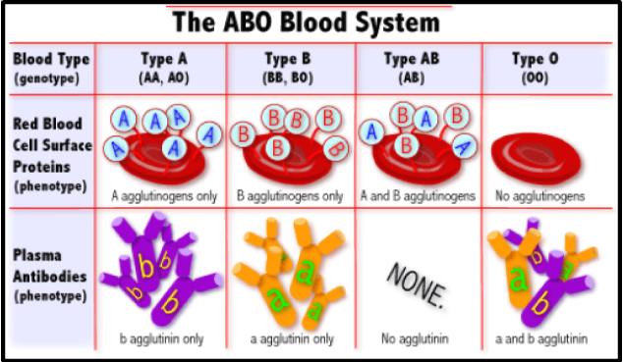

Type | You Can Give Blood To | You Can Receive Blood From
A+ | A+ AB+ | A+ A- O+ O-
O+ | O+ A+ B+ AB+ | O+ O-
B+ | B+ AB+ | B+ B- O+ O-
AB+ | AB+ | Everyone
A- | A+ A- AB+ AB- | A- O-
O- | Everyone | O-
B- | B+ B- AB+ AB- | B- O-
AB- | AB+ AB- | AB- A- B- O-
Blood donation possibilities

ANTIGENS AND ANTIBODIES

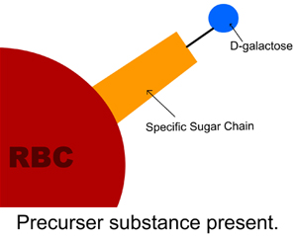

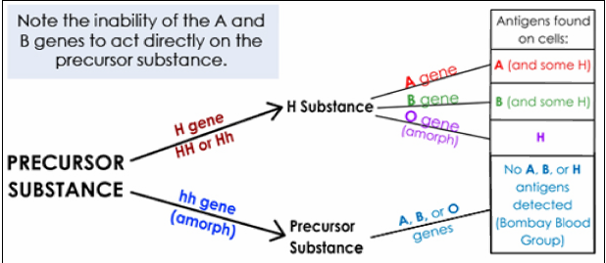
Blood group system
A series of antigens exhibiting similar serological and physiological characteristics, and inherited according to a specific pattern.

Importance of the ABO system:
This is the only blood group system in which antibodies are consistently, predictably, and naturally present in the serum of people who lack the antigen. Therefore ABO compatibility between donor and recipient is crucial since these strong, naturally occurring A and B antibodies are IgM and can readily activate complement and cause agglutination. If ABO antibodies react with antigens in vivo, result is acute hemolysis and possibly death.

Indications for ABO grouping:
ABO grouping is required for all of the following individuals:
- Blood Donors:since it can be life threatening to give the wrong ABO group to the patient.
- Transfusion recipients: since we need to know the donor blood is ABO compatible.
- Transplant Candidates and Donors: ABO antigens are found in other tissues as well. Therefore the transplant candidates and donors must be compatible.
- Prenatal Patients: To determine whether the mothers may have babies who are suffering from ABO-HDN. It is also beneficial to know the ABO group should she start hemorrhaging.
- Newborns: If the baby is demonstrating symptoms of Hemolytic Disease of the Newborn, the ABO group needs to be determined along with Rh and others.
- Paternity testing:Since the inheritance of the ABO Blood Group System is very specific, this serves as one of the first methods to determine the likelihood that the accused father is the father or not.

Discovery of the ABO system:
In 1900 Karl Landsteiner reported a series of tests, which identified the ABO Blood Group System. In 1910 he won Nobel prize for medicine for this discovery. He mixed the serum and cells of all the researchers in his lab and found four different patterns of agglutination. From those studies he developed what we now know as Landsteiner's rules:
- A person does not have antibody to his own antigens
- Each person has antibody to the antigen he lacks (only in the ABO system)

Incidence (%) of ABO Blood Groups in the US Population
ABO Group | Whites | Blacks
O | 45 | 49
A | 40 | 27
B | 11 | 20
AB | 4 | 4

ABO Typing
ABO typing involves both antigen typing and antibody detection. The antigen typing is referred to as the forward typing and the antibody detection is the reverse typing
- The forward typing determines antigens on patient's or donor's cells
a. Cells are tested with the antisera reagents anti-A, anti-B, (and in the case of donor cells anti-A,B)
b. Reagents are either made from hyperimmunized human sources, or monoclonal antibodies.
c. One advantages of the monoclonal antibodies are the antibody strength.
d. Another advantage of monoclonals: human source reagents can transmit infectious disease (hepatitis).
- Reverse typing determines antibodies in patient's or donor's serum or plasma
a. Serum tested with reagent A₁ cells and B cells
b. Reverse grouping is also known as backtyping or serum confirmation

Routine ABO Typing
Reaction of Cells Tested With |  | Red Cell ABO Group | Reaction of Serum Tested Against |  | Reverse ABO Group
Anti-A | Anti-B |  | A₁ Cells | B Cells
0 | 0 | O | + | + | O
+ | 0 | A | 0 | + | A
0 | + | B | + | 0 | B
+ | + | AB | 0 | 0 | AB

Discrepancies in ABO typing
- Results of forward and reverse typing must agree before reporting out blood type as seen in the about table.
- If forward and reverse do not agree, must identify cause of discrepancy.
- If cannot resolve discrepancy, must report out blood type as UNKNOWN and give group O blood

Characteristics of ABO antigens:
ABO antigens are glycolipid in nature, meaning they are oligosaccharides attached directly to lipids on red cell membrane. These antigens stick out from red cell membrane and there are many antigen sites per red blood cell (approximately 800,000)
Besides their presence on red blood cells, soluble antigens can be present in plasma, saliva, and other secretions. These antigens are also expressed on tissues other than red cells. This last fact is important to consider in organ transplantation.
ABO antigens are only moderately well developed at birth. Therefore ABO-HDN not as severe as other kinds of Hemolytic Disease of the Newborn.

Characteristics of ABO antibodies:
- These are expected naturally occurring antibodies that occur without exposure to red cells containing the antigen. (There is some evidence that similar antigens found in certain bacteria, like E.coli, stimulate antibody production in individuals who lack the specific A and B antigens.)
- Immunoglobulin M antibodies, predominantly
- They react in saline and readily agglutinate. Due to the position of the antigen and the IgM antibodies it is not necessary to overcome the zeta potential.
- Their optimum temperature is less than 30ºC, but reactions do take place at body temperature
- Not only are these antibodies expected and naturally occurring, they are also commonly present in high titer, 1/128 or 1/256.
- They are absent at birth and start to appear around 3-6 months as result of stimulus by bacterial polysaccharides. (For this reason, newborn blood is only forward typed.)

ABO INHERITANCE

Inheritance Terminology:
gene: determines specific inherited trait (ex. blood type)
chromosome: unit of inheritance. Carries genes.23 pairs of chromosomes per person, carrying many genes. One chromosome inherited from mother, one from father
locus: site on chromosome where specific gene is located
allele: alternate choice of genes at a locus (ex. A or B; C or c, Lewis a or Lewis b)
homozygous: alleles are the same for any given trait on both chromosome (ex. A/A)
heterozygous: alleles for a given trait are different on each chromosome (ex. A/B or A/O)
phenotype: observed inherited trait (ex. group A or Rh positive)
genotype: actual genetic information for a trait carried on each chromosome (ex. O/O or A/O)
dominant: the expressed characteristic on one chromosome takes precedence over the characteristic determined on the other chromosome (ex. A/O types as A)
co-dominant: the characteristics determined by the genes on both chromosomes are both expressed - neither is dominant over the other (ex. A/B types as AB)
recessive: the characteristic determined by the allele will only be expressed if the same allele is on the other chromosome also (ex. can type as O only when genotype is O/O)

ABO Genes
The A and B genes found on chromosome #9. We inherit one gene (allele) from our father and one from our mother. The two co-dominant alleles are A or B. Anytime an individual inherits an A or B gene it will be expressed.
The O gene signifies lack of A or B antigens. It is not expressed unless this gene is inherited from both parents (OO). Therefore the O gene is recessive.
Below is the example of two individuals who are A. One inherited only one A gene along with an O gene and is therefore heterozygous. The other inherited 2 A genes and is homozygous for A.
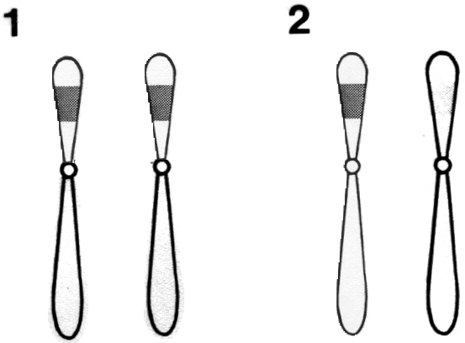
1 = A/A | 2 = A/O
1 = Homozygous A | 2 = Heterozygous A
Phenotype A | Phenotype A
Genotype A/A | Genotype A/0
Can Contribute Only an A Gene to Offspring | Can Contribute A or O Gene to Offspring

Inheritance Patterns
We can't determine genotypes of A or B people unless family studies are done. Some basic rules of ABO inheritance are as follows:
- A/A parent can only pass along A gene
- A/O parent can pass along either A or O gene
- B/B parent can only pass along B gene
- B/O parent can pass along either B or O gene
- O/O parent can only pass along O gene
- AB parent can pass along either A or B gene

ABO phenotypes and genotypes
1. Group A phenotype = A/A or A/O genotype
2. Group B phenotype = B/B or B/O genotype
3. Group O phenotype = O/O genotype
4. Group AB phenotype = A/B genotype

Offspring possibilities

Possibilities of an A/O mating with a B/O: (Children's genotypes in purple)
Mother's Genes | Father's Genes
Mother's Genes | B | O
A | AB | AO
O | BO | OO

Possibilities of AA mating with BB: (Children's genotypes in purple)
Mother's Genes | Father's Genes
Mother's Genes | B | B
A | AB | AB
A | AB | AB

Possibilities of an A/A mating with a B/O: (Children's genotypes in purple)
Mother's Genes | Father's Genes
Mother's Genes | B | O
A | AB | AO
A | AB | AO

Possibilities of an A/A mating with an O/O:
Mother's Genes | Father's Genes
Mother's Genes | O | O
A | AO | AO
A | AO | AO

Possibilities of an A/O mating with an O/O:
Mother's Genes | Father's Genes
Mother's Genes | O | O
A | AO | AO
O | OO | OO

Possibilities of an A/B mating with a O/O:
Mother's Genes | Father's Genes
Mother's Genes | O | O
A | AO | AO
B | BO | BO

BIOCHEMISTRY OF THE ABO SYSTEM
The ABO antigens are terminal sugars found at the end of long sugar chains (oligosaccharides) that are attached to lipids on the red cell membrane. The A and B antigens are the last sugar added to the chain. The "O" antigen is the lack of A or B antigens but it does have the most amount of next to last terminal sugar that is called the H antigen.
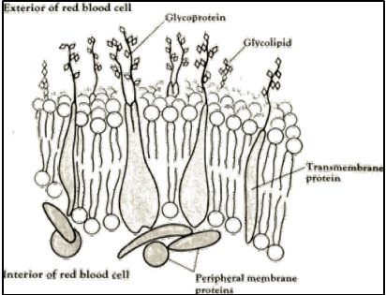

Production of A, B, and H antigens
The production of A, B and H antigens are controlled by the action of transferases. These transferases are enzymes that catalyze (or control) addition of specific sugars to the oligosaccharide chain. The H, A, or B genes each produce a different transferase, which adds a different specific sugar to the oligosaccharide chain.
To understand the process let's look at the sequence of events:
- Precursor chain of sugars is formed most frequently as either Type 1 or Type 2 depending on the linkage site between the N-acetylglucosamine (G1cNAc) and Galactose (Gal).
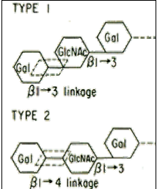
- H gene causes L-fucose to be added to the terminal sugar of precursor chain, producing H antigen (shown in this diagram of a Type 2 H antigen saccharide chaine).
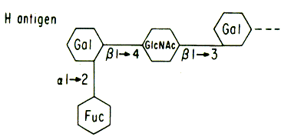
- Either A gene causes N-acetyl-galactosamineto be added to H substance, producing A antigen, (shown in this diagram) or
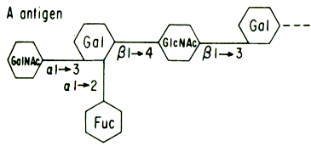
- B gene causes D-galactose to be added to H substance, producing B antigen.
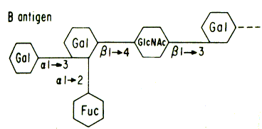
- If both A and B genes present, some H-chains converted to A antigen, some converted to B antigen.
- If H gene absent, no H substance can be formed, and therefore no A or B antigen. Result is Bombay blood group.

Bombay blood group:
The Bombay blood group lacks H gene and therefore cannot make H antigen (H substance). Since the H substance is the precursor for the A and B antigens, these antigens also are not made. The cells type as O and the serum has anti-A, anti-B, and anti-H since the individual lacks all of these antigens. Anti-H agglutinates O cells. The only cells Bombay individuals do not agglutinate are from other Bombay blood people since they lack the H antigen,

Subgroups of A and B

The subgroups of A and B are caused by decreased amounts of antigen on the red blood cells. They are inherited conditions. The most common are subgroups of A. Approximately 80% of the A's and AB's have a normal expression of A₁. Most of the other 20% are either A₂ or A₂B. This subgroup has fewer H chains converted to A antigen – result is more H chains on red cell, and fewer A antigens. A small percentage of the individuals

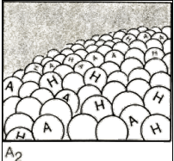
There are other, weaker subgroups of A exist: A₃; A_{int}; A_{m}, A_{x}; A_{el}. Each has a different pattern of reacting with anti-A, anti-A, and various antibody-like substances called lectins.

Lectins
Lectins are extracts of seeds of plants that react specifically with certain antigens. The two most common lectins used in Blood Bank are:
- Ulexeuropaeus, or lectin H, which agglutinates cells that have H substance.
- Dolichosbiflouros, or lectin A₁, which agglutinates cells with A₁.
Lectin-H reacts strongest with O cells, which has a high concentration of H antigen, and weakest with A₁ cells, which have a low concentration of H.
Lectin | O cells | A₂ cells | A₂B cells | B cells | A₁ cells | A₁B cells | Bombay cells
lectin-H | 4+ | 3+ | 2-3+ | 2+ | weak to negative | weak to negative | negative
Lectin-A₁ | negative | negative | negative | negative | positive | positive | negative

Differentiating Subgroups of A:
Use the following steps to help differentiate the subgroups of A:
- Use lectin-A₁ to differentiate A₁ cells from all others - will agglutinate only A₁ cells
- Look for weaker or mixed field reactions
- Look for anti-A₁ in serum (serum reacts with A₁ cells but not A₂ cells)
- Look at strength of reactions with anti-A,B or with lectin-H
GROUP | A₁ | A₂ | A₃ | A_{x}
Reaction with anti-A | 4+ | 4+ | mf | 0
Reaction with anti-A,B | 4+ | 4+ | mf | 2+
Reaction with Lectin-A₁ | 4+ | 0 | 0 | 0
Reaction with Lectin-H | 0-w | 1-2+ | 2+ | 2-3+
Presence of anti-A₁ | no | may | may | often in serum

Problems with A_{x}:
Because A_{x} cells initially type as O and serum usually has anti-A₁, (along with anti-B), patient forwards and reverses as O. Unfortunately when A_{x} is transfused into an O individual, the naturally occurring anti-A,B will react with the donor cells causing a transfusion reaction. Therefore: To prevent A_{x} from being erroneously typed as O, confirm all group O donors with anti-A,B.
Rarest Blood Type

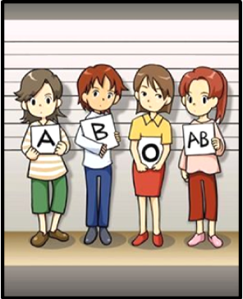

Rarest Blood Type in Humans:
The Australian scientist Karl Landsteiner was the first person to come up with the discovery of ABO blood group system. He was given the Nobel Prize in Physiology or Medicine in 1930 for this path breaking discovery. However, Landsteiner discovered A, B and O blood type. The fourth blood type explained in 1902 was carried out by Alfred von Decastello and Adriano Sturli.

It was found O is the most commonly found blood type. But, what is the rarest blood type in the world? The following blood types chart will help you understand and find the rarest blood type in the world.

Blood Type and Rh |  | Frequency | Number of People Found</TD<tr>
O⁺ | O Rh positive | 37.4% | 1 person in 3
O⁻ | O Rh Negative | 6.6% | 1 person in 15
A⁺ | A Positive blood type | 35.7% | 1 person in 3
A⁻ | A Rh Negative | 6.3% | 1 person in 16
B⁺ | B Rh Positive | 8.5% | 1 person in 12
B⁻ | B Negative blood type | 1.5% | 1 person in 70
AB⁺ | AB Rh Positive | 3.4% | 1 person in 29
AB⁻ | AB Rh Negative | 0.6% | 1 person in 170
From the above table you will understand that the rarest blood type in the world is AB negative. AB Rh negative is one of the most rarest blood types, followed by B Rh negative. The most common blood type of the group is O positive. It may be natures way to help those with rarest blood types, as O negative is termed as the 'Universal Donor'. The people with O negative blood group can donate blood to any blood type with RhD antigen. The blood type AB positive is said to be the 'Universal Receiver' as they can be donated with blood from either of the groups.
Rarest Blood Type in the World:

We have discussed that AB negative is the rarest blood type in the world. However, there is one blood group that is found to be really, really rare. Not many people around the world are even aware that this blood group even exists. This blood group is the Bombay blood type.
Bombay phenotype (hh) does not express the H antigen on the red blood cells. This antigen was only found in a Czechoslovakian nurse in 1961 and then in a brother sister duo of Massachusetts in 1968. It was first discovered in Bombay (now Mumbai) in 1950. Thus, the name Bombay blood type. This is one of the really rarest blood type in the world. People of this blood type can receive blood only from people with hh blood type. It is said that there are only 57 people in India with this blood type. The Bombay blood group does not have A or B antigens and has H antigen that is similar to type O. Thus, they cannot even receive blood from the O blood group as the donor H antigens on RBC will bind and destroy the RBC's of the receiver. However, they can donate blood as if they were type O.

Genetic Inheritance Patterns
ABO blood types are inherited through genes on chromosome 9, and they do not change as a result of environmental influences during life. An individual's ABO type is determined by the inheritance of 1 of 3 alleles (A, B, or O) from each parent. The possible outcomes are:
Parent Alleles | A | B | O
A | AA  (A) | AB  (AB) | AO  (A)
B | AB  (AB) | BB  (B) | BO  (B)
O | AO  (A) | BO  (B) | OO  (O)

The possible ABO alleles for one parent are in the top row and the alleles of the other are in the left column. Offspring genotypes are shown in black. Phenotypes are red.
Both A and B alleles are dominant over O. As a result, individuals who have an AO genotype will have an A phenotype. People who are type O have OO genotypes. In other words, they inherited a recessive O allele from both parents. The A and B alleles are codominant. Therefore, if an A is inherited from one parent and a B from the other, the phenotype will be AB. Agglutination tests will show that these individuals have the characteristics of both type A and type B blood.
The inheritance of ABO blood types does not always follow such straightforward rules of inheritance. ABO Blood type antigens are not only found on the surface of red cells. They are also normally secreted by some people in their body fluids, including saliva, tears, and urine. Whether someone is able to secrete them is genetically controlled. Police agencies now routinely use this so-called secretor system data to identify potential victims and criminals when blood samples are not available.Antibodies to alien antigens in the ABO group are usually present in our plasma prior to the first contact with blood of a different ABO type. This may be partly explained by the fact that these antigens are also produced by certain bacteria and possibly some plants. When we come in contact with them, our bodies may develop long-term active immunity to their antigens and subsequently to the same antigens on the surface of red blood cells. This usually occurs to babies within the first six months following their birth.
Environmental Factors
While blood types are 100% genetically inherited, the environment potentially can determine which blood types in a population will be passed on more frequently to the next generation. It does this through natural selection. Specific ABO blood types are thought to be linked with increased or decreased susceptibility to particular diseases. For instance, individuals with type A blood are at a somewhat higher risk of contracting smallpox and developing cancer of the esophagus, pancreas, and stomach. People who are type O are at a higher risk for contracting cholera and plague as well as developing duodenal and peptic ulcers. Research suggests that they are also more tasty to mosquitoes. That could be a significant factor in contracting malaria.
Note: A small number of people have two different ABO blood types. They are not simply AB codominant. Apparently, most of these blood chimera individuals shared a blood supply with their non-identical twin before birth. In some cases, people are unaware that they had a twin because he or she died early in gestation and was spontaneously aborted. As many as 8% of non-identical twins may have chimeric blood. Some people are microchimeric--they have a small amount of blood of a different type in their system that has persisted from a blood transfusion or passed across the placental barrier from their mother before birth. Likewise, fetal blood can pass into a mother's system. This fact has led some researchers to suggest that the significantly higher frequency of autoimmune disorders in women is a result of the presence of foreign white blood cells that had come from their unborn children during pregnancy.
An international team of researchers led by Henrick Clausen of the University of Copenhagen, Denmark have discovered a bacterial enzyme that can convert red blood cells of types A, B, and AB into O by stripping away their identifying surface antigens. This has the potential for dramatically improving the safety of blood transfusions. Clinical trials of this technique are now underway. ("Bacterial Glycosidases for the Production of Universal Red Blood Cells", published online in Nature Biotechnology, April 1, 2007.)
A research team led by Peer Bork of the European Molecular Biology Laboratory in Heidleberg, Germany discovered that people can be classified into one of 3 distinct types based on the kinds of bacteria in their guts. They refer to them as enterotypes. This type system is independent of blood types and may have equally important implications for peoples' health. How enterotypes are established is not known, but the authors suggest that babies may be randomly colonized by different species of bacteria and that they alter the gut so that only certain species of bacteria can live there. ("Enterotypes of the Human Gut Microbiome", published online in Nature, April 20, 2011.)

The chart below explains the national distribution of blood groups. .
ABO Blood Group | Rh(D) Type | Percentage of Population with this Group
O + | Pos | 37%
O - | Neg | 7%
Total Blood Type O |  | 44%
A + | Pos | 35%
A - | Neg | 7%
Total Blood Type A |  | 42%
B + | Pos | 8%
B - | Neg | 2%
Total Blood Type B |  | 10%
AB + | Pos | 3%
AB - | Neg | 1%
Total Blood Type AB |  | 4%
Total | Pos | 83%

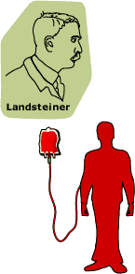
The Discovery of Human Blood Group:

Since 1628 when Harvey discovered blood circulation, human being ceaselessly attempted to do blood transfusion. In 1667, French philosopher Dennis and surgeon Murrays tried the first time to transfer 150ml lamb blood to human being. Followed that, some people repeated this experiments, but they got very serious consequences even causing people dead. After, the attempts of blood transfusion were suspended by human.
One century later, people again tried to do blood transfusion. In 1819, Blundell completed blood transfusion from one person to another person for the first time in history. In general speaking, the consequence of blood transfusion was disappointed in that period. Blood transfusion may either recover a person or cause his/her death.
Austrian scholar Karl Landsteiner began to work on this topic since 1900. He found that no aggregation phenomenon could be found when he put his own erythrocyte and blood serum together in a test tube; when he mixed together erythrocyte and blood serum sourced from different individuals, there might be aggregation or no aggregation. This phenomenon was once observed by many people, but he was the only person who gave it an explanation. Erythrocyte has two kinds of specific structures that may exist alone or together. Blood serum has the antibody called agglutinin of specific structure in erythrocyte; when agglutinin meets with the specific structure in erythrocyte, aggregation will happen, which might be very dangerous when a person is on process of blood transfusion.
Then, he drew the conclusion: Human blood group is genetic. His theory has placed a foundation for blood transfusion.
Since blood transfusion attempts in the past always were confronted with failure, therefore common physicians restricted themselves from this field; still, a large number of scientists were carrying on various experiments relating to blood transfusion.
Dramatically, the breaking-out of World War I became the event with great impetus driving the development of blood transfusion. Due to the urgent need of save the life of the wounded by war, large quantity of blood transfusion became an effective way to drive the wounded back from death. Doctor Oldenburg first applied aggregation reaction to blood matching test before blooding transfusion, and blood transfusion between human was only possible when no aggregation could be found when erythrocyte and blood serum were mixed together; this method gained great success and saved a great number of the wounded life. With continuous experiments and practices relating to blood transfusion in the following years, blood transfusion became safe; when time went to the end of 1920s, blood confusion turned a popular medical treatment in big cities in Europe and North America.
The ABO blood group system is widely credited to have been discovered by the Austrian scientist Karl Landsteiner, who found three different blood types in 1900.he was awarded the Nobel Prize in Physiology or Medicine in 1930 for his work.Due to inadequate communication at the time it was subsequently found that Czech serologist Jan Janskyhad independently pioneered the classification of human blood into four groups, but Landsteiner's independent discovery had been accepted by the scientific world while Janský remained in relative obscurity. Janský's classification is however still used in Russia and states of former USSR (see below). In America, Moss published his own (very similar) work in 1910.
Landsteiner described A, B, and O; Alfred Von Decastelloand Adriano Sturolidiscovered the fourth type, AB, in 1902. LudwikHirszfeldand E. Von Dungerndiscovered the heritability of ABO blood groups in 1910–11, with Felix Bernstein demonstrating the correct blood group inheritance pattern of multiple alleles at one locus in 1924. Watkins and Morgan, in England, discovered that the ABO epitopes were conferred by sugars, to be specific, N-acetylgalactosamine for the A-type and galactose for the B-type. After much published literature claiming that the ABH substances were all attached to glycosphingolipids, Laine's group (1988) found that the band 3 protein expressed a long polylactosaminechain.that contains the major portion of the ABH substances attached. Later, Yamamoto's group showed the precise glycosyltransferase set that confers the A, B and O epitopes.

Blood Transfusion
from Antiquity to the Discovery of the Rh Factor

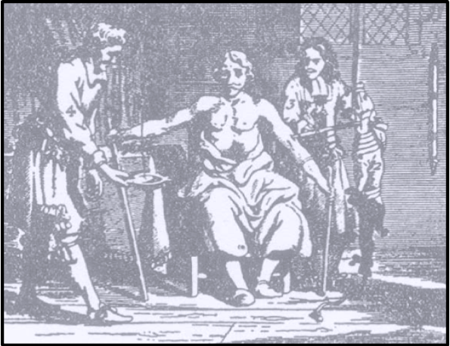

Fig. 1.The first illustration of thetransfusion of blood [5].Notethat the seated man is receiving atransfusion from a dog into the
left arm, while he simultaneouslyis being bled from the right armbyblood letting.

Use of blood as a therapeutic agent by drinking it as “Elixir Vitae” goes back before Biblical time. Despite the opposition of Celsus (25 BC – AD 50), drinkingblood continued; it was routine to drink the blood of fallen gladiators as a remedy for various ailments,including epilepsy.
Rational thinking about blood transfusion was prevented by the beliefs of Aristotle (384–322 BC) and Galen (130–200 AD), who taught that the blood was made in the heart or the liver and flowed until it was used up. These views remainedundisputed for more than 1400 years, until the discovery in 1616 of the blood circulation by William Harvey(1578–1657).
Harvey’s discovery gave a sudden impetus to transfer blood from animals to humans and from one person to another. The first blood transfusion was carried out in 1628 by an Italian physician, Giovanni Francisco Colle (1558–1631).In 1665, Richard Lower (1631–1691) inEngland successfully transfused dogs with blood.
In 1666, blood transfusion into a human was performed in Paris by the mathematician,philosopher, and teacher, Jean Baptiste Denis (1625–1704) ,He transfused lamb’s blood into 3 men with great success to cure their diseases, but the fourth patient died as the result of the transfusion.Denis, a target of opposition and jealousy of the medical and religious communities, was sued for wrongful death by the widow. Although Denis was found not negligent, the Paris court ordered him to stop further transfusions. Subsequently, the Medical Faculty of Paris petitioned the Parliament to outlaw blood transfusion throughout France.
The Parliament agreed with the petitioners; transfusions fell into disrepute until the early 1800s. Exceptions were a German army surgeon, Matthus Gottfried Purmann (1649 – 1711) and his associates. It is of interest that, among Purmann’s long listof reasons for transfusion, acute blood loss was not included.The revival of blood transfusion in England in 1796 came from Erasmus Darwin (1731–1802), the grandfather of Charles Darwin (1809–1882).
Erasmus Darwin advocated blood transfusion in conditions with inadequate nutrition. To transfer the blood from one person to another, he endorsed an earlier suggestion to use goose-quills tied together by a piece of chicken gut.
James Blundell (1790–1877) was an eccentric obstetrician at Guy’s Hospital and St.Thomas’s Hospital in London. After he had performed blood transfusion in dogs, he introduced human to human transfusion in acute hemorrhage following child birth. Blundell understood the incompatibility of interspecies transfusion and he developed a method of indirect transfusion.He replaced arterial blood with venous blood and described a three-way valve with an “impellor” and a “gravitator” for indirect transfusion. The “impellor” assured continuous supply of blood under pressure to the recipient and the “gravitator” was an apparatus to achieve uninterrupted flow of blood by gravity.
Blundell’s instrument was well received because once the transfusion begun, the operator had little to do, except as he wrote to guard against an overcharge of the recipient heart.As a practicing obstetrician, Blundell wrote two influential textbooks of obstetrics and he was the first to recommend transecting the Fallopian tubes on delivery by Caesarian section to prevent further pregnancy. He discontinued hospital practice in 1836, because of irreconcilable differences with the hospital administration, but he continued in private practice and was elected a Fellow of the Royal College of Physicians. He retired in his late fifties and devoted himself to studying literature and perfecting his Greek.
In the mid-1800s, transfusion was abandoned once again, when the infusion of physiologic salt solution was introduced as a blood substitute. Work in bacteriology of Jules Jean Baptiste Vincent Bordet (1870–1961) of Belgium showed that 2 substances (sensitizing antibody and complement) are involved in bacteriolysis, which established the basis for complement fixation.Shortly after this discovery, Bordet observed that the injection of red blood cells of an animal of another species induced the creation of antibodies in the serum and hemolyzed the red blood cells. For his contributions to immunology Bordet received the Nobel Prize in 1919 and an Institute was named after him in Brussels. From the initial experiments with blood transfusion in the1600s to the introduction of safe transfusions in the 1900s, the road was a long one.
It took approximately two and a half centuries from the origins of transfusion to the discovery of the blood groups in 1900 by Karl Landsteiner (1868-1943).
Landsteiner was an assistant in pathology at the University of Vienna when hediscoverediso-agglutinins in the human blood and identified 3 specific blood groups. The fourth group was added 2 years later.The discoveries that sodium citrate prevents the coagulation of blood and that the blood groups are inherited accordingtoMendelian laws were also crucial to the development of safe blood transfusion.
Landsteiner is credited with introducing darkfield microscopy for the diagnosis of Treponemapallidumand he was the first person to transmit poliomyelitis to monkeys, in an attempt to develop a vaccine. He received the Nobel Prize in 1930. In 1933, Landsteiner published the first monograph on specific antigen–antibody interactions and he emigrated to the United States. He became an esteemed research professor at the Rockefeller Institute in New York City, where he discovered the Rh factor . In 1942, the year before Landsteiner died, he described the crucial role of mononuclearcells in cellular immunity.
Early Practices:

Transfusion Before World War I: Although the concept of the therapeutic value of blood dates back to antiquity, transfusion in the modern sense of the term was a practical impossibility until William Harvey, in 1616, announced his discovery of the circulation of the blood. This discovery opened the way for serious experiments on the infusion of various substances into the bloodstream and eventually led to the use of whole blood for transfusion.
Claims to priority are various and confusing. It is clear, however, that Richard Lower, inspired by the previous experiments of Sir Christopher Wren in infusion techniques, performed the first successful animal transfusion in 1665, when he transferred blood from the carotid artery of one dog to the jugular vein of another. In November 1667, Lower transfused Mr. Arthur Coga, "a mildly melancholy insane man," with the blood of a lamb. Mr. Coga, according to Pepys, described his experience in Latin before the Royal Society of Medicine and stated that he was much better. He impressed Pepys as "cracked a little in his head."
The next animal-to-human transfusions were also performed on generally the same indications, by Jean Baptiste Denis, physician to Louis XIV. When Denis' fourth attempt ended fatally, he was charged with murder. He was eventually exonerated, but, 10 years later, the procedure was prohibited by law in France as well as in Italy and was also forbidden by the Royal Society of Medicine in England.
For the next 150 years, there was little interest in transfusion, but it is significant that Nuck in 1714 and Cantwell in 1749 declared that this procedure would be of value in severe hemorrhage. When interest in transfusion was revived by James Blundell in 1818, it was on the basis of replacement of lost blood in puerperal hemorrhage and after a series of experiments in which he had demonstrated that human blood loses none of its "vital properties" by passage through transfusion equipment. Blundell failed in his first four desperate attempts to save women on the point of death from postpartal hemorrhage, but he succeeded in five of the next six attempts.
In 1875, Landois, in a comprehensive monograph on transfusion, collected 347 cases in which human blood had been used and 129 cases in which animal blood had been used. By this time, important studies on the physiology of the blood were being performed by a number of qualified observers, and some physicians, such as Fordyce Barker, advocated transfusion " ... not exclusively in those desperate cases where favorable results are hardly looked for but ... before patients have arrived at, and fallen into, this desperate condition."
Techniques in use included transfusion with defibrinated blood, mediate transfusion with pure blood, immediate transfusion from vein to vein, and immediate transfusion from artery to vein.
Although the indications and rationale of blood transfusion were by this time apparently quite well understood, the indications during the last quarter of the century again became vague and irrational, the procedure was employed indiscriminately, and the number of severe reactions and fatalities increased. As a result, transfusion again began to be considered as a hazardous, and even a disreputable, procedure, to be employed only as a last resort and in desperation Special Problems.
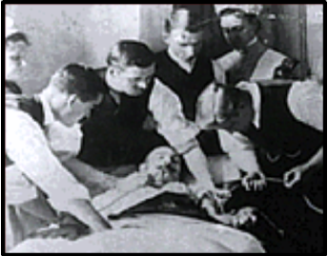
During the first years of the 20th century,a blood transfusion was frequently a more difficult technical procedure, and sometimes a procedure fraught with greater risks, than a major operation.
Its development as an effective and safe therapeutic method required the solution of a number of special problems:
1.Blood coagulation. First efforts to overcome this difficulty were made in 1835, with the use of defibrinated blood by Bischoff, and terminated in 1914, with the successful use of sodium citrate by Hustin, Weil, and Lewisohn.

2.Agglutination and hemolysis from admixture of incompatible bloods. The way was opened to the solution of this special problem in 1900, when Landsteiner published his epochal work on the identification of blood groups, based on his previous demonstration of the presence of isoagglutinating and isoagglutinable substances in the blood. Jansky in 1907 and Moss 3 years later, without knowledge of Jansky's studies, worked out the reciprocal agglutinating reactions of the four blood groups and classified them accordingly. The confusion that arose because of differences in nomenclature was eliminated after World War I, when the numbers previously used to designate blood groups were replaced by the letters A, B, AB, and O, each group thus being designated by the agglutinogens in Landsteiner's original scheme.
Communications in the early years of the 20th century were often slow, and foreign medical literature had only a limited circulation in the United States. No practical use, therefore, was made of Landsteiner's work until 1907, when Ottenberg, at Mount Sinai Hospital in New York, first matched donor and recipient before giving blood and thus made transfusion a safe procedure from the standpoint of compatibility. The validity of Ottenberg's work was not immediately realized; his offer to perform compatibility tests for the surgeons at his own hospital had no general acceptance for almost 5 years because such tests were considered unnecessary or misleading.
In 1911, Ottenberg demonstrated that it was safe to use as a donor a person whose serum agglutinated the recipient's red cells but unsafe and dangerous to use one whose red cells were acted upon by the recipient's serum. This demonstration eventually led to the widespread employment of group O donors as universal donors, since the red blood cells of this blood group are not agglutinable by the serum of any other blood group.
3. Technical difficulties. Until 1913, direct transfusion was used to the exclusion of any other technique. This was a difficult and time-consuming method, requiring a specially trained team to carry it out and totally unsuited for use in sudden emergencies. In 1892, von Ziemssen of Munich had performed transfusion by the syringe technique, but his report attracted no attention and when Lindeman described it in 1913, it was, for all practical purposes, a new method. With this technique, no dissection of blood vessels was necessary in either donor or recipient, and the exact quantity of blood transfused was known. The technique, however, required a trained team of at least four persons and the use of a large number of expensive syringes. Also, rapid injection of the blood was mandatory. In 1915, Unger introduced an apparatus based on the principle of the two-way stopcock, which overcame many of these difficulties. Dozens of variations of this apparatus were introduced during the next 15 years.
4. Infection. Infection ceased to be a major problem after first antiseptic, and then aseptic, techniques came into general use and as long as transfusion was employed only in hospitals and on what amounted to elective indications. The open containers originally used to collect blood for indirect transfusion first became impractical, and then a real source of danger, when indications for transfusion were extended.
Blood Banks:
Once blood transfusion was in wide use, storage of donated blood became a problem. The first "blood bank" was set up by Dr. Bernard Fantus in 1937 at Cook County Hospital in Chicago, Illinois. A method of preserving red blood cells for up to 21 days with acid citrate dextrose was developed in the 1940s. African-American surgeon Charles Richard Drew studied in depth a way to preserve and store blood ready for instant use. He discovered that plasma could be processed and reserved for a long time, and transfused without regard to blood type or matching in place of whole blood.
Drew established blood banks in England and the United States during World War II (1939-1945). These banks saved thousands of lives by making blood transfusion available to the wounded. Today,blood transfusion remains a widely used and critical medical procedure.
After World War II, methods were developed for separating the various constituents of blood. As a result, in addition to whole blood, a patient may receive "packed" red cells, granulocytes (white cells), platelets, plasma, or plasma components. Both natural and artificial blood substitutes are also used. Perhaps most serious of the remaining risks of blood transfusion is the possibility of transmitting disease via the donor's blood. Of special concern is the transmittal of the HIV virus and hepatitis. For this reason, donated blood is carefully screened.
The hunt for a substance to replace whole blood in transfusions has been underway since the late 1960s. The search has so far been unsuccessful, but research continues because success would eliminate several major problems in using fresh blood. These problems include a supply shortage in the face of increasing demand, the short shelf life of "whole blood" even under refrigeration, transmission of hepatitis, the AIDS virus, and other viral diseases, and the need for careful blood typing.

The primary job of artificial blood is to duplicate the oxygen-carrying function of hemoglobin. Hemoglobin is the iron-containing protein within the red cells of natural blood. Researchers and manufacturers seeking to create artificial blood have concentrated on two things: so-called "white blood" using fluorocarbons, and "red blood" made from modified hemoglobin.
White Blood:
Fluorocarbons are organic molecules that are able to dissolve large amounts of oxygen
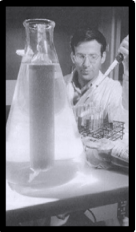
In recent years, research into a successful artificial blood formula has been of great importance to many bio-medical research companies.
Their potential value was dramatically demonstrated in 1966 by American physician Leland C. Clark, Jr., of the University of Cincinnati. He dropped a live mouse into a beaker full of a liquid fluorocarbon. The mouse was held completely immersed in the liquid by a weight on its tail but continued to breathe. The oxygen dissolved in the liquid is what made this possible.
Early fluorocarbons could not be used in human medicine because they concentrated in the liver and spleen. Ryoichi Naito, a chemist at the Japanese pharmaceutical firm of Green Cross, found he could overcome this problem by mixing perfluorodecalin with the fluorocarbon perfluoro-propylamine. The result was a milky white solution called Fluosol-DA. In 1989 Fluosol was approved by the U.S. Food and Drug Administration (FDA) for use during balloon angioplasty.. During the time the inflated balloon cuts off blood supply to some tissues, injected Fluosol can carry oxygen to the deprived tissue cells. Animal studies hold promise that Fluosol can be used to carry oxygen to tissues in other cases of blood circulation blockage.
Red Blood:
A different approach to blood substitution has centered on hemoglobin isolated from the red blood cell. Use of free hemoglobin was suggested back in the nineteenth century, but modern researchers several decades ago discovered that such use had several severe problems. Outside the red blood cell, hemoglobin holds on too tightly to oxygen and does not release enough to the tissue cells. Free hemoglobin also breaks down into two halves that are filtered out by the kidneys, which often causes severe damage.
To eliminate these difficulties, researchers have worked on various ways of modifying hemoglobin. One approach has been to chemically link the hemoglobin subunits together. The linked subunits form a bigger molecule (a polymer) that will not break down. Although researchers were concerned that the giant molecules could damage body organs, animal tests were encouraging.
Clinical Trials:
Surgeon Gerald Moss of the University of Chicago licensed his technique for multi-molecule linkage to Northfield Laboratories of Illinois. In 1987 Northfield began clinical trials of the modified hemoglobin in humans. The first round of tests were successful. During the second round in 1989 several trauma patients suffered allergic reactions to the hemoglobin product. This prompted an FDA advisory committee investigation. The investigators learned of a German trial conducted by physician KonradMessmer at Heidelberg University in the early 1980s in which the two volunteers suffered kidney failure after receiving a modified hemoglobin product. The FDA concluded that many organs of the body could be damaged by hemoglobin-based blood substitutes. The agency abruptly halted Northfield's human trials.
English biochemist Max Perutz discovered hemoglobin's atomic structure in 1960. Somatogen Incorporated of Boulder, Colorado, used this knowledge to produce a genetically engineered, modified hemoglobin that gave up its oxygen more easily and did not break down quickly. Somatogen produced its hemoglobin in yeast or bacteria rather than human or animal substances. The company sought FDA approval for human testing in the early 1990s.
Biopure of Boston began working with modified hemoglobin from cows in 1984 and began human trials of its product in Guatemala in 1990. DNX, a biotechnology company in Princeton, New Jersey, announced in 1991 that it had produced genetically-engineered pigs that made normal human hemoglobin. Some components of plasma, too, could be synthesized by the early 1990s. Genentech of California produced a plasma that promotes coagulation in hemophiliacs.
All these approaches hold promise for artificial blood. Researchers still remain uncertain about the cause of the toxic side effects produced by hemoglobin blood substitutes. They are not sure whether the side effects are due to impurities in the products or to the body's reaction to free hemoglobin.

New Hemoglobin Type Found:
Scientists at the University of Bonn have discovered a new rare type of haemoglobin. Haemoglobin transports oxygen in the red blood corpuscles. When bound to oxygen it changes colour. The new haemoglobin type appears optically to be transporting little oxygen. Measurements of the blood oxygen level therefore present a similar picture to patients suffering from an inherited cardiac defect. After examining two patients, the scientists now understand that the new type of haemoglobin distorts the level of oxygen measured.
The scientists have named the type 'Haemoglobin Bonn'. Haemoglobin transports oxygen to the body's cells and in return picks up carbon dioxide there. In doing so it changes colour. With an optical measuring instrument, known as a pulse oximeter, you can therefore measure whether there is enough oxygen present in the blood. The cause of anoxia can be an inherited cardiac defect, for example.
This was also the tentative diagnosis in the case of a four-year-old boy who was admitted to the Paediatric Clinic of the Bonn University Clinic. However, after a thorough examination, the paediatricians Dr. Andreas Hornung and his colleagues did not find any cardiac defect. A low saturation of oxygen had also been previously found in the blood of the boy's 41-year-old father, again without apparent signs of a cardiac defect.
Dr. Berndt Zur from Professor Birgit Stoffel-Wagner's team at the Institute of Clinical Chemistry and Pharmacology examined the boy's and the father's haemoglobin. He eventually realised that they were dealing with a new type of the blood pigment. 'The pulse oximeter is put on a finger as a clip and X-rays it with infrared radiation,' he explains. 'Haemoglobin absorbs infrared light in the absence of oxygen. The lower the content of oxygen in the blood, the less light penetrates the finger and reaches the sensor of the oximeter.' But Haemoglobin Bonn absorbs a bit more infrared light than normal oxygen saturated haemoglobin, even when combined with oxygen. 'That's why, at first, we did not understand why the patients did not have any particular health problems,' Dr. Zur says: Every human has two main heart ventricles. One pumps the blood through the arteries to the lungs, where the haemoglobin releases the carbon dioxide and takes on oxygen. The other one pumps the blood which is saturated with oxygen from the lungs to every cell in the body. Both ventricles must be separated by a wall in the heart, so that the oxygen-rich blood does not mix with the anoxaemic blood. But some people have a hole in this septum.
In such cases, the pulse oximeter shows anoxia. Doctors therefore see this as a sign of a cardiac defect. Another cause is what is known as the Apnoea Syndrome. In the patients affected, breathing can cease for more than a minute. That is why the father of the 4-year-old received oxygen treatment at nights for some time. 'If we had known about Haemoglobin Bonn before, father and son could have been spared the fear of a cardiac defect or the Sleep Apnoea Syndrome,' Dr. Zur explains.
Blood type discovery may lead to new tools in HIV fight
Scientists have discovered that certain rare blood types can make individuals more or less vulnerable to HIV infection, according to a study published in the journal Blood and reported by ScienceDaily.
Researchers have developed more sophisticated methods for typing blood in recent years. Moving beyond the old-fashioned grouping systems that split people into A, B and O blood types—and the more recent Rh blood typing system—they’ve uncovered another method for grouping people by their blood characteristics. The new method is concerned with a carbohydrate-carrying antigen called Pk. Some people have a lot of Pk in their blood, while others have none at all. Most people fall somewhere in between.
Nicole Lund, PhD, from the University of Toronto, and her colleagues previously found that people with Fabry disease—caused by a missing fat-metabolizing enzyme that can lead to eye, kidney and heart problems—who accumulate higher levels of Pk also have fewer body-wide infections. This led Lund’s team to examine whether blood Pk levels could influence whether or not someone became infected with HIV. The group studied the blood of three groups of people: those with high levels of Pk, those with normal levels and those whose cells don’t express any Pk at all. They found that the cells of people who express high levels of Pk, a rare group representing about one in a million people, were resistant to HIV infection. Conversely, the cells of those who express no Pk at all, representing about five in a million people, were particularly susceptible to HIV infection.
Don Branch, PhD, lead author of the study from the Canadian Blood Services, told ScienceDaily, “This study is not suggesting that your blood type alone determines if you will get HIV. However, it does suggest that individuals who are exposed to the virus may be helped or hindered by their blood status in fighting the infection.”
Another researcher involved in the study explained that this finding could open new avenues of research into protecting people from HIV infection.
Potential new weapon in battle against HIV infection identified:
Researchers have discovered a potentially important new resistance factor in the battle against HIV: blood types. An international team of researchers from Canadian Blood Services, The Hospital for Sick Children (SickKids) and Lund University in Sweden have discovered that certain blood types are more predisposed to contracting HIV, while others are more effective at fending it off.
A carbohydrate-containing antigen, termed Pk blood group which is distinct from the well-known ABO and Rh blood grouping systems, is present at variable levels on the surface of white and red blood cells in the general population. A study published today in Blood, which is currently available online, shows that cells from rare individuals (≈ 1 in a million) who produce excess of this blood group antigen have dramatically reduced sensitivity to HIV infection. Conversely, another slightly more common subgroup of people who do not produce any Pk (≈ 5 in a million) was found to be much more susceptible to the virus.
"This study is not suggesting that your blood type alone determines if you will get HIV," says lead author Dr. Don Branch of Canadian Blood Services. "However, it does suggest that individuals who are exposed to the virus, may be helped or hindered by their blood status in fighting the infection."
Increasing the level of the Pk antigen in cells in the laboratory also resulted in heightened resistance to HIV, while lowering it increased susceptibility. The Pk molecule has been previously studied extensively by The Research Institute at the Hospital for Sick Children Senior Scientist Dr. Cliff Lingwood; Lund University's Dr. Martin Olsson has identified underlying genetic reasons for Pk blood group variation.
"This discovery implicates the Pk level as a new risk factor for HIV infection and demonstrates the importance of blood-group-related science," says Dr. Olsson.
"The conclusions of this study pave the way for novel therapeutic approaches to induce HIV resistance and promote further understanding of the pandemic as a whole," says Dr. Lingwood.
This study was made possible by grants from: The Canadian Institutes for Health Research, Canadian Foundation for AIDS Research, Ontario HIV Treatment Network, Canadian Blood Services, SickKids Foundation, Swedish Research Council, the Medical Faculty of Lund University, and the government grants for clinical research to Lund University Hospital and Region Skåne, Sweden.

Biography:

Karl Landsteiner:

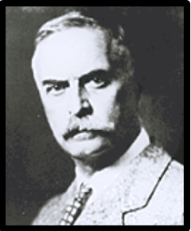
Born:1868
Died:1943
Nationality: American
Occupation:immunologist
Karl Landsteiner was one of the first scientists to study the physical processes of immunity. He is best known for his identification and characterization of the human blood groups, A, B, and O, but his contributions spanned many areas of immunology, bacteriology and pathology over a prolific forty-year career. Landsteiner identified the agents responsible for immune reactions, examined the interaction of antigens and antibodies, and studied allergic reactions in experimental animals. He determined the viral cause of poliomyelitis with research that laid the foundation for the eventual development of a polio vaccine. He also discovered that some simple chemicals, when linked to proteins, produced an immune response. Near the end of his career in 1940, he and [Alexander Wiener] discovered the Rh factor, which helped save the lives of many fetuses with mismatched Rh factor from their mothers. For his work identifying the human blood groups, he was awarded the Nobel Prize for medicine in 1930.

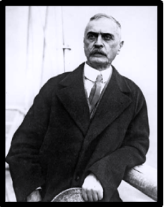

Born June 14, 1868, Landsteiner was the only child of Dr. Leopold Landsteiner, a famous Viennese journalist, and Fanny Hess Landsteiner. Leopold Landsteiner was the Paris correspondent for several German newspapers and the founder of the daily PRESSE, an influential liberal newspaper. The family lived in Baden bei Wien, an upper-middle-class suburb of Vienna. Karl was six years old when his father suffered a massive heart attack and died. Karl was placed under the guardianship of a family friend, but remained extremely close to his mother.

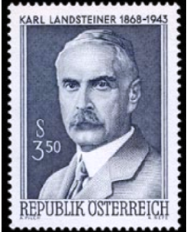

In 1885, when he was seventeen, Landsteiner passed the entrance examination for medical school at the University of Vienna, where early in his training he expressed enthusiasm for the study of chemistry. He took a year off from school at the age of twenty for his obligatory military service. When he was twenty-one, Landsteiner and his mother converted from Judaism to Catholicism.
Landsteiner graduated from medical school at the age of 23 and immediately began advanced studies in the field of organic chemistry, working in the research laboratory of his mentor, Ernst Ludwig . In Ludwig's laboratory Landsteiner's interest in chemistry blossomed into a passion for approaching medical problems through a chemist's eye.

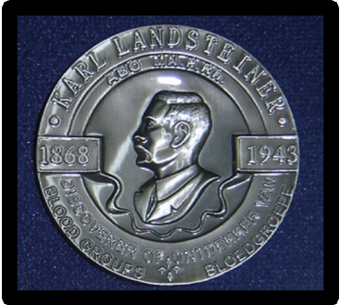

For the next ten years, Landsteiner worked in a number of laboratories in Europe, studying under some of the most celebrated chemists of the day: Emil Fischer, a celebrated protein chemist who subsequently won the Nobel Prize for chemistry in 1902, in Wurzburg; Eugen von Bamberger in Munich; and Arthur Hantzsch and Roland Scholl in Zurich.
Landsteiner published many journal articles with these famous scientists. The knowledge he gained about organic chemistry during these formative years guided him throughout his career. The nature of antibodies began to interest him while he was serving as an assistant to Max von Gruber in the Department of Hygiene at the University of Vienna from 1896 to 1897. During this time Landsteiner published his first article on the subject of bacteriology and serology, the study of blood. He had found a subject that was to occupy his entire scientific career.

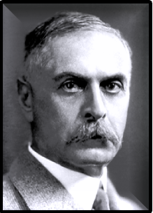
Landsteiner moved to Vienna's Institute of Pathology in 1897, where he was hired to perform autopsies. He continued to study immunology and the mysteries of blood on his own time. In 1900, Landsteiner wrote a paper in which he described the agglutination of blood that occurs when one person's blood is brought into contact with that of another. He suggested that the phenomenon was not a pathology, as was the prevalent thought at the time, but was due to the unique nature of the individual's blood. In 1901, Landsteiner demonstrated that the blood serum of some people could clump the blood of others. From his observations he devised the idea of mutually incompatible blood groups. He placed blood types into three groups: A, B, and C (later referred to as O). Two of his colleagues subsequently added a fourth group, AB.

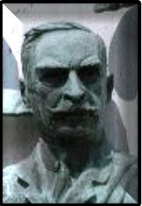
In 1907 the first successful transfusions were achieved by Dr. Reuben Ottenberg of Mt. Sinai Hospital, New York, guided by Landsteiner's work. Landsteiner's accomplishment saved many lives on the battlefields of World War I, where transfusion of compatible blood was first performed on a large scale. In 1902 Landsteiner was appointed as a full member of the Imperial Society of Physicians in Vienna. That same year he presented a lecture, together with Max Richter of the Vienna University Institute of Forensic Medicine, in which the two reported a new method of typing dried blood stains to help solve crimes in which blood stains are left at the scene.



In 1908 Landsteiner took charge of the department of pathology at the Wilhelmina Hospital in Vienna. His tenure at the hospital lasted twelve years, until March of 1920. During this time, Landsteiner was at the height of his career and produced fifty-two papers on serological immunity, thirty-three on bacteriology and six on pathological anatomy. He was among the first to dissociate antigens, which stimulate the production of immune responses known as antibodies, from the antibodies themselves. Landsteiner was also among the first to purify antibodies, and his purification techniques are still used today for some applications in immunology.

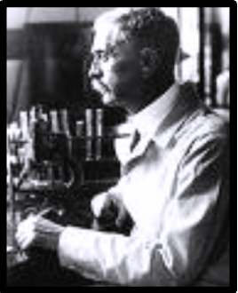
Landsteiner also collaborated with Ernest Finger, the head of Vienna's Clinic for Venereal Diseases and Dermatology.
In 1905, Landsteiner and Finger successfully transferred the venereal disease syphilis from humans to apes. The result was that researchers had an animal model in which to study the disease. In 1906, Landsteiner and Viktor Mucha, a scientist from the Chemical Institute at Finger's clinic, developed the technique of dark-field microscopy to identify and study the microorganisms that cause syphilis.
One day in 1908 the body of a young polio victim was brought in for autopsy. Landsteiner took a portion of the boy's spinal column and injected it into the spinal canal of several species of experimental animals, including rabbits, guinea-pigs, mice and monkeys. Only the monkeys contracted the disease. Landsteiner reported the results of the experiment, conducted with Erwin Popper, an assistant at the Wilhelmina Hospital.
It had generally been accepted that polio was caused by a microorganism, but previous experiments by other researchers had failed to isolate a causative agent, which was presumed to be a bacterium. Because monkeys were hard to come by in Vienna, Landsteiner went to Paris to collaborate with a Romanian bacteriologist, ConstantinLevaditi of the Pasteur Institute.
Working together, the two were able to trace poliomyelitis to a virus, describe the manner of its transmission, time its incubation phase, and show how it could be neutralized in the laboratory when mixed with the serum of a convalescing patient. In 1912 Landsteiner said that the development of a vaccine against poliomyelitis might prove difficult but was certainly possible. The first successful intravenous polio vaccine, developed by Jonas Salk, wasn't administered until 1955.
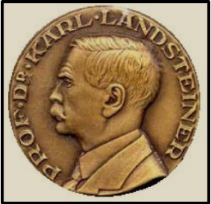

Landsteiner kept a grueling work schedule that allowed little time for social activity. He was serving at a war hospital in 1916 when, at the age of 48, he married Leopoldine Helene Wlasto. Helene bore a son christened Ernst Karl on April 8, 1917. After the war, Landsteiner's Austria was in chaos, with extreme shortages of food and fuel. He accepted a position as chief dissector in a small Catholic hospital in The Hague, Netherlands.
There, from 1919 to 1922, he performed routine laboratory tests on urine and blood. Nevertheless, he managed to publish twelve papers on different aspects of immunology . It was during this time that Landsteiner began working on the concept of haptens, small molecular weight chemicals such as fats or sugars, that determine the specificity of antigen-antibody reactions when combined with a protein "carrier." He combined haptens of known structure with well-characterized proteins such as albumin, and showed that small changes in the hapten could affect antibody production. He developed methods to show that it is possible to sensitize animals to chemicals that cause contact dermatitis (inflammation of the skin) in humans, demonstrating that contact dermatitis is caused by an antigen-antibody reaction. This work launched Landsteiner into a study of the phenomenon of allergic reactions.
In 1922, Landsteiner accepted a position at the Rockefeller Institute in New York. Throughout the 1920s Landsteiner worked on the problems of immunity and allergy. He discovered new blood groups: M, N and P, refining the work he had begun 20 years before. Soon after Landsteiner and his collaborator, Philip Levine, published the work in 1927, the types began to be used in paternity suits.
The Landsteiner family spent their summers in an isolated house on Nantucket that reminded Landsteiner of his Scheveningen home in the Netherlands. Landsteiner developed a profound dislike for his growing celebrity as the world's foremost authority on the mechanisms of immunity. He never got used to the noise and crowds of New York City, confessing to friends that he wished he could lock his family away when he was not home. Despite these problems, he became a United States citizen in 1929. Always shunning publicity, even avoiding offers to give public seminars, Landsteiner was stunned when he was besieged by reporters in 1930, upon the news that he had won the Nobel Prize.
In his Nobel lecture, Landsteiner gave an account of his work on individual differences in human blood, describing the differences in blood between different species and among individuals of the same species. This theory is accepted as fact today but was at odds with prevailing thought when Landsteiner began his work. In 1936 Landsteiner summed up his life's work in what was to become a medical classic: DIE SPEZIFITAT DER SEROLOGISCHEN REAKTIONEN, which was later revised and published in English, under the title THE SPECIFICITY OF SEROLOGICAL REACTIONS.
Landsteiner officially retired in 1939, at the age of seventy-one, but went on working. With [Alexander Wiener] he discovered another blood factor, labeled the Rh factor, for Rhesus monkeys, in which the factor was first discovered. The Rh factor was shown to be responsible for the dreaded infant disease, erythroblastosisfetalis, which occurs when mother and fetus have incompatible blood types and the fetus is injured by the mother's antibodies. During his later years, Landsteiner formed a friendship with Linus Pauling, the American biochemist who won the Nobel Prize in chemistry in 1954. Their discussions led Pauling to apply his knowledge to immunology and to contribute a chapter to the revised edition of Landsteiner's book, THE SPECIFICITY OF SEROLOGICAL REACTIONS.
Landsteiner was said to worry incessantly and was overcome toward the end of his life with fear that the Nazis would take over the civilized world. He began to fear for his family's lives. Something of a scandal developed when he tried to prevent publication of his Jewish descent. Later his fear of fascism was surpassed by the discovery that Helene had a malignant thyroid tumor. On June 14, 1943, Landsteiner celebrated his seventy-fifth birthday with his wife, Helene, and his son, who had completed medical school and was a practicing physician. On June 24, Landsteiner had just sent off the final revision of the manuscript for his book, when he was seized by a coronary obstruction.
He died two days later on Saturday, June 26, 1943. Helene died the same year on Christmas day. Upon his death, tributes were published around the world, but no mention of his death was published in his native Austria or Germany until 1947, after the war and the defeat of Nazism.

Emil Fischer
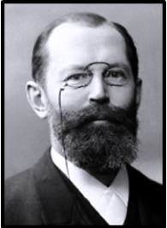
was born on October 9, 1852, at Euskirchen, in the Cologne district. His father was a successful business man. After three years with a private tutor, Emil went to the local school and then spent two years at school at Wetzlar, and two more at Bonn where he passed his final examination in 1869 with great distinction.
His father wished him to enter the family lumber business, but Emil wished to study the natural sciences, especially physics and, after an unsuccessful trial of Emil in the business, his father - who, according to the laureate's autobiography, said that Emil was too stupid to be a business man and had better be a student - sent him in 1871 to the University of Bonn to study chemistry.
There he attended the lectures of Kekulé, Engelbach and Zincke, and also those of August Kundt on physics, and of Paul Groth on mineralogy.

In 1872, however, Emil, who still wished to study physics, was persuaded by his cousin Otto Fischer, to go with him to the newly established University of Strasbourg, where Professor Rose was working on the Bunsen method of analysis. Here Fischer met Adolf von Baeyer, under whose influence he finally decided to devote his life to chemistry. Studying under von Baeyer, Fischer worked on the phthalein dyes which Rose had discovered and in 1874 he took his Ph.D. at Strasbourg with a thesis on fluoresceine and orcin-phthalein. In the same year he was appointed assistant instructor at Strasbourg University and here he discovered the first hydrazine base, phenylhydrazine and demonstrated its relationship to hydrazobenzene and to a sulphonic acid described by Strecker and Römer. The discovery of phenylhydrazine, reputed to have been accidental, was related to much of Fischer's later work.
In 1875 von Baeyer was asked to succeed Liebig at the University of Munich and Fischer went there with him to become an assistant in organic chemistry.
In 1878 Fischer qualified as a Privatdozent at Munich, where he was appointed Associate Professor of Analytical Chemistry in 1879. In the same year he was offered, but refused, the Chair of Chemistry at Aix-la-Chapelle. In 1881 he was appointed Professor of Chemistry at the University of Erlangen and in 1883 he was asked by the BadischeAnilin- und Soda-Fabrik to direct its scientific laboratory. Fischer, however, whose father had now made him financially independent, preferred academic work.
In 1888 he was asked to become Professor of Chemistry at the University of Würzburg and here he remained until 1892, when he was asked to succeed A. W. Hofmann in the Chair of Chemistry at the University of Berlin. Here he remained until his death in 1919.
Fischer's early discovery of phenylhydrazine and its influence on his later work have already been mentioned. While he was at Munich, Fisher continued to work on the hydrazines and, working there with his cousin Otto Fischer, who had followed him to Munich, he and Otto worked out a new theory of the constitution of the dyes derived from triphenylmethane, proving this by experimental work to be correct.
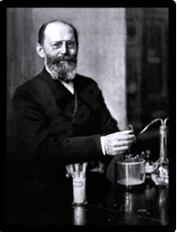
At Erlangen Fischer studied the active principles of tea, coffee and cocoa, namely, caffeine and theobromine, and established the constitution of a series of compounds in this field, eventually synthesizing them.
The work, however, on which Fischer's fame chiefly rests, was his studies of the purines and the sugars. This work, carried out between 1882 and 1906 showed that various substances, little known at that time, such as adenine, xanthine, in vegetable substances, caffeine and, in animal excrete, uric acid and guanine, all belonged to one homogeneous family and could be derived from one another and that they corresponded to different hydroxyl and amino derivatives of the same fundamental system formed by a bicyclic nitrogenous structure into which the characteristic urea group entered. This parent substance, which at first he regarded as being hypothetical, he called purine in 1884, and he synthesized it in 1898. Numerous artificial derivatives, more or less analogous to the naturally-occurring substances, came from his laboratory between 1882 and 1896.
In 1884 Fischer began his great work on the sugars, which transformed the knowledge of these compounds and welded the new knowledge obtained into a coherent whole. Even before 1880 the aldehyde formula of glucose had been indicated, but Fischer established it by a series of transformations such as oxidation into aldonic acid and the action of phenylhydrazine which he had discovered and which made possible the formation of the phenylhydrazones and the osazones.
By passage to a common osazone, he established the relation between glucose, fructose and mannose, which he discovered in 1888. In 1890, by epimerization between gluconic and mannonic acids, he established the stereochemical nature and isomery of the sugars, and between 1891 and 1894 he established the stereochemical configuration of all the known sugars and exactly foretold the possible isomers, by an ingenious application of the theory of the asymmetrical carbon atom of Van't Hoff and Le Bel, published in 1874. Reciprocal syntheses between different hexoses by isomerization and then between pentoses, hexoses, and heptoses by reaction of degradation and synthesis proved the value of the systematics he had established. His greatest success was his synthesis of glucose, fructose and mannose in 1890, starting from glycerol.
This monumental work on the sugars, carried out between 1884 and 1894, was extended by other work, the most important being his studies of the glucosides.
Between 1899 and 1908 Fischer made his great contributions to knowledge of the proteins. He sought by analysis effective methods of separating and identifying the individual amino acids, discovering a new type of them, the cyclic amino acids: proline and oxyproline. He also studied the synthesis of proteins by obtaining the various amino acids in an optically-active form in order to unite them. He was able to establish the type of bond that would connect them together in chains, namely, the peptide bond, and by means of this he obtained the dipeptides and later the tripeptides and polypeptides.
In 1901 he discovered, in collaboration with Fourneau, the synthesis of the dipeptide, glycyl-glycine and in that year he also published his work on the hydrolysis of casein. Amino acids occurring in nature were prepared in the laboratory and new ones were discovered. His synthesis of the oligopeptides culminated in an octodecapeptide, which had many characteristics of natural proteins. This and his subsequent work led to a better understanding of the proteins and laid the foundations for later studies of them.
In addition to his great work in the fields already mentioned, Fischer also studied the enzymes and the chemical substances in the lichens which he found during his frequent holidays in the Black Forest, and also substances used in tanning and, during the final years of his life, the fats.
Fischer was made a Prussian Geheimrat (Excellenz), and held honorary doctorates of the Universities of Christiania, Cambridge (England), Manchester and Brussels. He was also awarded the Prussian Order of Merit and the Maximilian Order for Arts and Sciences. In 1902 he was awarded the Nobel Prize in Chemistry for his work on sugar and purine syntheses.
At the age of 18, before he went to the University of Bonn, Fischer suffered from gastritis, which attacked him again towards the end of his tenure of the Chair at Erlangen and caused him to refuse a tempting offer to follow Victor Meyer at the Federal Technical University at Zurich and to take a year's leave of absence before he went, in 1888, to Würzburg. Possibly this affliction was the forerunner of the cancer from which he died.
Throughout his life he was well served by his excellent memory, which enabled him, although he was not a naturally good speaker, to memorize manuscripts of lectures that he had written.
He was particularly happy at Würzburg where he enjoyed walks among the hills and he also made frequent visits to the Black Forest. His administrative work, especially when he went to Berlin, revealed him as a tenacious campaigner for the establishment of scientific foundations, not only in chemistry, but in other fields of work as well. His keen understanding of scientific problems, his intuition and love of truth and his insistence on experimental proof of hypotheses, marked him as one of the truly great scientists of all time.
In 1888 Fischer married Agnes Gerlach, daughter of J. von Gerlach, Professor of Anatomy at Erlangen. Unhappily his wife died seven years after their marriage. They had three sons, one of whom was killed in the First World War; another took his own life at the age of 25 as a result of compulsory military training. The third son, Hermann Otto Laurenz Fischer, who died in 1960, was Professor of Biochemistry in the University of California at Berkeley.
James Blundell
pioneer of blood transfusion

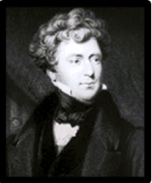

James Blundell (1790–1878)

James Blundell was born in 1790 in London. He trained in medicine first at the United Hospitals of St. Thomas’s and Guy’s, which included anatomy and surgery under Astley Cooper, and physiology and obstetrics under his uncle, Dr John Haighton, who was to greatly influence his career.
Blundell completed his training in Edinburgh, graduating there with his MD in 1813. He returned to London the following year, aged 24, and began to lecture in obstetrics and physiology at Guy’s under Haighton, succeeding his uncle as Professor in both these subjects on Haighton’s retirement in 1823.
Experiments on blood transfusion had been carried out in animals in the 17th century. Indeed, Jean Baptiste Denys in France and Richard Lower in Oxford, within a few months of each other in 1667, transfused blood from sheep to man. Such experiments were soon discarded, but Blundell, encouraged by the work of Leacock in Edinburgh, who showed transfusions of blood could be safely performed between same-species animals, began an extensive series of studies at Guy’s on dogs.
Blundell showed that blood lost none of its properties by passage through a syringe; venous blood is as effective as arterial and small quantities of air in the injected blood are tolerated. Blundell carried out his first human blood transfusion in 1818 – on a cachectic man dying of cancer of the stomach; his condition improved for some hours, but he died 56 hours afterwards. Now came the first dramatic success.
In 1825 Blundell was called to a woman dying of post-partum haemorrhage. Two ounces of blood were transfused from her husband, the patient rallied and survived. In all, Blundell transfused ten cases with five successes, these five included four examples of post-partum bleeding and a boy in shock after amputation of his leg. The donors were either the patient’s husband or attending doctors. Blundell wrote: ‘After undergoing the usual ordeal of neglect, opposition and ridicule, the operation will hereafter be admitted into general practice’.
Blundell was ahead of his time in many respects. Long before tracheal intubation had became a recognized procedure, he devised a small tracheal tube which he introduced over the forefinger passed down over the root of the tongue and into the rimaglottidis. With this he carried out artificial respiration on the newborn baby in respiratory arrest. He showed in the experimental animal that the peritoneum can be opened widely without ill effect. Moreover, organs including the kidney, spleen, uterus and ovary can be excised with survival of the animal.
Indeed, in 1828 he removed a woman’s uterus for cancer with success probably the first time this had been performed. Blundell’s distinguished career at Guy’s, as clinician, teacher and experimentalist, ended rather sadly in 1836, after 22 years of service.
Blundell proposed to appoint a senior lecturer to take over some of his duties and to allow him more time for his extensive private practice. While Blundell was away in Paris, the administrator advertised the post, and appointed a Dr Samuel Ashwell without Blundell’s knowledge or approval – and moreover without a fee to Blundell for transfer of some of his duties.Blundell continued in his private practice rather oddly arising at midday, seeing patients at his house in the afternoon and then doing home visits till late at night.

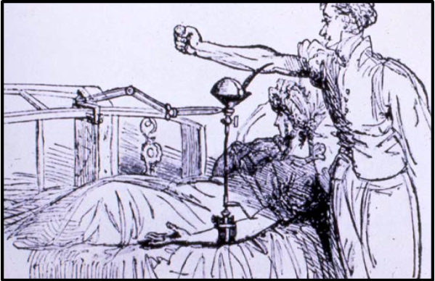
Blood Transfusion- Using the patient's husband as a donor.

In 1838 he was admitted as a Fellow of the Royal College of Physicians a rare honour for a ‘man midwife’ in those days. He retired in 1847 at the age of 56 years and lived, a wealthy bachelor, in a large house in Piccadilly. He devoted his time to literary pursuits, especially the study of Greek, and built up a collection of rare books on obstetrics and gynaecology.

Blundell remained in rude health until just before his death ‘in a fit of convulsions’ presumably a stroke on January 15 1877 at the age of 87 years. He left a fortune of £350,000, reckoned at today’s value at over £20 million. He wrote: ‘The fact that life may be saved by transfusion of blood into the veins will be beneficial a thousand years hence as it is on this day’.

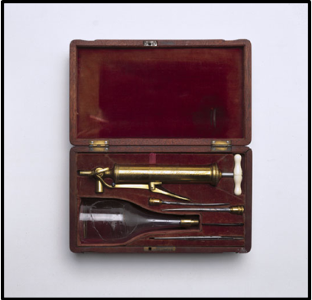

Manufactured by Savigny and Co, London. James Blundell (1790-1877), a British obstetrician, performed the first successful human to human blood transfusion in 1818. Using the patient's husband as the donor, he took blood from his arm and using a syringe, transfused it to the woman. Between 1825 and 1830, Blundell carried out a further 10 transfusions which he published details of, half of them being successful. The reason for the poor success rate of early transfusions was that the compatability of blood was not then understood. This problem was solved in 1900 when Karl Landsteiner (1868-1943) discovered blood groups.

William Harvey
The Circulation of Blood
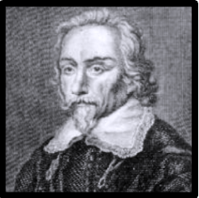
William Harvey was born April 1,1578, in Folkestone, Kent, England. His father, Thomas Harvey, was a successful farmer and merchant. He was the oldest of seven boys.
Harvey attended King's School in Canterbury from 1588 to 1593, and Cambridge University and Gonville and Caius College from 1593 to 1599. He received a B.A. in 1597.
He attended the University of Padua in Italy from 1599 to 1602, receiving an M.D. in 1602. He studied with Hieronymus Fabricius, who was a well regarded anatomist and had observed the one-way valves in blood vessels.
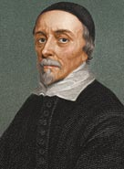

Harvey returned to England and married Elizabeth Browne, whose father was a physician to Queen Elizabeth I. He became a physician at St. Bartholomew's Hospital and lectured at the College of Physicians. In a 1616 lecture to the College, he first stated his theories about the circulation of blood. With the death of the Queen in 1603,James I ascended the throne. Harvey was appointed a physician to the court in 1618.
Harvey did not have inherited wealth. He had a private practice and received a patronage from the court. He did much later inherit some monies from his father and his brothers.
Harvey began investigating his theory that blood circulated throughout the body in 1615. The conventional wisdom of the day was that the liver converted food into blood and the various parts of the body consumed the blood.
Harvey believed that direct observation was the correct way to draw conclusions about scientific facts. He kept careful records of his experiments. He did not record his findings until he could prove them. This practice became known as the scientific method, and Harvey receives much credit for promoting its use. He dissected live animals and the bodies of executed criminals. He saw that the heart acted as a pump, pushing the blood throughout the body. Harvey saw that the one-way valves described by Fabricius meant the blood could only flow in one direction.Charles I became King in 1625, and Harvey was again named physician to the court. He remained very close to the court and traveled with several royals throughout England and Europe.
Finally, in 1628, Harvey published his book, An Anatomical Exercise Concerning the Motion of the Heart and Blood in Animals. He dedicated the book to King Charles I, who had sponsored much of the work Harvey had done. The book went on sale at a book fair in Frankfurt, Germany. The book received a mixed response. The medical community didn't immediately accept Harvey's premise. The belief that blood was produced by the liver and then consumed by
the body had already lasted 1400 years. Blood-letting continued to be a standard practice, as doctors believed many illnesses were caused by an over-supply of blood in the body. As time went by, and more discoveries were made, Harvey's work became undisputed.
In 1651, Harvey wrote that animals did not spontaneously generate, that life began from an egg. He theorized the joining of a sperm and egg as the beginning of life. Two centuries would pass before microscopes were capable of seeing a mammalian egg.Many of his papers were lost when a fire ripped through the library at the College of Physicians, but some remain and are on exhibit at the British Museum.
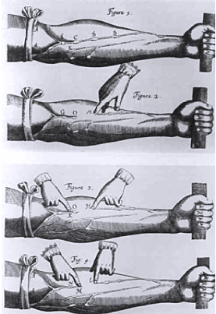

This illustration depicts one of William Harvey's experiments in his On the Circulation of the Blood (1628). Venal valves had already been discovered, but here Harvey shows that venal blood flows only toward the heart. He ligatured an arm to make obvious the veins and their valves, then pressed blood away from the heart and showed that the vein would remain empty because blocked by the valve.

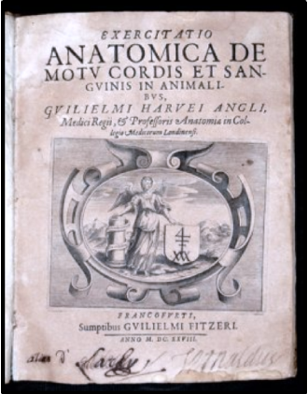

William Harvey died June 3, 1657. William Harvey Hospital in Ashford is named for him, as well as the Harvey Grammar School in Folkestone.

William Harvey's Book
Jan Jansky
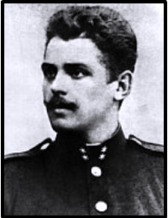

Jan Jansky Jan Jansky was born on April 3, 1873 in Prague. He was a Czechserologist, neurologist and psychiatrist. He is credited with the first classification of blood into the four types (A, B, AB, O) of the ABO blood group system.
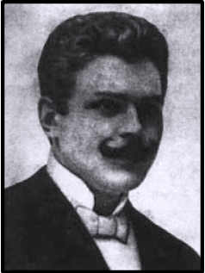

Jansky studied medicine at Charles University in Prague. From 1899 he worked in a psychiatric clinic in Prague. In 1914 he was named professor.
During World War I Jansky served two years as a doctor at the front until a heart attack disabled him. After the war he worked as a neuropsychiatrist in a military Hospital.
Through his psychiatric research, Jansky tried to find a correlation between mental diseases and blood diseases. He found no such correlation existed and published a study, Hematologickastudie u psychotiku (1907, Hematological study of psychotics), in which he classified blood into four groups I, II, III, IV. At the time this discovery passed almost unnoticed.
In 1921 an American medical commission acknowledged Jansky's classification (over that of Karl Landsteiner, who classified blood into only three groups; and was for this (blood types) discovery awarded the Nobel Prize in Physiology or Medicine in 1930). Jansky's classification remains in use today. Jansky was also a proponent of voluntary blood.

Reuben Ottenberg
(1882-1959)
American physician(hematologist)
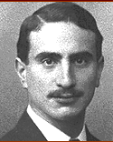
Dr. Ottenberg served Mount Sinai Hospital with distinction for 50 years and became one of its most productive physicians in the first half of the 20th century. Born in New York, Ottenberg received his B.A. from Columbia University in 1902 and his M.D. degree from the College of Physicians and Surgeons three years later.
Ottenberg's first paper, "Transfusion and Arterial Anastomosis" (ANNALS OF SURGERY, 1908), won the prize for the best paper of the year by a member of the house staff. Ottenberg describes an experimental study of performing sutureless arterial anastomoses utilizing tiny silver rings held in place by silver wire, rather than sutures, in animals for use in direct transfusion and then describes its use in two patients being transfused. He notes that the blood was tested for compatibility prior to use; the first report anywhere of the clinical use of compatibility testing. Years later Dr. Ottenberg was to note, "The subject is only brought in incidentally in a footnote. I was still an intern and did not realize how important the testing was to become. I should have made a separate article."
Ottenberg's first paper, "Transfusion and Arterial Anastomosis" (ANNALS OF SURGERY, 1908), won the prize for the best paper of the year by a member of the house staff. Ottenberg describes an experimental study of performing sutureless arterial anastomoses utilizing tiny silver rings held in place by silver wire, rather than sutures, in animals for use in direct transfusion and then describes its use in two patients being transfused. He notes that the blood was tested for compatibility prior to use; the first report anywhere of the clinical use of compatibility testing. Years later Dr. Ottenberg was to note, "The subject is only brought in incidentally in a footnote. I was still an intern and did not realize how important the testing was to become. I should have made a separate article."
Ottenberg's first paper, "Transfusion and Arterial Anastomosis" (ANNALS OF SURGERY, 1908), won the prize for the best paper of the year by a member of the house staff. Ottenberg describes an experimental study of performing sutureless arterial anastomoses utilizing tiny silver rings held in place by silver wire, rather than sutures, in animals for use in direct transfusion and then describes its use in two patients being transfused. He notes that the blood was tested for compatibility prior to use; the first report anywhere of the clinical use of compatibility testing. Years later Dr. Ottenberg was to note, "The subject is only brought in incidentally in a footnote. I was still an intern and did not realize how important the testing was to become. I should have made a separate article."
In 1954, Ottenberg received the Karl Landsteiner Award of the American Society of Blood Banks for "distinguished pioneering contributions to blood banking and hemotherapy." After noting his many contributions the award went on to state, "Everyone of these were milestones in the growth of our knowledge of blood groups and formed the basis for the subsequent development of blood transfusions."
In 1955 Mount Sinai Hospital honored Ottenberg when he was awarded the coveted Jacobi Medallion for his many years of service to the institution and for his monumental contributions to medicine.

References:
Introduction and Definition:
http://nobelprize.org/educational/medicine/landsteiner/readmore.html
http://nobelprize.org/nobel_prizes/medicine/laureates/1930/index.html
http://anthro.palomar.edu/blood/ABO_system.htm
The discovery of blood group:
http://nobelprize.org/educational/medicine/landsteiner/readmore.html
http://faculty.matcmadison.edu/mljensen/BloodBank/lectures/abo_blood_group_system.htm
biography karl landsteiner and all others
http://www.pbs.org/wnet/redgold/innovators/bio_ottenberg.html
http://nobelprize.org/nobel_prizes/medicine/laureates/1930/index.html
Rarest Blood Group
http://anthro.palomar.edu/blood/ABO_system.htm

Abstract:
The differences in human blood are due to the presence or absence of certain protein molecules called antigens and antibodies. The antigens are located on the surface of the red blood cells and the antibodies are in the blood plasma. There are more than 20 genetically determined blood group systems known today, but the AB0 and Rh systems are the most important ones used for blood transfusions.
According to the AB0 blood group system there are four different kinds of blood groups: A, B, AB or 0 (null).

Many people also have a so called Rh factor on the red blood cell's surface. This is also an antigen and those who have it are called Rh+. Those who haven't are called Rh-.
Blood transfusion will work if a person who is going to receive blood has a blood group that doesn't have any antibodies against the donor blood's antigens. But if a person who is going to receive blood has antibodies matching the donor blood's antigens, the red blood cells in the donated blood will clump.
It was found AB Rh negative is one of the most rarest blood types, followed by B Rh negative. The most common blood type of the group is O positive.
Use of blood as a therapeutic agent by drinking it as “Elixir Vitae” goes back before Biblical time. Despite the opposition of Celsus (25 BC – AD 50), drinkingblood continued; it was routine to drink the blood of fallen gladiators as a remedy for various ailments,including epilepsy.
Rational thinking about blood transfusion was prevented by the beliefs of Aristotle (384–322 BC) and Galen (130–200 AD), who taught that the blood was made in the heart or the liver and flowed until it was used up.
These views remainedundisputed for more than 1400 years, until the discovery in 1616 of the blood circulation by William Harvey(1578–1657).
Harvey’s discovery gave a sudden impetus to transfer blood from animals to humans and from one person to another.
The first blood transfusion was carried out in 1628 by an Italian physician, Giovanni Francisco Colle (1558–1631).In 1665, Richard Lower (1631–1691) inEngland successfully transfused dogs with blood.
In 1666, blood transfusion into a human was performed in Paris by the mathematician,philosopher, and teacher, Jean Baptiste Denis (1625–1704). He transfused lamb’s blood into 3 men with great success to cure their diseases, but the fourth patient died as the result of the transfusion.
Followed that, some people repeated this experiments, but they got very serious consequences.
One century later, people again tried to do blood transfusion.
In 1819, James Blundell completed blood transfusion from one person to another person for the first time in history.
The ABO blood group system is widely credited to have been discovered by the Austrian scientist Karl Landsteiner, who found three different blood types in 1900.it was subsequently found that Czech serologist Jan Janskyhad independently pioneered the classification of human blood into four groups.

Dramatically, the breaking-out of World War I became the event with great impetus driving the development of blood transfusion. Due to the urgent need of save the life of the wounded by war, large quantity of blood transfusion became an effective way to drive the wounded back from death. Doctor Oldenburg first applied aggregation reaction to blood matching test before blooding transfusion, and blood transfusion between human was only possible when no aggregation could be found when erythrocyte and blood serum were mixed together. when time went to the end of 1920s, blood confusion turned a popular medical treatment.
Once blood transfusion was in wide use, storage of donated blood became a problem. The first "blood bank" was set up by Dr. Bernard Fantus in 1937 at Cook County Hospital in Chicago, Illinois.

* Chairman, History of Medicine Department, Institute For The History Of Arabic Science, Aleppo University, Aleppo-Syria President of ISHIM (www.ishim.net) P.O. Box: 7581, Aleppo, Syria e-mail: ankaadan@gmail.com Phone 963 944 300030, Fax 963 21 2236526 ** Medicine Doctor, Master stage student, Institute for the History of Arabic Science, Aleppo University
*

