Eye Glasses in History
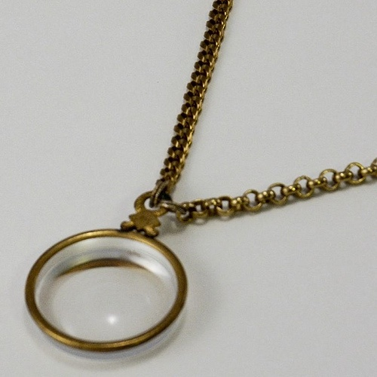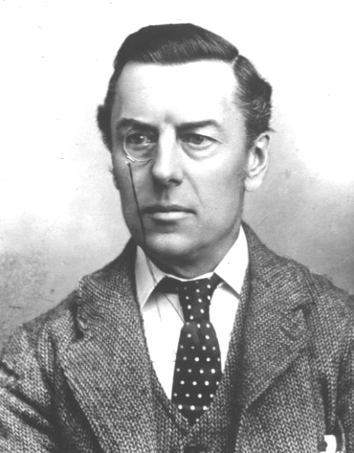

Submitted by
Abdul Nasser Kaadan, MD, PhD*
** Ayman Foad Bankasly

Contents
Introdaction | 1
History of eyeglasses | 2
Precursors | 2
- Lenses in ancient Egypt | 2
- Lenses in ancient Greece | 2
- Lenses in ancient Roman | 2
- Lenses in the 9 th century | 3
- Lenses in the 10 th century | 4
- Lenses in the 11 th century | 5
- Lenses in the 12 th century | 6
- Lenses in the 13 th century | 7
Invention of eyeglasses | 8
Later developments | 10
- Monocle | 10
- Pince-nez | 12
- Lorgnette | 13
- Scissors-glasses | 15
Types | 17
- Corrective | 17
- Safety | 22
- Sunglasses | 25
- 3D glasses | 27
- Reading glasses | 28
- Bifocals, trifocals, and progressive lenses | 29
- Extreme magnification (bioptics) | 31
Fashion | 32
- Personal image | 32
- Rimless style | 34
Abstract | 35
Arabic Abstract | 36
References | 37
Books | 41
Directory of Persons | 42
Directory of Figures | 44

Introduction
Glasses - also called eyeglasses (formal) , spectacles, or specs (informal) - are frames Bearing lenses worn in front of the eyes, normally for vision correction or eye Protection.
Safety glasses are a kind of eye protection against flying debris or against Visible and near visible light or radiation.
Sunglasses allow better vision in bright Daylight, and may protect against damage from high levels of ultraviolet light. Other Types of glasses may be used for viewing visual information (such as stereoscopy) or Simply just for aesthetic or fashion values.
The word lens comes from the Latin name of the lentil , because a double-convex Lens is lentil-shaped. The genus of the lentil plant is lens .and the most commonly Eaten species is lens culinaris. The lentil plant also gives its name to a geometric figure.

History of eyeglasses
Precursors
-Lenses in ancient Egypt
The earliest historical reference to magnification dates back to ancient
Egyptian hieroglyphs in the 5th century BC, which depict “simple glass
Meniscal lenses”. ^{[1]}
-Lenses in ancient Greece
The earliest written records of lenses data to Ancient Greece, with
Aristophanes’ play The Clouds (424 BC) mentioning a burning-glass
(a biconvex lens used to focus the sun’s rays to produce fire). ^{[1]}
-Lenses in ancient Roman
The earliest written record of magnification dates back to the 1 st centuries AD, when Seneca the Younger, a tutor of Emperor Nero of Rome, wrote: "Letters, however small and indistinct, are seen enlarged and more clearly through a globe or glass filled with water”. ^{[1]} Nero (reigned 54 – 68 AD) is also said to have watched the gladiatorial games using an emerald as a corrective lens. ^{[2]}
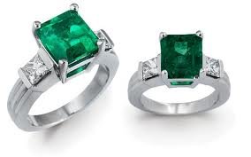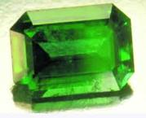
Figure 1: Emerald Ring Figure 2: Emerald % 2520 Clarity.
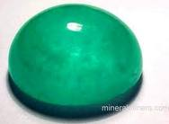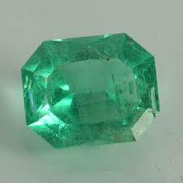
Figure 3: Emerald % 255C Gallery Figure 4: Emerald stone
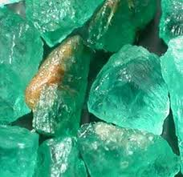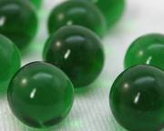
Figure 5: Crude Emerald. Figure 6: Emerald Marine
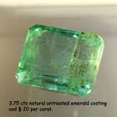
Figure 7: Emerald 300X300
- Lenses in the 9th century
Corrective lenses were said to be used by Abbas Ibn Firnas in the 9th century, ^{[3]} who had devised a way to produce very clear glass. These glasses could be shaped and polished into round rocks used for viewing and were known as reading stones.
Abbas Ibn Firnas⁽⁾ (810 – 887 A.D.),also known as Abbas Qasim Ibn Firnas, Was a muslim Berber polymath:^{[4] [5]}an inventor, engineer, aviator, physician,Arabic poet,and Andalusian musician. He was born in Izn-Rand Onda, Al-Andalus (today’s Ronda,Spain),and lived in the Emirate of Cordoba.He is known for an early attempt at aviation. ^{[6] [7]}

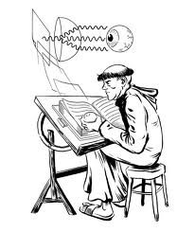
Ibn Firnas designed a water clock called Al-Maqata,devised a means of manufacturing colorless glass, he invented various glass planispheres, Made corrective lenses(“reading stones”) , developed a chain of rings that could be used to simulate the motions of the planets and stars, and developed a process for cutting rock crystal that allowed Spain to cease exporting quartz to Egypt to be cut. ^{[6] [7]}
Figure 8: Abbas Ibn Firnas, reading stone.
-Lenses in the 10th century
Ibn Sahl used what is now known as Snell’s law to calculate the shape of lenses. ^{[8]} Ibn Sahl (c.940-1000) ⁽⁾was a Muslim Persian mathematician
, Physicist and optics engineer of the Islamic Golden Age associated with The Abbasid court of Baghdad.Ibn Sahl’s 984 treatise On Burning Mirror and Lenses sets out his understanding of how curved mirrors and lenses bend and focus light. Ibn Sahl is credited with first discovering the law of refraction, usually called Snell’s Law. ^{[9] [10]} He used the law of refraction to derive lens shapes that focus light with no geometric aberration , known as anaclastic lenses.
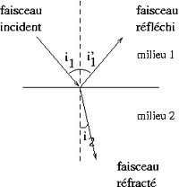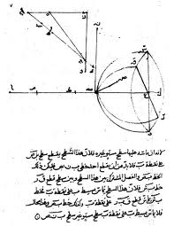
Figure 9: Ibn Sahl (Snell,s low). Figure10: Ibn Sahl,s work on
refraction and optics

-Lenses in the 11th century
Widespread use of lenses did not occur until the use of reading stones in the 11 th century and the invention of spectacles, probably in Italy in the 1280s. Scholars have noted that spectacles were invented not long after the translation of Ibn al-Haytham’s Book of Optics into Latin, ^{[11]} but it is not clear what role,if any,the optical theory of the time played in the discovery.Ibn Sahl’s treatise was used by Ibn al-Haitham.
Abu Ali al-Hasan ibn al-Hasan ibn al-Haytham(965 in Basra – c.1040 in cairo) ⁽⁾ was a Persian^{[12]} or Arab^{[13]} scientist and polymath. ^{[14]} He made significant contributions to the principles of optics, as well as to physics,
anatomy, astronomy, engineering, mathematics, medicine,ophthalmology, philosophy, psychology, visual perception, and to science in general with his early application of the scientific method. He is sometimes called al-Basri, after his birthplace in the city of Basra. ^{[15]} He was also nicknamed Ptolemaeus Secundus (“Ptolemy the Second”) ^{[16]} or simply “The Physicist”^{[17]} in medieval Europe. Alhazen wrote insightful comm -entaries on works by Aristotle, Ptolemy, and the Greek mathematician Euclid. ^{[18]}
Born circa 965, in Basra, Iraq and part of Buyid Persia at that time, ^{[20]} he lived mainly in Cairo, Egypt, dying there at age 76. ^{[16]} Over-confident about practical application of his mathematical knowledge, he assumed that he could regular the floods of the Nile. ^{[19]}

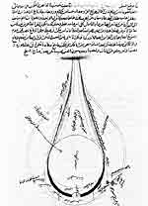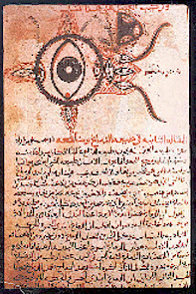
Figure 11: Ibn Al-Haytham,s anatomy Figure 12: Eye Diagram Ibn
of the eye Al-Haytham

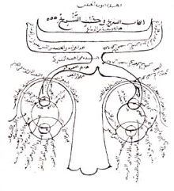
Figure 13: Optics (dated 1083): Ibn al-Haytham's Optics, written in Eqypt in the first half of the 11th Century, represented a theory of vision that went beyond Galen, Euclid and Ptolemy. This diagram of the two eyes seen from above, shows the principal tunics and humours and the optic nerves connecting the eyeballs to the brain
-Lenses in the 12th century
Sunglasses, in the form of flat panes of smoky quartz, protected the eyes from glare and were used in China in the 12th century or possibly earlier. Similarly, the Inuit have used snow goggles for eye protection. However, they did not offer any corrective benefits^{[21]} and the use by historians of the term "sunglasses" is anachronistic before the twentieth century.
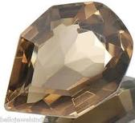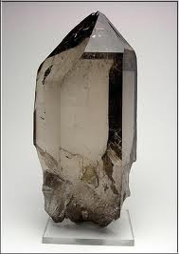
Figure 14: Smoky Quartz Gemstone. Figure 15: Smoky Quartz, Large loose
– 800X566.
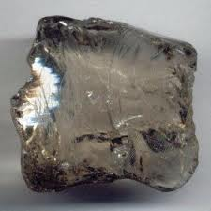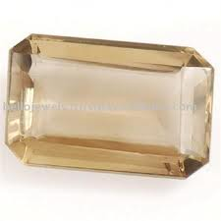
Figure 16: Smoky Quartz – 336X330. Figure 17: Natural Smoky Quartz
-Lenses in the 13th century
Englishman Robert Grosseteste's treatise De iride ("On the Rainbow"), written between 1220 and 1235, mentions using optics to "read the smallest letters at incredible distances". A few years later, Roger Bacon is also known to have written on the magnifying properties of lenses in 1262.^{[22]}
Reportedly, spectacles were in use in China by the rich and elderly at the time of Marco Polo's arrival in 1270 or 1271,^{[23][24]} although the Chinese credit their invention to Arabia in the 11th century.^{[23]}

Invention of eyeglasses
Many theories abound for who should be credited for the invention of traditional eyeglasses. Despite evidence of spectacles in China in 1270, and Chinese claims of themselves importing spectacle technology from the Middle East in the 11th century, some people theorise that spectacles were first invented between 1280 and 1300 in Italy. Some also theorise that the first European inventor of spectacles was Salvino D'Armate.
In 1676, Francesco Redi, a professor of medicine at the University of Pisa, wrote that he possessed a 1289 manuscript whose author complains that he would be unable to read or write were it not for the recent invention of glasses. He also produced a record of a sermon given in 1305, in which the speaker, a Dominican friar named Fra Giordano da Rivalto, remarked that glasses had been invented less than twenty years previously, and that he had met the inventor. Based on this evidence, Redi credited another Dominican friar, Fra Alessandro da Spina of Pisa, with the re-invention of glasses after their original inventor kept them a secret, a claim contained in da Spina's obituary record.^{[25]} However, Spina most likely learned to make spectacles after seeing them made by another individual,^{[26]} a talent for which he was known at the time.
Another potential inventor is Salvino D'Armate, who is credited with inventing the first wearable eye glasses on 16 September 1284 in Italy.^{[27]} In a 1684 history of Florence, Leopoldo del Migliore wrote that the church of Santa Maria Maggiore contained a memorial honoring D'Armati with the inscription: Here lies Salvino degl' Armati, son of Armato of Florence, inventor of eyeglasses. May God forgive his sins. A.D. 1317. The church has been rebuilt several times since the 13th century,^{[28]} however, and this tomb no longer exists, so the claim cannot be verified.
Seated apostle holding lenses in position for reading. Detail from Death of the Virgin, by the Master of Heiligenkreuz, ca. 1400–30 (Getty Center).
The earliest pictorial evidence for the use of eyeglasses is Tommaso da Modena's 1352 portrait of the cardinal Hugh de Provence reading in a scriptorium. Another early example would be a depiction of eyeglasses found north of the Alps in an altarpiece of the church of Bad Wildungen, Germany, in 1403.
These early spectacles had convex lenses that could correct both hyperopia (farsightedness), and the presbyopia that commonly develops as a symptom of aging. Nicholas of Cusa is believed to have discovered the benefits of concave lens in the treatment of myopia (nearsightedness). However, it was not until 1604 that Johannes Kepler published in his treatise on optics and astronomy, the first correct explanation as to why convex and concave lenses could correct presbyopia and myopia.

Later developments
The American scientist Benjamin Franklin, who suffered from both myopia and presbyopia, adopted bifocals in 1784 to avoid having to regularly switch between two pairs of glasses^{[29]} although the claim that he actually invented them is disputed.
The first lenses for correcting astigmatism were constructed by the British astronomer George Airy in 1825.^{[29]}
Over time, the construction of spectacle frames also evolved. Early eyepieces were designed to be either held in place by hand(monocle ), or by exerting pressure on the nose (pince-nez).
A monocle is a type of corrective lens used to correct or enhance the vision in only one eye. It consists of a circular lens, generally with a wire ring around the circumference that can be attached to a string. The other end of the string is then connected to the wearer's clothing to a
void losing the monocle. The antiquarian Philipp von Stosch wore a monocle in Rome in the 1720s, in order to closely examine engravings and antique engraved gems, but the monocle did not become an article of gentlemen's apparel until the nineteenth century. It was introduced by the dandy's quizzing glass of the 1790s, as a sense of high fashion.
Figure 18: Monocle glasses. Figure 19: Monocle glasses.
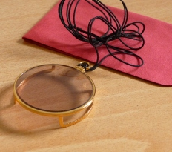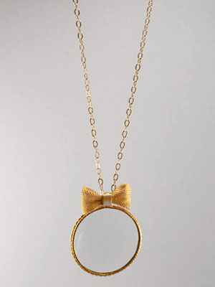
Figure 20: Golden Monocle glasses. Figure 21: Monocle with necklaces.
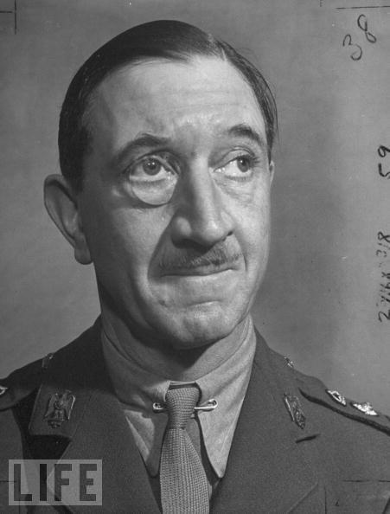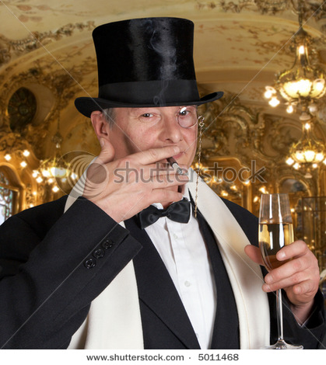
Figure 22: Monocle glasses. Figure 23: Stock photo.
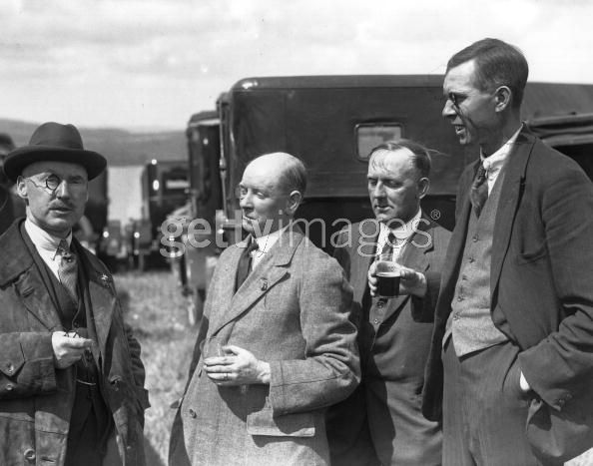
Figure 24: Monocle glasses.
Pince-nez are a style of spectacles, popular in the 19th century, which are supported without earpieces, by pinching the bridge of the nose. The name comes from French – pincer, to pinch, and nez, nose.
Although pince-nez were used in Europe in the 15th, 16th, and 17th centuries, modern ones appeared in the 1840s and reached their peak popularity around 1880 to 1900. By the late 1930s, they were popular mostly with the elderly.
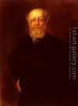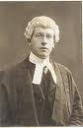
Figure 25: Pince-nez glasses Figure 26: Pince-nez glasses.
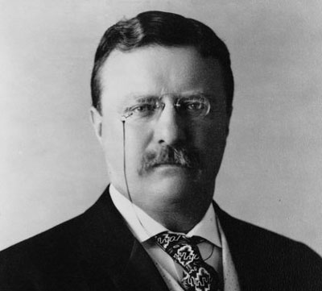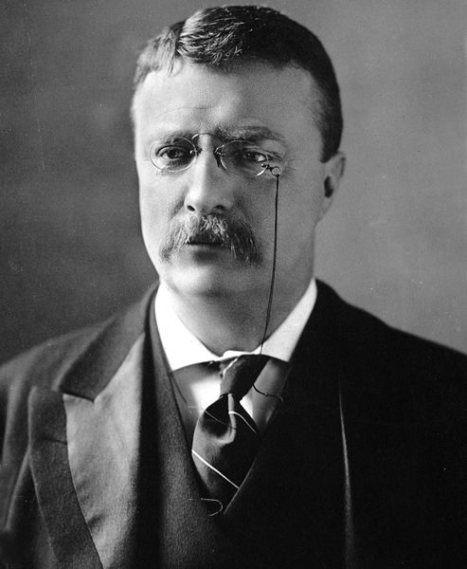
Figure 27: Theodor Roosevelt picture. Figure 28: Theodor Roosevelt picture.

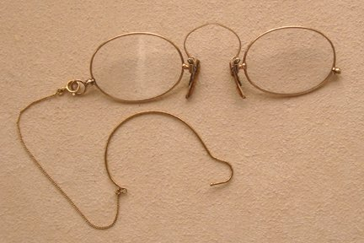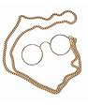
Figure 29: Golden Pince-nez glasses. Figure 30: Pince-nez glasses.
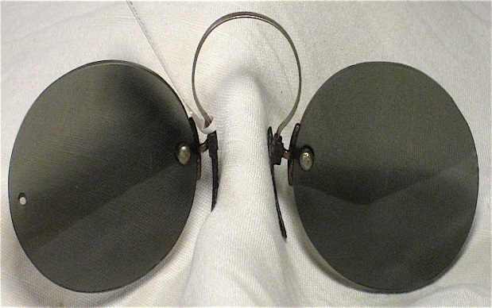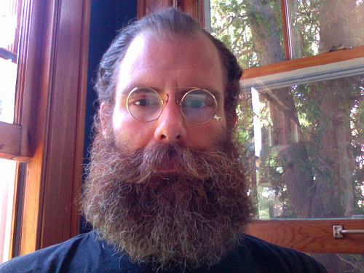
Figure 31: Pince-nez glasses. Figure 32: Pince-nez glasses.

Girolamo Savonarola suggested that eyepieces could be held in place by a ribbon passed over the wearer's head, this in turn secured by the weight of a hat. The modern style of glasses, held by temples passing over the ears, was developed some time before 1727, possibly by the British optician Edward Scarlett. These designs were not immediately successful, however, and various styles with attached handles such as "scissors-glasses" and lorgnettes were also fashionable from the second half of the 18th century and into the early 19th century.
Lorgnette is a pair of spectacles with a handle, used to hold them in place, rather than fitting over the ears. It is derived from the French lorgner, to take a sidelong look at, and Middle French, from lorgne, squinting. They were invented by an Englishman named George Adams. The lorgnette was usually used as a piece of jewelry, rather than to enhance vision. Fashionable ladies usually preferred them to spectacles. These were very popular at masquerade parties and used often at the opera (becoming the model for today's fancier opera glasses). They were worn popularly in the 19th century.

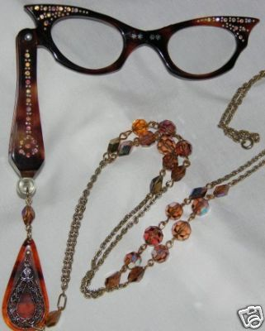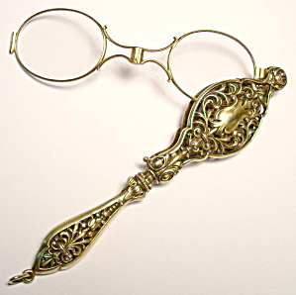
Figure 33: Lorgnette glasses with Kristal lace Figure 34: Golden Lorgnette glasses.

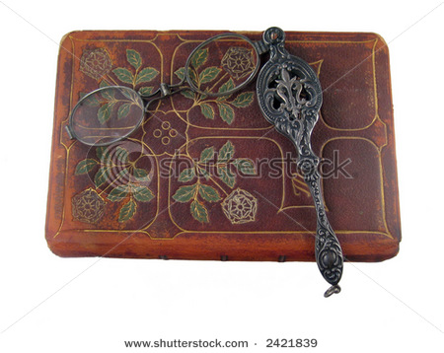
Figure 35: Stock Lorgnette glasses.

Scissors-glasses (or binocles-ciseaux) are eyeglasses, normally used to correct distance-vision, mounted on scissoring stems rather than on temple stems as modern eyeglasses are.
The invention of scissors-glasses solved the problem of the single lensed monocle or "quizzing glass", thought to be tiresome to the eye, by providing two lenses on a "Y" shaped frame. They usually had a ring in the end of the handle so that they could be worn on a ribbon or gold chain around the neck.
Elegant examples, often gilded and highly ornamented, became common among the more fashionable members of French and German society in the second half of the 18th century. George Washington, Lafayette and Napoleon used scissors glasses. In French they are called binocles or binocles-ciseaux and the French scissor glasses are more delicate, ornate, and more of a fashion accessory than those made in other parts of Europe.

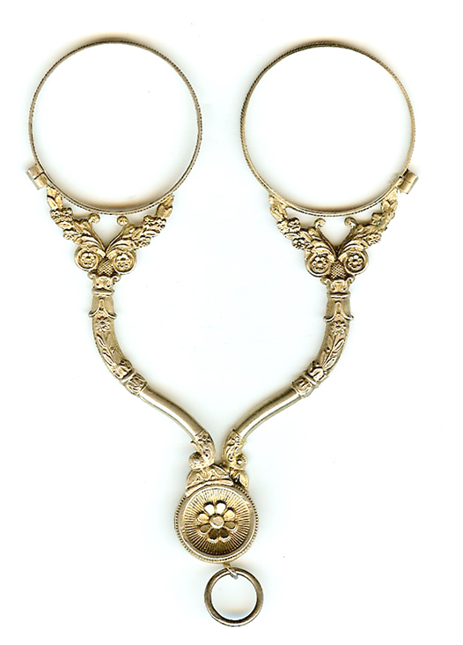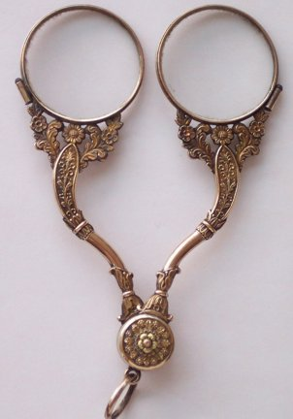
Figure 36: Golden Scissors glasses. Figure 37: Scissors glasses.

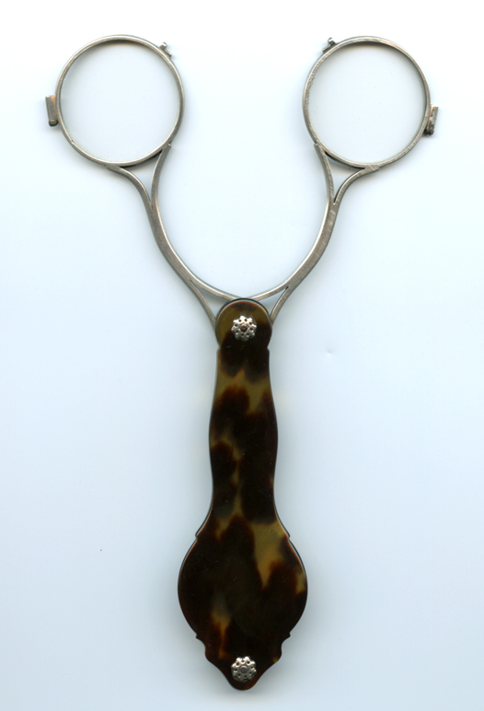
Figure 38: Stock Scissors glasses.

In the early 20th century, Moritz von Rohr at Zeiss (with the assistance of H. Boegehold and A. Sonnefeld^{[30]}), developed the Zeiss Punktal spherical point-focus lenses that dominated the eyeglass lens field for many years.
Despite the increasing popularity of contact lenses and laser corrective eye surgery, glasses remain very common, as their technology has improved. For instance, it is now possible to purchase frames made of special memory metal alloys that return to their correct shape after being bent. Other frames have spring-loaded hinges. Either of these designs offers dramatically better ability to withstand the stresses of daily wear and the occasional accident. Modern frames are also often made from strong, light-weight materials such as titanium alloys, which were not available in the earlier times.

Types
Corrective
Seattle skyline as seen through a corrective lens, showing the effect of refraction.
Main articles: Corrective lens, Pinhole glasses, and Refraction error Corrective lenses are used to correct refractive errors of the eye by modifying the effective focal length of the lens in order to alleviate the effects of conditions such as nearsightedness (myopia), farsightedness (hyperopia) or astigmatism. Another common condition in older patients is presbyopia which is caused by the eye's crystalline lens losing elasticity, progressively reducing the ability of the lens to accommodate (i.e. to focus on objects close to the eye).
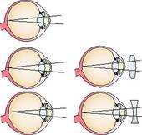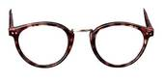
Figure 39: Demonstrating how Corrective Figure 40: Eye glasses.
lenses aid in seeing.
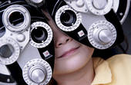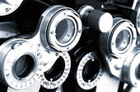
Figure 41: Girl getting vision tested. Figure 42: Phoropter.
The power of a lens is generally measured in diopters. Glasses correcting for myopia will have negative diopter strengths, and glasses correcting for hypermetropia will have positive diopter strengths. Glasses correcting for astigmatism require two different strengths placed at right angles in the same lens.
Prescription lenses, made to conform to the prescription of an ophthalmologist or optometrist, are used to make prescription glasses, which are then verified correct using a professional lensmeter.
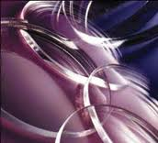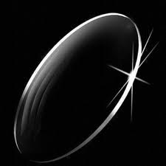
Figure 43: Prescription lenses. Figure 44: Prescription lenses.
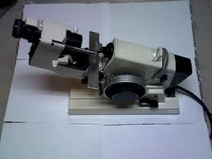
Figure 45: Lensmeter.
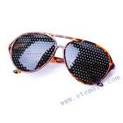
Pinhole glasses are a type of corrective glasses which do not use a lens and are claimed to help correct the eye's refractive error without introducing the image distortion of traditional lens-based glasses. Pinhole glasses do not actually refract the light or change the focal length, they operate by reducing the size of the blur circles in the retinal images. In blurry vision, every point on the object corresponds with a blur circle in the image. By reducing the size of the blur circles, they reduce the overlap of the blur
Figure 46: Pinhole glasses.

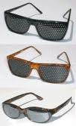
circles in the image, clarifying the vision somewhat. They do not heal the eye of refractive error, as sometimes claimed, and vision with pinhole glasses, although clearer than without them, is not as clear as with conventional lenses.
Correcting one's vision is done by using lenses to move the focal point on the retina accordingly with one's particular needs. The depth of the curve, the thickness of the lens, and the precise shape of the
lens can all be used to change the focal point.^{[31]}. Figure 47: Pinhole glasses.
Eyeglasses can normally correct and compensate for four types of vision deficiencies:
- Myopia is a vision disorder that causes far objects to appear blurred but near objects are seen clearly.^{[32]} Individuals suffering from myopia are prescribed eyeglasses with concave lenses, which compensate for the refraction error by moving the image of the distant objects that cannot be seen clearly backward onto the retina.
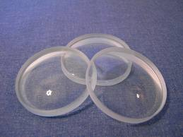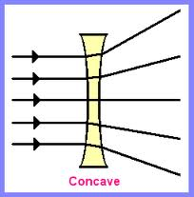
Figure 48: Concave lenses. Figure 49: Demonstrating how Concave
lenses works.
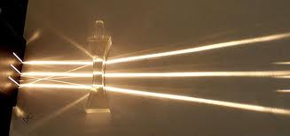
Figure 50: Concave lens diverging rays.
- Correcting hyperopia is normally done with eyeglasses with convex lenses. With this disorder, the patients can see distant objects clearly but they have trouble with seeing objects that are close to them. Eyeglasses with convex lenses compensate for the refraction errors by moving the image of a distant object forward onto the retina.^{[32]}.
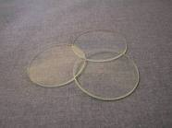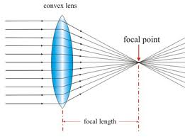
Figure 51: Convex lenses. Figure 52: Demonstrating how
Convex lenses works.
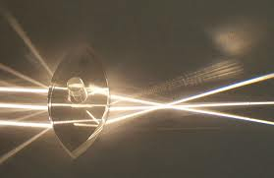
Figure 53:Large Convex lens.
Astigmatism is typically corrected with a cylindrical lens. This disorder is caused by a non-uniform curvature in the refractive surfaces of the eye, which leads to an abnormality in focusing the light rays on the retina. As a result, a part of the light rays are focused on the retina and the other part is focused behind it or in front of it.
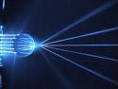 | 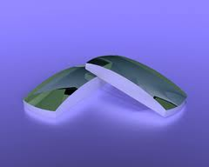 | 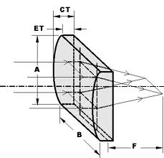
Figure 54: Large Cylindrical lens. | Figure 55: Cylindrical lenses. | Figure 56: Demonstrating how Cylindrical lenses works.
- Presbyopia is more frequent in people over 40 years old and it is corrected with convex lenses. These patients need reading or bifocal eyeglasses.
Corrective eyeglasses can significantly improve the life quality of the patient as they are helpful in both correcting vision disorders and reducing problems that appear when such lenses are needed, such as headaches or squinting.

Corrective lenses can also be added to work masks or eyeglasses which are used in sports.
Eyeglass lenses are commonly made from plastic, including CR-39 and polycarbonate. These materials reduce the danger of breakage and weigh less than glass lenses. Some plastics also have more advantageous optical properties than glass, such as better transmission of visible light and greater absorption of ultraviolet light.^{[43]} Some plastics have a greater index of refraction than most types of glass; this is useful in the making of corrective lenses shaped to correct various vision abnormalities such as myopia, allowing thinner lenses for a given prescription. Newer plastic lenses, called iZon, can also correct for the symptoms of the higher order aberrations that naturally occur on a person's optical system (including retina, lens, and cornea).[citation needed] These lenses create sharper vision for people who have problems with blurry or dull vision, as well as help reduce the halos, starbursts, and comet-tails often associated with night time driving.[citation needed]
Scratch-resistant coatings can be applied to most plastic lenses giving them similar scratch resistance to glass. Hydrophobic coatings designed to ease cleaning are also available, as are anti-reflective coatings intended to reduce glare, improve night vision and make the wearer's eyes more visible.^{[33]}

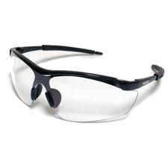
Safety
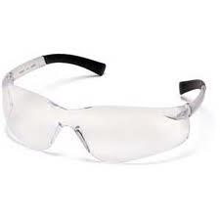
Safety glasses are usually made with shatter-resistant plastic lenses to protect the eye from flying debris. Although safety lenses may be constructed from a variety of materials of various impact resistance, certain standards suggest that they maintain a minimum 1 millimeter thickness at the thinnest point, regardless of material. Safety glasses can vary in the level of protection they provide. For example, those used in medicine may be expected to protect against blood splatter while safety glasses in a factory might have stronger lenses and a stronger frame with additional shields at the temples to protect from sawdust, flying wood, or metal. The lenses of safety glasses can also be shaped for correction.
Figure 57: Safety glasses.

Figure 58: Safety glasses.

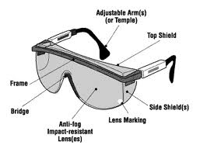
Safety glasses with side shields
The American National Standards Institute has established standard ANSI Z87.1 for safety glasses in the United States, and similar standards have been established elsewhere.
Figure 59: Safety glasses with side shields.

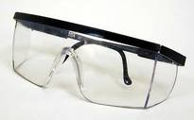
OSHA provides guidance on the type of safety eyewear that should be used for a particular application.
Some safety glasses are designed to fit over corrective glasses or sunglasses. They may provide less eye protection than goggles or other forms of eye protection, but their light weight increases the likelihood that they will actually be used. Modern safety glasses tend to be given a more stylish design in order to encourage their use. Corrective glasses with plastic lenses can be used in place of safety glasses in many environments; this is one advantage that they have over contact lenses.
Figure 60: Safety glasses with side shields.

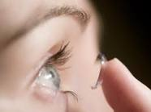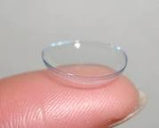
Figure 61: Plastic lenses. Figure 62: Plastic lenses
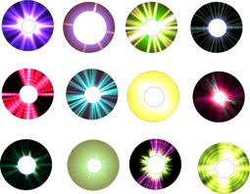
Figure 63: Colored Plastic lenses


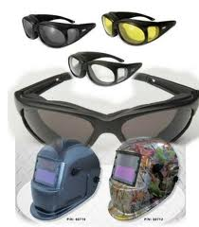
There are also safety glasses for welding, which are styled like wraparound sunglasses, but with much darker lenses, for use in welding where a full sized welding helmet is inconvenient or uncomfortable. These are often called "flash goggles", because they provide protection from welding flash.
Figure 64: Safety glasses for welding.

Worker safety eyewear is available in various lens colors and/or with coatings to protect or enable eyesight in different lighting conditions, particularly when outdoors.
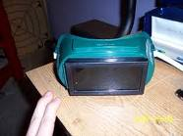
Nylon frames are usually used for protection eyewear for sports because of their lightweight and flexible properties. They are able to bend
Figure 65: Safety glasses for welding. P 23.

Figure 66: Safety glasses for welding. P 23.

slightly and return to their original shape instead of breaking when pressure is applied to them. Nylon frames can become very brittle with age and they can be difficult to adjust.
Safety lenses are usually made of
polycarbonate.^{[34]} Polycarbonate and Trivex
lenses are the lightest and most shatter-resistant, making them the best for impact protection,^{[43]} though polycarbonate offers poor optics due to high dispersion, having a low Abbe number of 31. Safety glasses are also available in prescription form for those persons who need corrective lenses.^{[35]} Depending on the particular area in which the individuals work, they may be required to wear side protectors additionally to safety eyeglasses.
In order to comply with the ANSI Z87.1 requirements, safety eyeglasses must pass the high velocity and high mass tests. Also, the lenses of protective goggles, faceshield windows and welding filters cannot be thinner than 3 mm excepting the high impact lenses which are meant to be installed in prescription frames which cannot be thinner than 2 mm.
Sunglasses
Sunglasses may be made with either prescription or non-prescription lenses that are darkened to provide protection against bright visible light and, possibly, ultraviolet (UV) light.
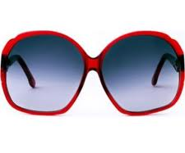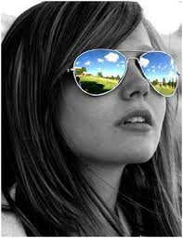
Figure 67: Sunglasses Figure 68: Sunglasses.
Photochromic lenses, which are photosensitive, darken when struck by UV light.
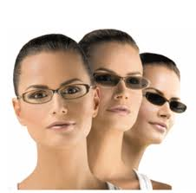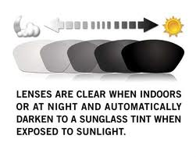
Figure 69: Photochromic lenses. Figure 70: Photochromic lenses.

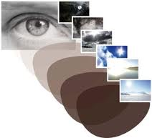
Figure 71: Photochromic lenses.
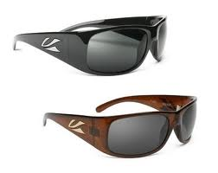
Light polarization is an added feature that can be applied to sunglass lenses. Polarization filters remove horizontally polarized rays of light, which eliminates glare from horizontal surfaces (allowing wearers to see into water when reflected light would otherwise overwhelm the scene). Polarized sunglasses may present some difficulties for pilots since reflections from water and other structures
Figure 72: Light polarization glasses.

often used to gauge altitude may be removed, or instrument readings on liquid crystal displays may be blocked.
Yellow lenses increase color contrast and improve depth perception. They are worn by people driving at dusk, but are detrimental to vision at night. Any tint further reduces incoming light to the retina, and yellow tints also reduce glare-recovery times for night drivers.^{[36]} Brown lenses are common among golfers, but cause color distortion. Blue, purple, and green lenses offer no real benefits to vision enhancement, and are mainly cosmetic. Some sunglasses with interchangeable lenses have optional clear lenses to protect the eyes during low light or night time activities and a colored lens with UV protection for times where sun protection is needed.
Sunglasses are often worn just for aesthetic purposes, or simply to hide the eyes. Examples of sunglasses that were popular for these reasons include teashades and mirrorshades. Many blind people wear opaque glasses to hide their eyes for aesthetic reasons.

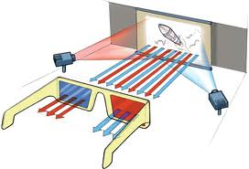
3D glasses
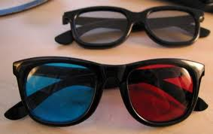
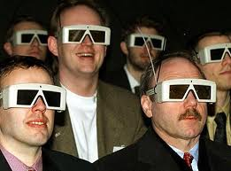
The illusion of three dimensions on a two dimensional surface can be created by providing each eye with different visual information. Classic 3D glasses create the illusion of three dimensions when viewing specially prepared images. The classic 3D glasses have one red lens and one blue or cyan lens. Another kind of 3D glasses uses polarized filters, with one lens polarized vertically and the other horizontally, with the two images required for stereo vision polarized the same way. Polarized 3D glasses allow for color 3D, while the red-blue lenses produce a dull black-and-white picture with red and blue fringes. Both types have been distributed to audiences at 3D movies.
Figure 73: 3D glasses traditional.

Figure 74: 3D glasses.

Figure 75: 3D glasses used in theatres.

One kind of electronic 3D spectacles uses electronic shutters, while virtual reality glasses and helmets have separate video screens for each eye. A 3D effect can also be produced using LCD shutter glasses.^{[37]}

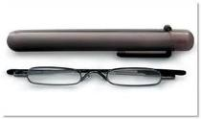
Reading glasses
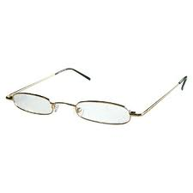
Magnifying lenses or generic spectacles that are used to treat mild presbyopia and hyperopia can be bought off the shelf. Although such glasses are generally considered safe, an individual prescription, as determined by an ophthalmologist or optometrist and made by a qualified optician, usually results in better visual correction and fewer headaches & visual discomfort. There have also been many cases where people have delayed having a proper eye examinaton with an optometrist or ophthalmologist, preferring to purchase off the shelf glasses, who have put their sight at risk from conditions such as AMD, Glaucoma and complications from Diabetes. It is important to stress off the shelf readers are not a replacement for regular eye examinations.
Figure 76: Reading glasses. P 27.

Reading glasses come in two main styles: full frames, in which the entire lens is made in the reading prescription, and half-eyes, the smaller "Ben Franklin" style glasses that sit lower down on the nose.^{[38]}
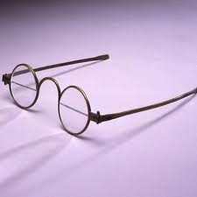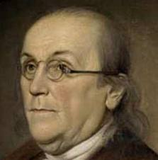
Figure 77: Ben Franklin glasses Figure 78: Ben Franklin

Full reading glasses are more suitable for people who only need them for close-up reading while half-eye reading glasses can be used to read at smaller or larger distances. The reading glasses are most of the time needed by people who have never worn glasses.
Although specialists recommend individuals who need to wear eyeglasses to have them custom-made according to their own needs, most of the patients prefer buying them at a pharmacy or department store. This type of eyeglass-shopping became very popular in the 1990s when it was estimated that over 30 million pairs were sold per year. These reading glasses are not as expensive as the custom-made ones and they are certainly designed to catch the buyer's eye. Glasses that can be purchased off the shelf are available in a wide variety of colors and designs, suitable for different tastes. As this habit can result in worsening one's vision problems, there is a new alternative to buy eyeglasses easy and cheap from online prescription eyeglasses stores.^{[39]}
The downside of the ready-made eyeglasses is that they are basically made in "one size", meaning that they come with the same prescription in the same lenses and the location of the optical center of the lenses is also the same. Yet, most individuals who need reading glasses need different prescriptions in each eye and wearing such pre-made eyeglasses can result in headaches, eyestrain or nausea. These "side effects" tend to occur when the prescription that the glasses have is too far from the one that the individual needs.

Bifocals, trifocals, and progressive lenses
As people age, their ability to focus is lessened and many decide to use multiple-focus lenses, which can be bifocal or even trifocal, to cover all the situations in which they use their sight. Traditional multifocal lenses have two or three distinct horizontal viewing areas, each requiring a conscious effort of refocusing.
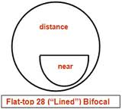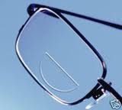
Figure 79: Bifocal lens dimensions Figure 80: Bifocals lenses. P 29.
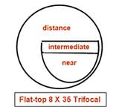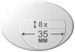
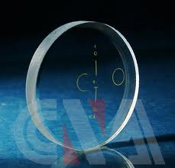
Figure 81: trifocal lens dimensions Figure 82: trifocals lenses. P 29.
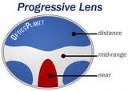
Some modern multifocal lenses, such as progressive lenses (known as "no-line bifocals"), give a smooth transition between these different focal points, unnoticeable by most wearers, while other glasses have lenses specifically intended for use with computer monitors at a fixed distance. People may have several pairs of glasses, one for each task or distance, with specific glasses for reading, computer use, television watching, and writing.
Figure 83: Progressive lenses.

Figure 84: Progressive lenses.

Extreme magnification (bioptics)
A form of glasses with extreme magnification to improve the distance vision of those with severe eyesight impairment, especially people with albinism, are known as bioptics or a bioptic telescope. They may take the form of self-contained glasses that resemble goggles or binoculars, or may be attached to existing glasses.
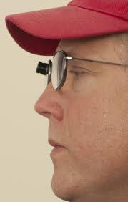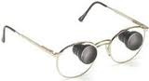
Figure 85: Bioptics glasses. Figure 86: Bioptic telescope glasses.

Fashion
Personal image
United States senator Barry Goldwater in horn-rimmed glasses
Glasses can be a major part of personal image and expression, from Groucho Marx and Buddy Holly to the extravagance of Elton John and Dame Edna Everage.
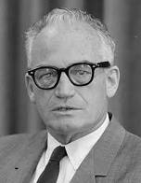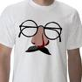
Figure 87: Barry Goldwater. Figure 88: Groucho Marx.
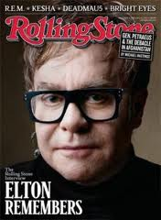
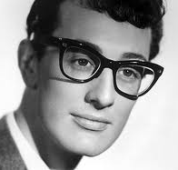
Figure 89: Buddy Holly. P 31. Figure 90: Elton John. P 31.

Eyewear became a fashion accessory in the 1950s.^{[40]} Browline glasses were the standard for men in the 1950s and 1960s.
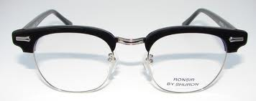
Figure 91: Browline glasses.

For some celebrities, glasses form part of their identity. United States Senator Barry Goldwater continued to wear lensless horn-rimmed glasses after being fitted with contact lenses because he was not recognizable without his trademark glasses. British soap star Anne Kirkbride had the same problem: her character on Coronation Street, Deirdre Barlow, became so well-known for her big frames that she was expected to wear them at social gatherings and in international tours, even though Kirkbride has always worn contact lenses. Comedian Drew Carey continued to wear glasses for the same reason after getting corrective laser eye surgery. British comedic actor Eric Sykes, who became profoundly deaf as an adult, wears glasses that contain no lenses; they are actually a bone-conducting hearing aid. Masaharu Morimoto wears glasses to separate his professional persona as a chef from his stage persona as Iron Chef Japanese. John Lennon wore his round-lens 'Windsor' spectacles from some of his time with the Beatles to his murder in 1980. The rock band Weezer is known for some of the members wearing thick-rimmed glasses, as well as actor Jeff Goldblum who is often seen in the Browline glasses style. Singer Anastacia, who dominated the European charts in the early 21st century, is noted for wearing odd coloured glasses.
In popular culture, glasses were all the disguise Superman and Wonder Woman needed to hide in plain view as alter egos Clark Kent and Diana Prince, respectively.

Rimless style
Three-piece rimless and semi-rimless glasses are common variations that differ from regular glasses in that their frames do not completely encircle the lenses. Three-piece rimless glasses have no frame around the lenses, and the bridge and temples are mounted directly onto the lenses. Semi-rimless (or half-rimless) glasses have a frame that only partially encircles the lenses (commonly the top portion). When the style was first introduced in the 1930s, lenses were screwed directly to the front of the frame; most modern variations feature the lenses held inside of the frame by high strength nylon wire,^{[41]} although the semi-rimless style has been around since at least the 1940s. A rare and currently noncommercial variation are rimless and frameless glasses attached to a piercing at the bridge of a wearer's nose.^{[42]} Such glasses have the visual look of the pince-nez.
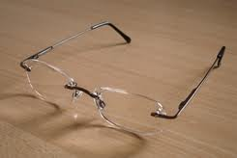
Figure 92: Rimless Style.

Abstract

The discovery of the stone and glass lenses throughout the ancient history was the chance that inspired the peoples of ancient Egypt, Greeks and Romans in illustrating and magnifying what the mere eye couldn’t see. Afterwards, the inventions which were based on the needs of humanity started going ahead and the permanent development that led to the advance of those lenses and studied them scientifically.

The development of sciences in the Islamic Age led to the developing of the Arabs scientists to this science and explaining the mechanism of these lenses and that led to establish the theories and rules that explain the mechanism and make more use of them in correcting sight.

In The Middle Ages, and after the flourishing of sciences in Europe, the science of optics flourished and developed . The lenses had started to take the formal original shapes where they put in front of the eyes in different shapes , and at the time, the name of medical spectacles had appeared at the beginning of the modern age , in their familiar shapes that we know nowadays.

The advance of the modern science led to a raise of human need to various and new kinds of these glasses because they aren’t used only for correcting sight , but also to protect the eye from any external effects that may hurt it , and also in other fields .

References:
Web site: Wekipedia

1-^ ª ^{b} Kriss, Timothy C.; Kriss, Vesna Martich (April 1998). "History of the Operating Microscope: From Magnifying Glass to Microneurosurgery". Neurosurgery 42 (4): 899–907. doi:10.1097/00006123-199804000-00116. PMID 9574655.
2- ^ Pliny the Elder. "Natural History". http://www.perseus.tufts.edu/cgi-bin/ptext?lookup=Plin.+Nat.+37.16. Retrieved 2008-04-27.
3-^ Dr. Kasem Ajram (1992). Miracle of Islamic Science, Appendix B. Knowledge House Publishers. ISBN 0-911119-43-4.
4- ^ « Ibn Firnas ('Abbâs) » by Ahmed Djebbar, Dictionnaire culturel des science, by Collective under the direction of Nicolas Witkowski, Du Regard Editions, 2003, ISBN 2-84105-128-5.
5- ^ ª ^{b} Lynn Townsend White, Jr. (Spring, 1961). "Eilmer of Malmesbury, an Eleventh Century Aviator: A Case Study of Technological Innovation, Its Context and Tradition", Technology and Culture 2 (2), p. 97-111 [100]:
"Ibn Firnas was a polymath: a physician, a rather bad poet, the first to make glass from stones (quartz), a student of music, and inventor of some sort of metronome."
6- ^ ª ^{b} ^{c} ^{d} ^{e} ^{f} "'Abbas Ibn Firnas". John H. Lienhard. The Engines of Our Ingenuity. NPR. KUHF-FM Houston. 2004. No. 1910. Transcript. Retrieved on 2009-08-31.
7- ^ ª ^{b} ^{c} ^{d} ^{e} ^{f} ^{g} ^{h} Lynn Townsend White, Jr. (Spring, 1961). "Eilmer of Malmesbury, an Eleventh Century Aviator: A Case Study of Technological Innovation, Its Context and Tradition", Technology and Culture 2 (2), p. 97-111 [100f.]
8-Rashed, R. (1990). "A pioneer in anaclastics: Ibn Sahl on burning mirrors and lenses." Isis, 81, 464–491.
9- ^ K. B. Wolf, "Geometry and dynamics in refracting systems", European Journal of Physics 16, p. 14-20, 1995.
10- ^ ª ^{b} R. Rashed, "A pioneer in anaclastics: Ibn Sahl on burning mirrors and lenses", Isis 81, p. 464–491, 1990.-
11^ ª ^{b} Kriss, Timothy C.; Kriss, Vesna Martich (April 1998). "History of the Operating Microscope: From Magnifying Glass to Microneurosurgery". Neurosurgery 42 (4): 899–907. doi:10.1097/00006123-199804000-00116. PMID 95746551-
12- ^ (Child, Shuter & Taylor 1992, p. 70)
(Dessel, Nehrich & Voran 1973, p. 164)
(Samuelson Crookes, p. 497)
Understanding History by John Child, Paul Shuter, David Taylor - Page 70. "Alhazen, a Persian scientist, showed that the eye saw light from other objects. This started optics, the science of light. The Arabs also studied astronomy, the study of the stars. "
13- ^ (Smith 1992)
(Grant 2008)
(Vernet 2008)
Paul Lagasse (2007), "Ibn al-Haytham", Columbia Encyclopedia (Sixth ed.), Columbia, ISBN 0-7876-5075-7, http://www.encyclopedia.com/doc/1E1-IbnalHay.html, retrieved 2008-01-23
14- ^ Review of Ibn al-Haytham: First Scientist, Kirkus Reviews, December 1, 2006:
a devout, brilliant polymath
(Hamarneh 1972):
A great man and a universal genius, long neglected even by his own people.
(Bettany 1995):
Ibn ai-Haytham provides us with the historical personage of a versatile universal genius.
15- ^ ª ^{b} ^{c} ^{d} ^{e} ^{f} ^{g} ^{h} (O'Connor & Robertson 1999)
16- ^ ª ^{b} ^{c} ^{d} (Corbin 1993, p. 149)
17- ^ (Lindberg 1967, p. 331)
18- ^ "The rainbow bridge: rainbows in art, myth, and science". Raymond L. Lee, Alistair B. Fraser (2001). Penn State Press. p.142. ISBN 0271019778
19^ ª ^{b} ^{c} ^{d} ^{e} (Sabra 2003)-
20-^ ª ^{b} ^{c} ^{d} ^{e} ^{f} (Lorch 2008)
21-^ Ament, Phil (2006-12-04). "Sunglasses History - The Invention of Sunglasses". The Great Idea Finder. Vaunt Design Group. http://www.ideafinder.com/history/inventions/sunglasses.htm. Retrieved 2007-06-28.
22- ^ "....Optics Highlights: II. Spectacles". University of Maryland, Department of Electrical & Computer Engineering. http://www.ece.umd.edu/~taylor/optics2.htm. Retrieved 2007-09-01.
23- ^ ª ^{b} The Foundation of the American Academy of Ophthalmology. "Ophthalmic Heritage & Museum of Vision: The History of Spectacles". http://faao.org/what/heritage/exhibits/online/spectacles. Retrieved September 17, 2010.
24- ^ The Foundation of the American Academy of Ophthalmology. "Ophthalmic Heritage & Museum of Vision: Spectacular Chinese Spectacles". http://faao.org/what/heritage/exhibits/online/ChineseSpectacles.cfm. Retrieved September 17, 2010
25- ^ "Famous Historical Statements up to 1600". Antique Spectacles. http://www.antiquespectacles.com/statements/1600.htm. Retrieved 2007-09-01.
26- ^ James, Peter; Nick Thorpe (November 1995). Ancient Inventions. New York: The Random House Publishing Group. pp. 292. ISBN 0-345-40102-6. http://books.google.com/books?id=VmJLd3sSYecC.
27- ^ Bellis, Mary. "The History of Eye Glasses or Spectacles". About.com:Inventors. http://inventors.about.com/od/gstartinventions/a/glass_3.htm. Retrieved 2007-09-01.
28- ^ "Church of Santa Maria Maggiore". http://www.yourwaytoflorence.com/db/chiese/maggiore.htm. Retrieved September 17, 2010.
29- ^ ª ^{b} Bellis, Mary. "The Inventions and Scientific Achievements of Benjamin Franklin". http://inventors.about.com/od/fstartinventors/ss/Franklin_invent_4.htm. Retrieved 2007-09-01.
30- ^ "Eyeglass Lenses and Visual Aids from Industrial Production". Zeiss.com. http://www.zeiss.com/C12567A100537AB9/Contents-Frame/6B49EEA709EAE719C1256919003DAE2B. Retrieved 2007-09-02.
31- ^ "What are Corrective Lenses?". http://www.wisegeek.com/what-are-corrective-lenses.htm. Retrieved 2010-06-14.
32- ^ ª ^{b} "Eyeglasses Prescription Eyeglasses". http://www.eyeglassdirect.com/. Retrieved 2010-06-14.
33- ^ DeFranco, Liz (May 2006). "Do You Need Lens Coatings?". All About Vision. http://www.allaboutvision.com/lenses/coatings.htm. Retrieved 2007-09-01.
34- ^ "Safety Glasses and Eye Safety Q&A". http://www.allaboutvision.com/askdoc/eye-safety.htm. Retrieved 2010-06-14.
35- ^ "Choosing and Using Eye Protection". http://www.eyesafety.4ursafety.com/eye-safety-articles.html#choosing. Retrieved 2010-06-14.
36- ^ "Dangerous Misconceptions of Night-Driving Lenses". Laramy K Optical. April 2009. http://www.laramyk.com.
37- ^ "Technologies for Consumer 3D Anatomical Interactivity". OCB Media. 1 October 2008. http://www.ocbmedia.com/news/56/Technologies-for-Consumer-3D-Anatomical-Interactivity/. Retrieved 2009-01-26.
38- ^ "Reading Glasses". http://www.allaboutvision.com/over40/readers.htm. Retrieved 2010-06-14.
39 ^ "Optical Eyeglasses Prescription Frames". http://www.opticaleyeglasses.org/prescription.html. Retrieved 2010-06-14.
40- ^ Pauline Weston Thomas. "1950s Glamour with Fifties Accessories - Fashion History". http://www.fashion-era.com/1950s/1950s_2_fashion_accessories.htm. Retrieved September 17, 2010.
41 ^ O'Keefe, Jackie (July/August 2003). "The Newest Technologies in Rimless Eyewear". Vision Care Product News. Archived from the original on 2005-12-19. http://web.archive.org/web/20051219152145/http://www.visioncareproducts.com/CE-old/frames_newest.html. Retrieved 2006-01-09.
42- ^ "Pierced Glasses". http://www.piercedglasses.com/mark2.html. Retrieved 2007-08-07.
43- ^ ª ^{b} ^{c} DeFranco, Liz (April 2007). "Polycarbonate Lenses: Tough as Nails". All About Vision. http://www.allaboutvision.com/lenses/polycarb.htm. Retrieved 2007-09-01.
Books:
Zerikly, Khyruddin, 1969 A.D – Al-Aalam, 15th Edi.
Broklman, Karol, 1975 A.D –The History of Arabic Literature, The first Arabic translated Version.

Directory of Persons

Abbas Ibn Firnas………… P 3.
Anne Kirkbride………….. P 33.
A.Sonnefeld……………... P 16.
Bad Wildungen………….. P 9.
Barry Goldwater………… P 32.
Ben Franklin…………….. P 28
Benjamin Franklin………. P 10.
Buddy Holly…………….. P 32.
Clark Kent………………. P 34.
Dame Edna Everage…….. P32.
Deirdre Barlow………….. p 33.
Diana Prince…………….. P 34.
Drew Carey……………... P 33.
Edward Scarlett…………. P 13.
Elton John……………….. P 32.
Eric Sykes……………….. P 33.
Fra Alessandro…………... P 8.
Fra Giordano…………….. P 8.
Francesco Redi…………... P 8.
George Adams…………… P 13.
George Airy……………… P 10.
George Washington……… P 15.
Girolamo Savonarola…….. P 13.
Groucho Marx……………. P 32.
H.Boegehold……………... P 16.
Ibn al-Haytham…………... P 5.
Ibn Sahl…………………… P 4.
Jeff Goldblum…………….. P 33.
Johannes Kepler…………... P 9.
John Lennon……………… P 33.
Lafayette…………………... P 15.
Leopoldo del Migliore…….. P 8.
Marco Polo………………... P 8.
Masaharu Morimoto………. P 33.
Mortiz von Rohr…………... P 16.
Napoleon…………………... P 15.
Nero………………………... P 2.
Nicholas of Cusa…………… P 9.
Philipp von Stosch…………. P 10.
Robert Grosseteste…………. P 7.
Roger Bacon……………….. P 7.
Salvino D’Armate………….. P 8.
Salvino degel……………….. P 8.
Seneca the Younger………… P 2.
Singer Anastacia……………. P 33.
Theodore-roosevelt…………. P 12.
Tommaso…………………… P 9.
Weezer……………………… P 33.

Directory of Figures:
Figure 1: Emerald Ring……………………………………………………. P 2.
Figure 2: Emerald % 2520 Clarity…………………………………….. P 2.
Figure 3: Emerald % 255C Gallery.......................................P 2.
Figure 4: Emerald stone………………………………………………..… P 2.
Figure 5: Crude Emerald………………………………………………….. P 3.
Figure 6: Emerald Marine – 1440X1153…………………………… P 3.
Figure 7: Emerald 300X300……………………………………………… P 3.
Figure 8: Abbas Ibn Firnas, reading stone…………..……...P 4
Figure 9: Ibn Sahl (Snell,s low)……………………………. P4.
Figure 10: Ibn Sahl,s work on refraction and optics……..... P4.
Figure 11: Ibn Al-Haytham,s anatomy of the eye…..……… P6.
Figure 12: Eye Diagram Ibn Al-Haytham……………...........P 6.
Figure 13: Ibn al-Haytham's Optics………………….……….P 6.
Figure 14: Smoky Quartz Gemstone……………………………………. P 7.
Figure 15: Smoky Quartz, Large loose – 800X566……………….. P 7.
Figure 16: Smoky Quartz – 336X330………………………………….. .P 7.
Figure 17: Natural Smoky Quartz 450X450………………………….. P 7.
Figure 18: Monocle glasses…………………………………………………. P 10.
Figure 19: Monocle glasses……………………………………………..….. P 10.
Figure 20: Golden Monocle glasses…………………………………….. P 11.
Figure 21: Monocle with necklaces……………………………………… P 11.
Figure 22: Monocle glasses…………………………………………..…….. P 11.
Figure 23: Stock photo…………………………………………………………. P 11.
Figure 24: Monocle glasses………………………………………………….. P 11.
Figure 25: Pince-nez glasses………………………….……………………… P 12.
Figure 26: Pince-nez glasses………………………….……………………… P 12.
Figure 27: Theodor Roosevelt picture………….………………….……. P 12.
Figure 28: Theodor Roosevelt picture………….……………………….. P 12.
Figure 29: Golden Pince-nez glasses……………………………………... P 13.
Figure 30: Pince-nez glasses with necklaces…………………….….… P 13.
Figure 31: Pince-nez glasses…………………………………………….….… P 13.
Figure 32: Pince-nez glasses………………………………………….…….… P 13.
Figure 33: Lorgnette glasses with Kristal lace………………………... P 14.
Figure 34: Golden Lorgnette glasses……………………………………... P 14.
Figure 35: Stock Lorgnette glasses………………………………………… P 14.
Figure 36: Golden Scissors glasses……………………………….……….. P 15.
Figure 37: Scissors glasses………………………………….……………….... P 15.
Figure 38: Stock Scissors glasses…………………………………………..… P 16.
Figure 39: Demonstrating how Corrective lenses aid in seeing..P17.
Figure 40: Eye glasses…………………………………………………………….. P 17.
Figure 41: Girl getting vision tested………………………………………… P 17.
Figure 42: Phoropter…………………………………………………………….… P 17.
Figure 43: Prescription lenses…………………………………………………. P 18.
Figure 44: Prescription lenses…………………………………………………. P 18.
Figure 45: Lensmeter……………………………………………………………... P 18.
Figure 46: Pinhole glasses………………………………………………………. P 18.
Figure 47: Pinhole glasses………………………………………………………. P 19.
Figure 48: Concave lenses………………………………………………………. P 19.
Figure 49: Demonstrating how Concave lenses works……………. P 19.
Figure 50: Concave lens diverging rays………………………………….. P 19.
Figure 51: Convex lenses……………………………………………………….. P 20.
Figure 52: Demonstrating how Convex lenses works……………. P 20.
Figure 53:Large Convex lens…………………………………………………. P 20.
Figure 54: Large Cylindrical lens……………………………………………. P 20.
Figure 55: Cylindrical lenses………………………………………………….. P 20.
Figure 56: Demonstrating how Cylindrical lenses works………… P 20.
Figure 57: Safety glasses………………………………………………………… P 22.
Figure 58: Safety glasses………………………………………………………… P 22.
Figure 59: Safety glasses with side shields……………………………... P 22.
Figure 60: Safety glasses with side shields……………………………... P 22.
Figure 61: Plastic lenses…………………………………………………………. P 23.
Figure 62: Plastic lenses…………………………………………………………. P 23.
Figure 63: Colored Plastic lenses……………………………………………. P 23.
Figure 64: Safety glasses for welding....…… P 24.

Figure 65: Safety glasses for welding……………………………………… P 24.
Figure 66: Safety glasses for welding……………………………………… P 24.
Figure 67: Sunglasses…………………………………………………………….. P 25.
Figure 68: Sunglasses…………………………………………………………….. P 25.
Figure 69: Photochromic lenses…………………………………………….. P 25.
Figure 70: Photochromic lenses…………………………………………….. P 25.
Figure 71: Photochromic lenses…………………………………………….. P 25.
Figure 72: Light polarization glasses………………………………………. P 26.
Figure 73: 3D glasses traditional……………………………………………. P 27.
Figure 74: 3D glasses…………………………………………………………….. P 27.
Figure 75: 3D glasses used in theatres………………………………….. P 27.
Figure 76: Reading glasses……………………………………………………. P 28.
Figure 77: Ben Franklin glasses…………………………………………….. P 28.
Figure 78: Ben Franklin………………………………………………………… P 28.
Figure 79: Bifocal lens dimensions……………………………………….. P 30.
Figure 80: Bifocals lenses……………………………………………………… P 30.
Figure 81: trifocal lens dimensions……………………………………….. P 30.
Figure 82: trifocals lenses…………………………………………………….. P 30.
Figure 83: Progressive lenses……………………………………………….. P 30.
Figure 84: Progressive lenses……………………………………………….. P 30.
Figure 85: Bioptics glasses……………………………………………………. P 31.
Figure 86: Bioptic telescope glasses……………………………………… P 31.
Figure 87: Barry Goldwater………………………………………………….. P 32.
Figure 88: Groucho Marx……………………………………………………… P 32.
Figure 89: Buddy Holly…………………………………………………………. P 32.
Figure 90: Elton John……………………………………………………………. P 32.
Figure 91: Browline glasses………………………………………………….. P 33.
Figure 92: Rimless Style………………………………………………………… P 34.

* Chairman, History of Medicine Department, Institute for the History of Arabic Science, Aleppo University, Aleppo-Syria The President of ISHIM (www.ishim.net) P.O. Box: 7581, Aleppo, Syria e-mail: ankaadan@gmail.com Phone 963 944 300030, Fax 963 21 2236526 ** Bachelor of Pharmacy Master stage student, Institute for the History of Arabic Science, Aleppo University
*
He was a Live in 887A.D = 274 H , Zerikly, P:264.
Abo Assad Al-Alaa Sahl. He was contemporary with Abe Saed Al-Sagaze how was a live in 969 A.D.=358H. Broklman, part 4,page 190. .
Mohammed Ibn Hassan Ibn Al- Haytham, He mostly died in 430 H . Broklman, part6,page 83.

