History of developing of hearing aids
By
Abdul Nasser Kaadan, MD, PhD*

** Ashraf Al-Assi

تاريخ تطور المعينات السمعية
إعداد

الدكتور عبد الناصركعدان*
الدكتور أشرف العاصي *
Contents

page
Introduction 1
Who invented the hearing aid? 2
Initial trials for developing hearing aids 3
- The ear horn hearing aid 3
- The ear trumpet hearing aid 4
- Speaking tubes 5
The Nineteenth Century and hearing aids 7
- Pre-Electric Horns, Trumpets, etc. (1800s) 7
- Nineteenth Century & concealed hearing aids 8
- The acoustic throne and acoustic chair hearing aids 9
- Other types of Hidden Hearing Aids 12
Did Alexander Graham Bell play a role in the invention of the electric hearing aid 20

The Twentieth Century & Electrical hearing aids 21

- Electronic Hearing Aids - Carbon 22
- Electronic Hearing Aids - Vacuum Tube 22
- Transistor Hearing Aids 23
- Hearing aid glasses 23
- Hybrid Hearing Aids 26
- Digital Hearing Aids 27
- 2000 - 2010: Feedback elimination, memory settings and listening preference 27
- 2010: Patient Input, Fuzzy Logic and ADRO 28
Summary 29

Introduction

From carved hearing horns to almost invisible digital instruments, the hearing aid has a rich history colored by strokes of genius, as well as flashes of the bizarre.
Since the dawn of Man hearing loss has been a true cause for innovation. The first attempt at solving hearing loss was a hand against the ear, which would simply collect more sound waves to make sounds clearer.
This concept remained the same for most of hearing aid history even if the means, style and materials have continuously changed. It is only in the last hundred years that hearing aids have changed dramatically, since electricity has begun to play a part and radically improve what they are capable of.
But it's important to review the history of hearing aids in order to understand just where the industry is headed.
Hearing aids and other hearing devices have come a long way from their humble beginnings as large, trumpet-like devices to small, practically invisible digital processing instruments. Below is a brief history of hearing devices over the past several centuries.

Who invented the hearing aid?
No one person invented the hearing aid. Hearing aids fashioned from horns, sea shells, or other natural material probably existed long before the ear trumpet was first manufactured.
Giovanni Battista Porta was most likely the first to actually describe one of these early hearing aids.
Porta wrote a book entitled Natural Magick, published in 1588, in which he describes wooden aids shaped like animal ears. How widespread these homemade aids were is difficult to say.
In 1627 Francis Bacon wrote about the value of ear trumpets to the deaf as well as the use of speaking tubes.
These hearing devices were probably not manufactured in the way we know it today. Most were created for specific users and reflected their tastes and needs.

Initial trials for developing hearing aids
The ear horn hearing aid
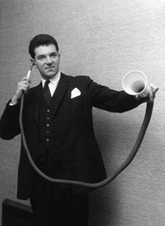
Although there are no recorded dates, it is thought that ear horns have existed in every civilization for thousands of years since humans first created carved objects. Made from materials like wood, metal and horn, quite simply these early hearing aids were wide at one end to collect sound waves and narrow at the other end to funnel amplified sound into the ear
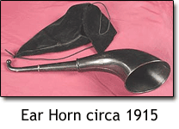
The 1st hearing aid

The ear trumpet hearing aid:
This was a metal version of the ear horn.
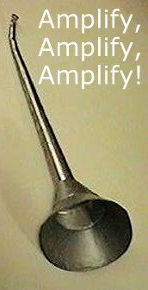
The only real difference was the improved industry which made them.
Ear trumpets could be produced in a range of styles, shapes and sizes to suit the preferences of the customer, and the varied extent of their hearing loss.
These hearing aids were being used by many people from the 1700s onwards, including Beethoven
Ear trumpets were probably early man's first attempt at coping with hearing problems. In pre-historic times, hearing trumpets were simply hollowed-out horns of cows, rams or other animals. Later versions in wood and metal followed the same general contours as the natural horns
In later centuries, man continued to refine trumpets, experimenting with the acoustical properties of such materials as silver, shell, horn, artificial tortoise shell, and most recently, plastic.
The hearing trumpets shown here all date from the Eighteenth and Nineteenth Centuries. In this period, it was common to fashion hearing trumpets from metal covered with vulcanite (hard rubber), or from brass, and them paint them black. In either case, it was hoped that the black finish would make the hearing trumpet less conspicuous against dark clothing worn by the user
The first hearing aid was the simple ear trumpet. While it has likely been a part of history since the beginning of time, its first recorded use was in the 1700s. This hearing aid was large, looked like a trumpet, and had to be held up to the ear>
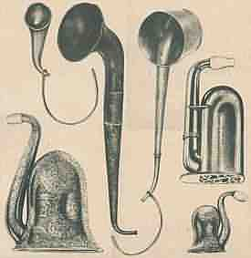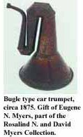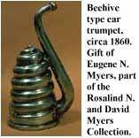

Speaking tubes:
all operate on a common principle - they pick up sound close to its source and direct it via a narrow pathway, usually a flexible tube, to the ear.
In operation, the speaker talks directly into a funnel at one end of the tube and the listener holds the small tip at the other end in his ear.
In the 17th Century, speaking tubes were adapted to a very special sort of hearing problem by Puritan couples who were courting.
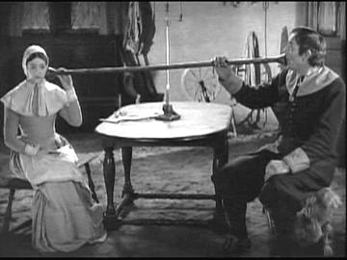
Custom of the time required the two to sit across a table from each other, and speaking tubes were used to ensure the privacy of their conversations.
Cup Anatomicals, used to slightly enlarge the sound-collecting area of the ear, may also have been worn by persons suffering from collapse of the entrance to the external auditory canal.
Ear wells in a case evidently served the same function as Cup Anatomicals and closely resemble the ear specula used in examining the ear canal and tympanic membrane.

The Nineteenth Century and hearing aids
Pre-Electric Horns, Trumpets, etc. (1800s)
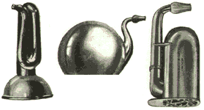
The earliest appearance of these is unknown, but they became very popular in the 1800's and a few are made in Europe to this day.
Next was the Clarvox Lorgnette Trumpet in the early 1800s. The trumpet came with a pair of glasses attached. While this hearing aid was still rather large, it was meant to be less conspicuous than the previous trumpet.

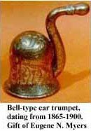
The 1850s brought about the London Dome. This was smaller than the trumpet, and also more detailed. It came in different sizes. Someone who had very bad hearing would get a larger dome than someone who only had mild hearing loss.

In 1887, the ear tube came along. This hearing device was quite different than any other hearing aid. The person with hearing loss put one end in their ear, and the speaker spoke in the other end.

Nineteenth Century & concealed hearing aids
With increasing concern over how hearing aids were being perceived in public, the 1800s saw a large increase in the amount of hearing aids which could be concealed, hidden or simply made less obvious, and more decorative as well as functional.
This may have helped people with a hearing loss to wear hearing aids in public, since they were often crafted artistically to look more socially acceptable and fashionable. Some were even covered in flesh-tone enamel for added concealment, or matched to the hair color of the wearer.
Hiding hearing devices by disguising them as everyday items became almost an art form."Sensitive persons, particularly ladies, have an aversion to advertising their affliction in public by the use of many of the usual forms of hearing instruments. To meet this very natural objection, such instruments have been ingeniously combined with fans, parasols, umbrellas, muffs, handbags or reticules, bouquet holders, opera glasses, and more. Other instruments are attached to the head and ears, and may be concealed by the cap, hat, bonnet or hair. For gentlemen, walking sticks and umbrellas of various sizes have powerful sound collectors fitted to them; also dinner plate holders and field glasses and the inside of the ordinary silk hat," reported the Hawksley Catalogue of Otacoustical Instruments to Aid the Deaf in 1895.

The acoustic throne and acoustic chair hearing aids
Acoustic thrones of various types were popular with many European royal families during the 18th and 19th centuries
For the royalty of Europe however, walking around in their finest robes and dresses with an ear horn or trumpet against their ears seemed to be getting more laughs from their loyal subjects than loving admiration. It simply wasn’t kingly or queenly to have a servant stood only two feet away shouting down a horn in to the royal ear.
The ear horn was for commoners, and some monarchs with hearing loss preferred to receive visitors while seated on specially-made hearing aid thrones.
These adapted seats included built-in tubes which would collect the sound of a voice several feet away and channel it up in to an echo chamber inside the throne, which would amplify the sound coming out of the seat around the monarch’s head. The throne was even mobile, so that wherever the monarch went they could hear the voices of subjects without them having to get too close.
Ear trumpets were incorporated into the designs of acoustic chairs.
Some horns were hidden; other chairs used the armrests to gather sound and convey it by tube. For instance the throne which was made for King Goa VI of Portugal by the firm F.C. Rein & Son in 1819.
One such was designed by F.C. Rein for King John VI (aka, King Goa VI) of Portugal. The armrests were hollowed out and carved in the shape of lions' heads , courtiers would kneel and speak into the mouthpieces formed by the openings in the arms.
Those visiting the king were required to kneel before him so they spoke into the heads. Sound was then carried by a tube in the back of the chair.
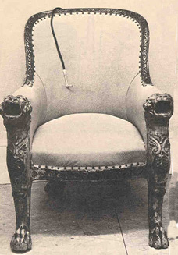
Resonators were concealed inside, and sound was conveyed from the arms to an earpiece which was fitted on the end of a tube.
Acoustic Chairs were a clever example of incorporating a hearing device within an everyday object.
Perhaps the most ingenious design of an acoustic throne was created by F. C. Rein for King John VI of Portugal
Today, King Goa's throne is in the Amplivox Museum in London.

Today, having a hearing problem is usually accepted by society without thinking less of the individual. But in times past, this was not always true. "The deaf are, as a general rule, very sensitive over their infirmity, and hence dislike any instrument which is conspicuous, or makes this condition more apparent; for this reason many other devices have been invented, which seek to conceal this fact, as much as possible." wrote Dr. James A. Campbell in 1882.
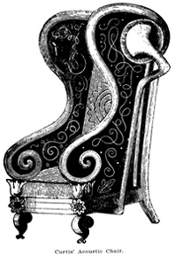
An acoustical chair
manufactured by Curtis.
Hearing devices were also disguised to be hidden under beards, in tabletop vases, as canteens, walking canes, in a long handle for opera glasses, as headbands hidden under hats, scarves, and wigs and as jewelry.
Fortunately, with the progress of technology and with the acceptance of the loss of hearing, elaborate hiding places for hearing aids were no longer needed.
Other types of Hidden Hearing Aids
Here are several forms of hidden hearing aids were commonly used in nineteenth century
Auricles
Among the first types of concealed hearing aid, auricles were composed of a small metal sound collector shaped like a trumpet, shell or flower attached to a thin metal headband. They were hands-free and could be concealed to an extent in the hairline. Or in the case of flower-shaped auricles, made to look like decoration rather than a hearing aid.
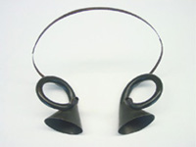
Acoustic Fan hearing aids
Popular with women in the nineteenth century, these thin metal fans collected sound when held behind the ear, and funneled it in to an attached hearing aid earpiece or small ear trumpet. These instruments could help hearing to a certain extent, but their main benefit was discreetly telling people you had a hearing loss, so that they would know to speak more loudly. There were also fans which used the process of bone conduction.
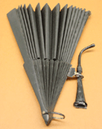
An acoustical fan with an attached ear horn
Bone conduction hearing aids
The effect of bone conduction happens when sound waves are collected in a device and transferred to the ear as vibrations in the bones or teeth. Although it was written about in the 1500s, it wasn’t used to help hearing loss until the 1600s. By the Victorian era it was used in hearing aids like audiphones.
The Audiphone hearing aid
This bone conduction hearing aid fan was patented in 1879. The user would grip the end of the fan between their teeth, so that sound vibrations collected by the thin body of the fan would be transmitted through the teeth and skull, and in to the inner ear.
They may seem like a strange idea, but some bone conduction devices like the audiphones could improve hearing by as much as thirty decibels and the method is still used today with items like bone-conduction phone receivers. Then as now however, the vast majority of hearing aid devices remained air-conduction instruments, collecting sound vibrations from the air.
The Beard Receptacle hearing aid
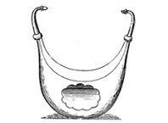
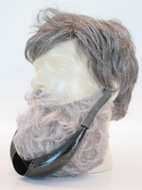
This hearing aid was designed to be concealed within the large beard of the wearer. The curved body of the hearing aid collected sound, and funneled it up in to a pair of earpieces. It was recommended that the user should wear a scarf to help keep the hearing aid secure, and to conceal it further.

The Hair Receptor hearing aid
The hair receptor hearing aid was shaped like a wide headset, covered with silk and flat enough to be concealed beneath a woman’s bouffant hairstyle.
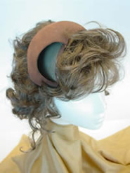
This hearing aid is prime example of the growing desire in the Victorian era to hide hearing aids as cleverly and effectively as possible to avoid them being seen.
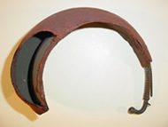
Acoustic Table Urn & Vase Receptacle hearing aids
Made from the early 1800s onwards, these table-top hearing aids were designed to collect multiple sounds from different directions and funnel them in to a hearing tube. These hearing aids were designed for use during conversation around the table, but were also designed to hold flowers or fruit in order to be concealed, and to appear more as table decoration.
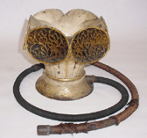 A hearing aid disguised as a vase

Acoustic Cane, Umbrella and Parasol hearing aids
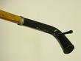
These hearing aids were disguised in handles, where sound was collected in the tip of the hollow handle and funneled in to an ear piece coming from the handle base. The handle would be rested upon the shoulder so that the earpiece could swivel out to be fitted in the ear during conversation.
Opera Glasses & Lorgnettes hearing aids
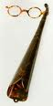
These devices combined hearing aid with optical aid, ideally for use in the opera house when seeing and hearing a distant performer was a struggle, especially for those with a hearing loss. Some ‘opera glass lorgnettes’ were even designed with the hearing trumpet section disguised as the handle of the eyepiece.
Opera Dome hearing aids
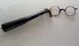
Known as Opera Domes because of their popularity with patrons of the theatre, these cup-shaped hearing aid trumpets were used in exactly the same way, but came in a wide range of shapes, styles and sizes to suit the tastes and hearing loss of the individual user.

Mourning Trumpet hearing aids
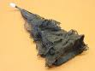
Attitudes in the Victorian era placed a lot of emphasis on mourning the death of a loved one, and even Opera Dome hearing aids came suitably disguised in black fabric, lace and ribbon to match the black mourning clothes of the owner.

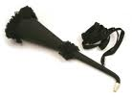
Tapered cone hearing aids
Designed especially for ladies’ use, these slender and more feminine versions of the ear trumpet hearing aid were covered in silk, lace and ribbon for concealment, and were often attached to a dress or tied around the neck with a silk cord. 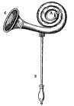
Artificial Concha hearing aids
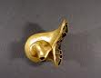
This more compact and ornate design of hearing aid was one of the first to be moulded to the ear of the user, and specially designed to complement the wearer’s jeweler and hairstyle. With the decorative appearance of an ornate shell, it acted to collect and funnel sound in to the inner ear. It was self-retaining, so that nothing was needed to hold it in place, and its smaller size was normally well suited to people with mild hearing loss.

Bouquet Holder hearing aids
A hearing aid composed of a palm-sized metal dome and rubber hearing tube. The dome could be worn on a dress and concealed by fabric, while also holding several flowers to act as an ‘acoustic ornament’.
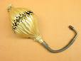
Acoustic Hat hearing aids
For men who preferred not to carry a small bouquet around on their front, the acoustic hat was a clever way of hiding an ear trumpet hearing aid. The sound was collected in the main body of the hat above the head, while a discreet listening tube would be the only thing seen on the outside.
The Magneto-Telephone hearing aid
This type of hearing aid was designed to use a transmitter disguised as a badge to be worn on the jacket or in the breast pocket. Although in 1892 it was the earliest electric hearing aid to be patented, this type was never actually made.

Bone conduction fans, or as one brand was named, the "Dentaphone," transmitted sound through the skull or teeth. It was a flat paddle fitted with a diaphragm. Sound was transmitted through a wooden piece gripped in the teeth.
The Dentaphone, used in the later part of the 19th Century, consisted of a round case with a thin diaphragm in the center. This was connected to a small piece of wood via a silk covered wire. When the wood piece was held between the teeth and the wire stretched taught, sound vibrations picked up by the diaphragm would pass to the user's teeth, and from there by bone conduction to the inner ear.

Did Alexander Graham Bell play a role in the invention of the electric hearing aid?
Alexander Graham Bell (1847-1922) was much concerned about deafness through most of his career. In 1872, Bell opened a school for teachers of the deaf in Boston and later founded the American Association to Promote the Teaching of Speech to the Deaf. Historians have noted that Bell attempted to invent an electrical hearing aid. They speculate that his wife, Mabel Hubbard, who was deaf since the age of four, was his inspiration. Although Bell's experiments did not produce the first electric hearing aid, they did lead him to his invention of the telephone. Unlike electric hearing aids, early telephones worked on magnetic principles and did not use a carbon transmitter.
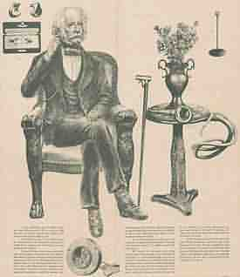

The Tewntieth Century and Electrical Hearing Aids
The final years of the nineteenth century gave birth to the idea of electrically-powered hearing aid instruments, and in 1899 the first electrically-powered hearing aids could be bought for about $400. Most people could never afford one on an average wage of a few dollars per week, but it would only be a matter of time before the technology would become much more effective, and much more affordable. The basic components were there; a battery box, earpiece and microphone, which at the time was made of carbon dust but would later be refined.
Electronic Hearing Aids - Carbon (1899-1940s)
These are based on the telephone principle but Alexander Graham Bell had nothing to do directly with their development. These appeared first in limited quantities in a table model about 1899, but in wearable and practical instruments began to be available only in 1902.Carbon aids were popular through the 1940's. Most of these used a rather large 3-volt or 6-volt battery but did not have enough power to assist those with more than a moderate hearing loss.
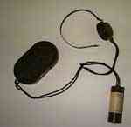
Carbon Hearing Aid
Electronic Hearing Aids - Vacuum Tube (1920s-1930s)
Unlike the carbon instruments, these had adequate power for severe hearing losses but were also usable by persons with a lesser loss. The first one appeared in 1921, but this type did not become practical until the early 1930's, and did not appear in a wearable version until 1936. Vacuum tube aids required two batteries, so costs were rather high.
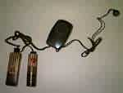
Vacuum Tube
Transistor Hearing Aids (1952, 53)
These can also be properly called electronic hearing aids. They appeared in a few models in late 1952 and virtually replaced vacuum tube hearing aids by the end of 1953. Transistors need only one battery and the reduced size permitted development of a number of types of hearing aids:
- The body aid, or pocket aid, continued to be popular, especially for those with severe loss, and could now be made smaller than vacuum tube versions.
- Eyeglass hearing aids attained considerable popularity, particularly after Eleanor Roosevelt allowed her name and photograph to be used wearing one.
Hearing aid glasses:The development of the transistor in the late 1940s enabled once-cumbersome hearing aids to be streamlined into single units practical for everyday use. What could be more practical than incorporating a hearing aid – or two – into eyeglasses? The first eyeglass model was introduced in the United States in 1954. By 1959, they accounted for approximately 50% of the market.
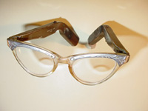
They had disadvantages such as thicker frames, especially with the early generation ones, and the fact that you automatically took your hearing aids off when you removed your glasses.
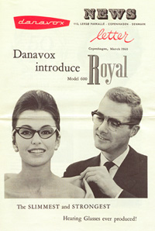
With smaller and smaller BTE and ITE hearing aids becoming more popular, the eyeglass-style eventually lost favor with the hard of hearing consumer.
- Behind-the-ear(BTE), or over-the-ear(ITE) models were a huge improvement in cosmetic appeal and are still the aid of choice for those with severe to profound loss
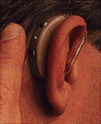
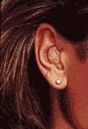
- In-the-ear models come in several versions: stock or non-custom models, custom concha models, half shell models, and canal aids. The most recent development is the completely-in-the-canal aids. Today, body and eyeglass aids account for less than 1% of hearing aid sales in the United States.
BTE | ITE
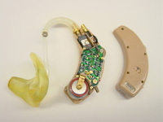
Internal workings of an analogue BTE hearing aid

Hybrid Hearing Aids (1977)
Hybrid hearing aids use a combined digital/analog circuitry. The first patent for hybrid technology was received in 1977 and the first commercial release of a digital chip to be integrated in an analog hearing aid occurred in 1986. These hearing aids have greatly increased our flexibility in fitting the hearing-impaired population.
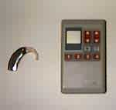
Hybrid Hearing Instrument
Digital Hearing Aids (1984-88, 1996-2000)
Digital hearing aids utilize digital signal processing (DSP) chips which became available in 1982. Experimental body-worn digital hearing aids were developed soon after. Project Phoenix was established in 1984 and commercially produced the first wearable DSP hearing aid in 1988. Unfortunately, it was large (the combined size of a body aid and a behind-the-ear aid) and expensive and thus not a financial success. As recently as April 1996, the first fully digital behind-the-ear and in-the-ear instruments were made commercially available with a computing capacity of 40 million instructions per second. The current era of DSP hearing aids holds promise for maximum flexibility in fulfilling the unique needs of the hearing impaired population.
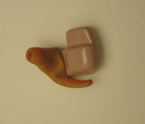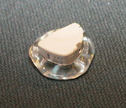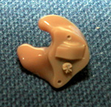
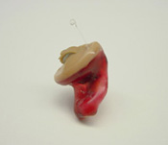
In the ear aids
2000 - 2010: Feedback elimination, memory settings and listening preference
With hearing aid hardware capable of being tucked away almost invisibly in to the ear canal , attention was turned to perfecting the software which was available to create a digitally-enhanced hearing experience. Improved software reduced feedback which had plagued older models. Preferred settings and removable memory devices meant that a hearing aid could perform specifically to the user’s tastes and needs without having to be manually readjusted.

2010: Patient Input, Fuzzy Logic and ADRO
Modern hearing aids are fitted with the patient’s specific tastes and hearing needs as the basis for hearing loss treatment. Improved hearing check techniques and customization processes can create hearing aids specifically moulded to fit the shape of an individual ear for complete comfort. Hearing testing can be carried out that will narrow down the range of sounds the patient struggles to hear, and to make changes to the hearing aid software that will pick up the sounds they most want to hear.

Fuzzy logic refers to the digital software used in modern hearing aids that decides which settings to use at any one time. This modern software is capable of dealing with unclear or ‘fuzzy’ decisions, rather than simply yes/no decisions, so that a range of presets such as volume level, background noise cut-out, feedback elimination and directional sound pickup can be juggled and changed constantly. The result is a hearing experience that is closer than ever to matching natural hearing as a fluid, seamless experience.
Adaptive Dynamic Range Optimization, or ADRO, is the type of software that allows this fuzzy logic to work. It means that the modern digital hearing aid adjusts itself from second to second in order to pick up sound signals which will be most desired and most useful to the wearer at any one time.
Summary
From their size to their shape to the way in which they function, the hearing aid technology that is used today is far different from what hearing aids used 100, 50, or even five years ago.
The history of hearing aids is far reaching and colorful--the earliest hearing aids worked without electricity, while the earliest electric models were simply too large to be portable.
Today, digital hearing aids are discrete, lightweight, and have the capability to be adjusted for different environments and to amplify sound without distortion, And the future holds many exciting improvements to hearing aid technology as a whole.
But it's important to review the history of hearing aids in order to understand just where the industry is headed.

References
Books and Essaya:
- LEE .K.J, 2003- Essential Otolaryngology Head & Neck Surgery. 8th edition , Mc Graw-Hill , U.S.A , 1136 pages.
- Pasha.R, 2001- Otolaryngology Head & Neck Surgery. Singular , Pakistan, 675 Pages.
- Deafness in Disguise: Concealed Hearing Devices of the 19th and 20th Centuries, Washington University School of Medicine, St. Louis, Missouri, Published by the Bernard Becker Medical Library.

Web Sites:
- http://www.articlesnatch.com
- http://www.hearingcenteronline.com/
- http://www.hearingaidsear.com/index.php/index.php
- http://www.seniorlvgmag.com/advertising.html
- http://www.roger-russell.com/sonopg/sonopg.htm
- http://deafness.about.com/od/newtodeafness/u/dailylife.htm
- http://www.zoundshearing.com/
- http://www.webmd.com/community/
- http://www.freehearingtest.com/har-types.shtml
- http://www.listentometoday.com/blog/?p=53
- http://www.svwsticker.com/
- http://www.hearingaidscritic.com/
- http://www.macromedia.com
- http://www.hearingaidmuseum.com
- http://www.sooperarticles.com/pdf/the-history-of-hearing-aids-an-introduction-64282.pdf
- http://www.ascenthearing.co.uk/contact_us/email/index.html
- http://www.hearingaidreport.com
- http://health.howstuffworks.com/hearing-aid6.htm
- http://hearing-aids.americahears.com/aid-technology.html
- http://ehhs.kent.edu/spa/museum.cfm
- http://images.google.co.uk
- http://www.buzzle.com/articles/hearing-aids/

* Chairman, History of Medicine Department, Institute for the History of Arabic Science, Aleppo University, Aleppo-Syria The President of ISHIM (www.ishim.net) P.O. Box: 7581, Aleppo, Syria e-mail: a.kaadan@scs-net.org Phone 963 944 300030, Fax 963 21 2236526 ** Master stage student, Institute for the History of Arabic Science, Aleppo University
*
* أستاذ ورئيس قسم تاريخ الطب - معهد التراث العلمي العربي – جامعة حلب. دكتوراه في تاريخ الطب العربي الإسلامي – طبيب اختصاصي في جراحة العظام. هاتف 300030 944 963 ، بريد إلكتروني: a.kaadan@scs-net.org
* * طالب ماجستير في معهد التراث العلمي العربي – جامعة حلب.

