Blood Transfusion in History
Abdul Nasser Kaadan MD, PhD*, Mahmud Angrini MD**

* Chairman, History of Medicine Department, Aleppo University, Aleppo-Syria.

The President of ISHIM (www.ishim.net).

E-mail: a.kaadan@scs-net.org

** Master Student, History of Medicine Department, Aleppo University, Aleppo-Syria. Master Degree in Laboratory Medicine.
E-mail: dr-ma@aloola.sy

------------------------------------- Summary -----------------------------------
The transfusion time line highlights many of the discoveries, inventions, observations, and practices, which, since ancient times, have led to a remarkable progress and resulted in the effective treatments that are now taken for granted.
The recent practice of transfusion isn’t the result of one man’s effort; but, it is the glamorous consequence of many inventors and physicians of deferent eras and regions.
In our treatise, we tried to shed light on the most important events in the history of blood transfusion epic. We tried to follow the steps in the development of blood transfusion, from the ancient and medieval eras to the modern era. We conventionally divided the history of transfusion in the modern era to seven periods, according to the main concern of every period.
Although the major developments of blood transfusion were in the last sixty years, we can’t ignore the contributions of the Ancient physicians who created the dream that has recently become true.

Keywords: Transfusion, Blood Bank, History of Medicine, Richard Lower, James Blundell, Karl Landsteiner.

Introduction
Man must have recognized that loss of blood was frequently associated with weakness and death. This was manifested by Greeks and Romans committing suicide by cutting their wrists. Blood was recognized as having numerous mysterious properties, including initially that of carrying both the mental and physical characters of its owner. Early attempts at replacing lost blood involved the drinking of blood by the patient.
The practicality of transfusion has, to some degree, paralleled and in some instances been the consequence of, developments in other sciences. The idea though of the theoretical beneficial effects of blood transfusion has been recognized for over three centuries. This older history is based on the traditional idea of blood as being the ‘living-force’ of the body.
Blood Transfusion in the Ancient and Medieval Eras
One of the first writings relating to a ‘transfusion’ is contained in the seventh book of the epic poem Metamorphoses, which was written in 43 BC by the Roman poet Ovid.
The Arabic physicians practiced venesection, cupping and blood leech in order to treat diseases.
The famous physician Al-Zahrawi - Albucasis (936-1013 AD), in the thirty Essay of his best work “Kitab al-Tasrif”, described the method and indications of venesection and drew pictures of the Scalpels that he designed and used in venesection.
Blood Transfusion in the Modern Era
It is conventionally divided into seven periods.
- First Thoughts of Blood Transfusion
One of the most frequently quoted candidates for this noteworthy honor is Pope Innocent VIII (1432-1492), Giovanni Cibo, who was reputedly ‘transfused’ sometime between 1490 and 1492.
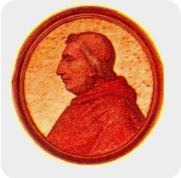
Pasquale Villari (1827-1917), the Italian historian, claimed that the Pope had some sort of illness (in the light of present knowledge, this was probably chronic renal disease), that rendered him semi-comatose. All three boys, who were selected as donors, apparently died shortly after the procedure, possibly as a result of air embolism, but there was no change to the Pope's condition.
Andreas Libavius (1555-1616) imagined how blood was taken from the artery of one young man and infused into the artery of another old man. He described blood transfusion accurately and vividly enough, but he never transfused anyone.
Pope Innocent VIII
- Blood Transfusion from an Animal to an Animal
Francis Potter (1594-1678) is thought by some to possibly be the first person to conceive of transfusion on a practical basis. In 1649 he attempted the procedure of transfusion between two chickens, though it is likely that because of the size of such birds, it probably proved unsuccessful.
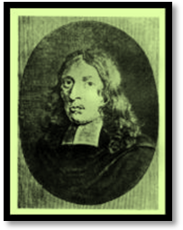
The ‘established’ priority claim however for proposing and demonstrating the intravenous administration of medications (into the veins of dogs) is made by the British Dr (later to become Sir) Christopher Wren (1632-1723) who developed in 1656 an animal bladder attached to two quills 'needles' for this purpose.
Richard Lower (1631-1691) was the first person to give a blood transfusion to animals successfully. He did this, early in February of 1665, when he bled one dog almost to the point of death. Then he tied the artery, and transfused this dying dog from a larger dog-a mastiff-and revived the bled dog. He successfully did this three times.
Richard Lower
- Blood Transfusion from an Animal to a Man
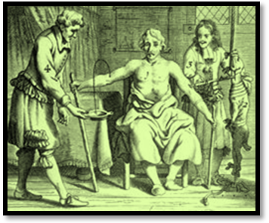
In England 1666, Richard Lower, assisted by Dr Edmund King, transfused a 32 old man named Arthur Coga to improve his mind. Lower described the quills and silver pipes used to carry the blood between the carotid artery of the donor sheep and a vein of the recipient’s arm.
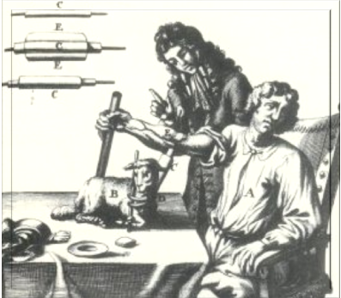
Dr Jean-Baptiste Denys (1640-1704), a young French physician, read of Lower's experiments in the Journal des Savants. In 1667, Denys was asked to treat a 15-year-old boy, who had suffered from a fever for many months. Accordingly he was bled to the extent of about three ounces and received in exchange nine ounces of blood from the carotid artery of a lamb. The boy had survived but he suffered a present-day indication of an incompatible transfusion reaction. Denys’ second transfusion was performed on a 45-year-old man using a reported 20 ounces of lambs' blood and described the man as feeling stronger than before the transfusion. Following the transfusion of at least four individuals, Denys and his associate performed a further transfusion in 1668 to a 34-year-old mad man, called Antoine Mauroy. Denys removed ten ounces of blood from the vein of his right arm, and replaced them with five or six ounces of blood from a calf.
Richard Lower and Edmund King
Transfused Arthur Coga in 1666
Two days later, the man was transfused a second time. This resulted in what is now recognized as a hemolytic transfusion response. Mauroy died the following evening. Mauroy's widow accused Denys and Emmerez of contributing to the death of her husband by the transfusion. Consequently, in 1678, an edict from the French parliament ruled transfusion to be criminal act if performed in France. This had repercussions in London where the Royal Society rapidly washed its hands of transfusion as well. Finally, in 1679 the Pope joined the general outcry and also announced a ban on the procedure. As a result, the practice fell into general disrepute for more than a century and a half.
Dr Jean-Baptiste Denys Transfused
Antoine Mauroy

- Blood Transfusion from a Man to a Man
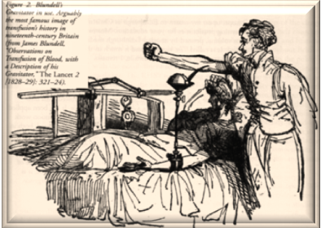
James Blundell (1790-1877) had placed transfusion on a scientific basis and re-awakened interest in its use and he was also the first to transfuse human blood. Blundell initially advocated direct transfusion. He described transfusion by syringe in several papers, noting the necessity of removing air from the instrument before transfusion, as well as experiencing the problems of blood clotting. In 1818, Blundell, with the help of the surgeon Henry Crine Noyes, his niece’s husband, transfused a 35-year-old man with what would now be called gastric carcinoma. Approximately 14 ounces of blood were administered by syringe in small amounts, from several donors, at intervals of 5-6 minutes. Despite temporary improvement in his condition, the patient died 56 hours later. His disease was incurable and nothing could really have been expected from the transfusion. Blundell then invented a rather strange instrument called an ‘impellor’,
Blundell Performed the First Human to Human
Successful Transfusion in 1828 using his Gravitator
which was essentially a funnel and pump combined; a diagram of which appeared in his book, published in 1824.
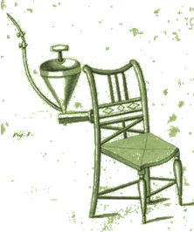
Later, Blundell invented another instrument, the ‘Gravitator’. He used his Gravitator in 1828 to make his first successful transfusion for a woman. She recovered from severe post-partum hemorrhage after receiving eight ounces of blood from Blundell's assistant during the course of three hours. This case was published in journal ‘The Lancet’ in 1829.
Blundell also actively encouraged his contemporaries to practice transfusion. For the most part, these were obstetricians who used the procedure in cases of postpartum hemorrhage.
The Impellor of Blundell
Fixed to a Chair
- Establishing Transfusion Procedures
It is obvious that one of the first problems that had to be solved before blood transfusion could be placed on a practical footing was the prevention of blood coagulation. One of the first people to use an ‘anticoagulant’ additive was J. Neudorfer, who in 1860 recommended the addition of sodium bicarbonate as an anticoagulant.
Defibrillated blood was used by Sir Thomas Smith (1809-1881) who, in 1873, used the procedure in St Bartholomew’s Hospital for in the first reported case of a transfusion to an infant (who was suffering from Hemolytic Disease of the Newborn).
During the final quarter of the 19th Century, frustration and discouragement with blood as a transfusion product resulted in a brief period of enthusiasm for the transfusion of milk, which was thought of as a ‘blood substitute’. The most outspoken advocate of milk transfusions was T.G. Thomas, who was an American physician discouraged by the use of blood because of its "tendency to coagulation". However, by 1880 increasing numbers of adverse reactions associated with the administration of milk, besides the introduction, between 1875-1880, of physiological saline solution for infusion use, with its associated convenience and lack of danger to the recipient, led to milk's general abandonment.
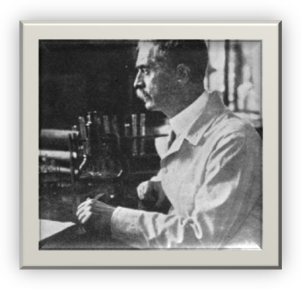
The discovery (in 1900) of the human ABO blood groups by Dr Karl Landsteiner (1868-1943) in Vienna was the major step in understanding that these reactions were in fact due to what is now known to be blood group incompatibility (probably associated with intravascular hemolysis). From these early experiments he identified three groups, called A, B and C (C was later to be re-named O). The forth much rarer blood group AB, was discovered a year later. He was awarded Nobel Prize in Physiology or Medicine in 1930.
Karl Landsteiner (1868-1943)
At Mount Sinai Hospital in New York, American Doctor Reuben Ottenberg (1882-1959) performs the first transfusion using cross matching, and over the next several years successfully uses the procedure in 128 cases, virtually eliminating transfusion reactions.
- The Impact of War
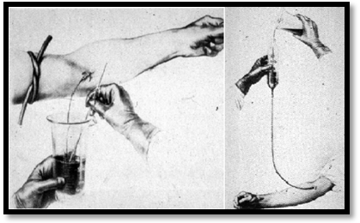
War was not an incidental factor to the developments in blood transfusion, as it created unprecedented demand for the life-saving fluid. In 1914, almost simultaneously, researchers Albert Hustin of Brussels and Luis Agote of Buenos Aires discover that adding sodium citrate to blood will prevent it from clotting. In 1915, the American physician Richard Lewisohn (1875- 1961), at New York's Mount Sinai Hospital, formulates the optimum concentration of sodium citrate that can be mixed with donor blood to prevent coagulation, but pose no danger to the recipient.
Richard Lewisohn’s Method in performing blood Transfusion
At the beginning of World War II, it had become the exclusive method of blood transfusion used in surgery and medicine.
Dr. Richard Weil determines that citrated blood can be refrigerated and stored for a few days and then successfully transfused.
In 1916, At the Rockefeller Institute in New York, Francis Peyton Rous and J.R. Turner used a glucose additive as a red cell energy supplement to improve red cell preservation. Thus, they develop a citrate-glucose solution that allows blood to be stored for a few weeks after collection and still remain viable for transfusion.
The voluntary blood donor scheme was pioneered in London in 1921 by the British librarian Percy Lane Oliver (1878-1944) following a request of the Red Cross service to provide two blood donors at short notice. Oliver's work attracted attention worldwide. The development of electrical refrigeration resulted shortly after in the first ‘blood bank’ being set up in Barcelona in 1936.
The idea of stored blood was originally used by the Canadian doctor Henry Norman Bethune (1890-1939). He set up a mobile blood-transfusion service to rush bottled blood in refrigerated trucks to the wounded at the front in the Spanish Civil War.
Bernard Fantus (1874-1940), at Chicago’s Cook County Hospital, established the first blood bank in the United Stated in 1937. Thus, he invented the name “blood bank”.
Dr Philip Levine (1900-1987) co-discoverer with Karl Landsteiner and Alexander Wiener (1907-1976)⁵² the ‘Rhesus’ (now termed Rh) blood group system factors, associated with the potentially fatal condition of Hemolytic Disease of the Newborn.
In 1943, acid-citrate-dextrose (ACD) anticoagulant preservative solution, was developed for the storage of blood by Australian doctor John Loutit and British Professor Patrick Mollison (1914-2003), which extended the vitality of blood units to 21 days.
Plasma fractionation was developed by Edwin Cohn (1892-1953) in 1944.
In 1945, the British Professor Robin Coombs (1921-2006) described anti-globulin testing, which is nowadays referred to as “Coombs Test”. This test has formed the base of a large number of laboratory investigations in the fields of hematology and immunology.
- Blood Transfusion in The Last Sixty Years
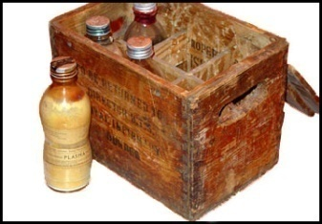
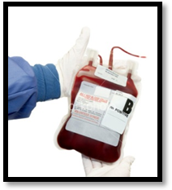
Most of the important developments in transfusion medicine have only been achieved in last sixty years. Blood was collected into reusable glass bottles in the first half of the twentieth century.
Reusable Glass Bottles
In 1949, trials of plastic bags were conducted by the American Red Cross. Plastic bags were disposable and, because of their flexibility, facilitated the separation of blood components.
Current Plastic Bags
ACD preservative solution was supplanted in 1957 by citrate phosphate dextrose (CPD), which extended the vitality of blood units to 28 days. CPDA-1 was developed in 1979 and extended the shelf time of blood units to 35 days. CPDA-2 (Citrate Phosphate Dextrose Adenine) was developed in the 1980s. It extended the shelf time of blood units to 42 days.
Dr. Judith Graham Pool (1919-1975) was an American physiologist at Stanford University. She is best known for the discovery of cryoprecipitation in 1965.
In 1969, S. Murphy and F. Gardner demonstrate the feasibility of storing Platelets at room temperature, revolutionizing platelet transfusion therapy.
In the late 1990s, there was a transition in terminology from Blood Banking to Transfusion Medicine.
From 1987 to 2008, a series of more sensitive tests are developed and implemented to screen donated blood for infectious diseases.
References
Books and Essays
- Bauer A.W., 2004- From Blood Transfusion to Haemotherapy – the Anniversary of the German Society for Transfusion Medicine and Immunology (DGTI) from a Medicinal-Historical and Bioethical Perspective. Transfuse Med Hemother; 31:1-6
- Brailey L. L., 2000- Transfusion Medicine: A History. www.med.unc.edu/wrkunits/syllabus/yr4/gen/medhist/publish/bloodtrans.ppt
- Kaadan, A. N., 1999- The Surgery of al-Zahrawi. Dar al-Qalam al-Arabi, Aleppo- Syria; 357 pages.
- Keynes G., 1992- Blood Transfusion. Oxford Medical Publication, London-UK; 166 Pages.
- Learoyd P., 2006- A Short History of Blood Transfusion. NBS–Scientific & Technical Training (STT)-042; 18 Pages.
- Sturgis C.C., 1942- The History of Blood Transfusion. Bull Med Libr Assoc; 30(2): 105–112.
- Zallen D.T., Christie D. A., and Tansey E.M., 2004- The Rhesus Factor and Disease Prevention, Wellcome Trust Centre for the History of Medicine at UCL, London-England; Volume 22, 100 pages.
Web Sites
- http://www.abcb.com/laws/index.htm
- http://artscad.com/A.nsf/Opra/SRVV-6MDNX5
- http://www.bmj.com/cgi/content/full/325/7378/1485
- http://brunelleschi.imss.fi.it/museum/esim.asp?c=23257
- www.dvd4arab.com/showthread.php?t=104664
- http://en.wikipedia.org/wiki/Albert_Roussel
- http://en.wikipedia.org/wiki/Bernard_Fantus
- http://en.wikipedia.org/wiki/Blood
- http://en.wikipedia.org/wiki/Blood_libel
- http://en.wikipedia.org/wiki/Blood_transfusion
- http://en.wikipedia.org/wiki/Charles-Ãdouard_Brown-SÃ©quard
- http://en.wikipedia.org/wiki/Christopher_Wren
- http://en.wikipedia.org/wiki/Erasistratus
- http://en.wikipedia.org/wiki/James_Blundell_(physician)
- http://en.wikipedia.org/wiki/Jean-Baptiste_Denys
- http://en.wikipedia.org/wiki/John_Aubrey
- http://en.wikipedia.org/wiki/John_Braxton_Hicks
- http://en.wikipedia.org/wiki/Metamorphoses
- http://en.wikipedia.org/wiki/Pope_Innocent_VIII
- http://en.wikipedia.org/wiki/Richard_Lower_(physician)
- http://en.wikipedia.org/wiki/Robert_Boyle
- http://en.wikipedia.org/wiki/Robin_Coombs
- http://www.pbs.org/wnet/redgold/history/timeline1.html
- http://www.pbs.org/wnet/redgold/history/timeline2.html
- http://www.pbs.org/wnet/redgold/history/timeline3.html
- http://www.pbs.org/wnet/redgold/history/timeline4.html
- http://www.pbs.org/wnet/redgold/history/timeline5.html
- http://www.pbs.org/wnet/redgold/innovators/bio_Bethune.html
- http://www.pbs.org/wnet/redgold/innovators/bio_cohn.html
- http://www.pbs.org/wnet/redgold/innovators/bio_drew.html
- http://www.pbs.org/wnet/redgold/innovators/bio_fantus.html
- http://www.pbs.org/wnet/redgold/innovators/bio_Lewisohn.html
- http://www.pbs.org/wnet/redgold/innovators/bio_ottenberg.html
- http://www.pbs.org/wnet/redgold/innovators/bio_Oliver.html
- http://www.pbs.org/wnet/redgold/innovators/bio_Robertson.html
- http://www.psri.net/bloodbank/highlights.html
- http://www.scienceclarified.com/Al-As/Anatomy.html
- http://www.watchtower.org/e/20000108/article_03.htm

