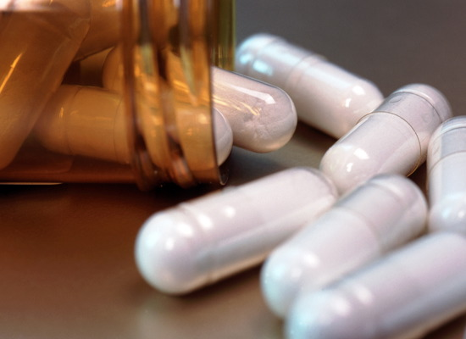
By
Abdul Nasser Kaadan, MD, PhD*
Osama Klef**

Contents

Page
Introduction 3
Chapter One: Earliest uses of antibiotic 4

Chapter Two: antibiotics in Arab history 6

Chapter Three The 19-th and early 20-th centuries 7
I- Antibiotics developed in this period 7
II- Development of penicillin as an antibiotic 9
- Who is Alexander Fleming 9
- Man to know 12
Chapter four : other antibacterial drugs 15
Chapter fife : antifungal agents 23
Chapter six : antiviral drug 25
Abstract 35
References: 36

Keyword Antibacterial*: Working against bacteria either by destroying it or keeping it from multiplying.
Antibiotic resistance: The ability of bacteria to resist the actions of antibiotic drugs.
Soil bacteria: Bacteria found in the soil that destroy other bacteria.
Herb :plants which are used for medicinal purposes .
wounds: any break in the skin or an organ caused by violence or surgical incision .
disinfectant: chemical agent that destroys a harmful organism (i.e. bacteria).
synthesized : made .
Nobel Prize: international prize awarded annually for outstanding achievements in various professional fields (physics, chemistry, literature, peace, economics, medicine and physiology).
Mold : A large group of fungi (like Penicillium) that cause mold (as on bread or cheese). A common trigger for allergies.
IDU :Idoxuridine.
(HSV):herpes simplex virus.
TFT :trifluorothymidine .
AZT: azidothymidine.
Immunocompromised: unable to develop a normal immune response usually because of malnutrition or immunodeficiency or immunosuppressive .
* In my study I’ll follow the next arrangement:
b:book
W: Means Web Site. For Example, W1: Web Site Number one.
Introduction
What is antibiotic^{w1} ?
Gr. anti, "against"; bios, "life") An antibiotic is a chemical substance produced by one organism that is destructive to another. The word antibiotic came from the word antibiosis a term coined in 1889 by Louis Pasteur's pupil Paul Vuillemin which means a process by which life could be used to destroy life.
Antibiotic drugs are made from living organisms such as fungi, molds, and certain soil bacteria that are harmful to disease-causing bacteria. Antibiotics can also be produced synthetically (artificially) or combined with natural substances to form semi synthetic antibiotics.
Earliest uses of antibiotic
The earliest evidence of humans using plants or other natural substances for therapeutic purposes, comes from the Neanderthals, who lived over 50,000 years ago. In northern Iraq, archaeologists uncovered evidence of human remains that had been buried with a range of herbs, some of which are now known to be antibacterial-that is, used to kill bacteria or to prevent them from multiplying. Many of these herbs are still used by the inhabitants of this region today. And in other regions, many other antibacterial substances-both organic and inorganic-have been used over time.
The first prescription for treating infections may well have come from the Egyptians around 1550 BC. Written as "mrht," "byt," and "ftt," it was a mixture of lard, honey, and lint, and was used as an ointment for dressing wounds.
The first prescription for treating infections may well have come from the Egyptians around 1550 BC. Written as "mrht," "byt," and "ftt," it was a mixture of lard, honey, and lint, and was used as an ointment for dressing wounds.
We know that honey is antibacterial-it kills bacterial cells by drawing water out of them. In addition, the enzyme inhib- ine, which is found in honey, converts glucose and oxygen into hydrogen peroxide, a well-know disinfectant.
Tincta in melle linamenta was a regular prescription in Roman times. It is essentially the same ointment that the Egyptians used, with honey as the active ingredient. The Greeks also used honey in wound dressings, often combining it with copper oxide.
Honey was not the only antibacterial substance used by the Egyptians. Fragrant resins, such as frankincense and myrrh, were used to preserve human remains. Onions, which also have antibacterial properties, have often been found in the body cavities of mummies.
Another herb, the radish, is also thought to have been used therapeutically by the Egyptians. The anti-infective property of this herb was confirmed with the isolation of raphanin, a substance that has significant antibacterial activity against a broad range of infections.

An Egyptian physician, quoted in the
Ebers Papyrus around 1550 BC, stated that if a
"wound rots. ..then bind on it spoiled barley bread." Indeed, the Egyptians used all kinds of molds to treat surface infections. The ancient Chinese also used molds to treat boils, carbuncles, and other skin infections.
Wine and vinegar have been popular treatments for infected wounds since the time of Hippocrates. Vinegar is an acid and a powerful antiseptic-a substance that kills the germs that cause disease.
Inorganic substances have also been used to treat infections throughout the ages. Copper was widely used by the Egyptians, Greeks, and Romans, often in combination with honey.

Uses of antibiotics in Arab history

Arabic sciences use many type of herbal , as antibiotic to improve the heal of windows. They insert new type of treatment ways , such as the treatment of eye infection .

Razi use Saffron ,oliban , and Molmol to
treatment Blisters which happened in the eye;
when the Blisters Sprung up, Razi use honey which solvent in water to clear it up .
In his book ,Razi speaks about a lot of herbs ,that have antibiotic action :
Olive , Onions, Vinegar , and Salt.
"The mixture of Vinegar and salt when
expose to sun then use as a gargle it well Razi^{w1}
hell up mouth infection "^{b1}

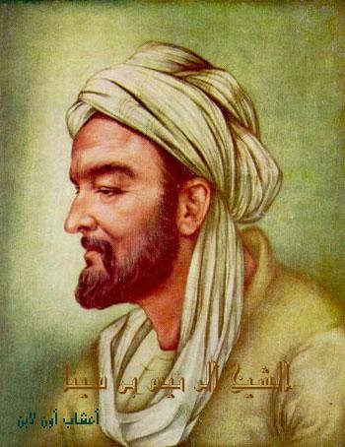
Avicenna use Junipers to treat window and ulcer , he said:"it's powder help to treat inflammation ulcer and Warts when it's mix with honey"^{b2}.
Avicenna describe ways of prepare this drug, and how to use .

Avicenna ^{w4}

b1:alhawe electronic edition.
b2 : alkanon electronic edition.

The 19-th and early 20-th centuries

The nineteenth and early twentieth centuries saw the discovery and development of many new antibiotics. Most were discovered as doctors and scientists worked to isolate and develop "good" bacteria that could be used in the treatment of infectious diseases.
Many different antibiotic substances were discovered and developed.
The growing acceptance of the germ theory of disease, a theory which linked bacteria and other microbes to the causation of a variety of ailments. As a result, scientists began to devote time to searching for drugs that would kill these disease-causing bacteria.

BACTERIA^{w5}
Antibiotics developed in this period
Pyocyanase^{w3}
In Germany in 1888, an antibacterial substance called pyocyanase was isolated. Animal trials of this substance showed it to be very effective. In fact, the results were so exciting that trials were undertaken in humans suffering from a variety of infections. However, the results of the human trials were very disappointing- pyocyanase was found to be too toxic. Consequently, all research on this substance stopped.
Salvarsan^{w3}
In 1910, a more promising agent called salvarsan, which was actually a dye, was shown to be effective in the treatment of syphilis, a common sexually transmitted disease at the time. toxicity in humans was a major barrier to its development and widespread use.

Sulfa drugs
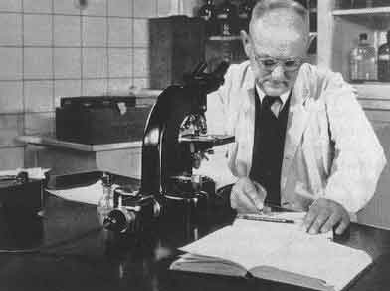
Sulfa drugs^{w29}, originally developed for use in the industry, were the first effective drugs used to fight bacterial infection in humans. Prontosil, the first sulfa drug, was discovered in 1935 by German chemist Gerhard Domagk (1895–1964).
Also called sulfonamides, these drugs are synthesized in the laboratory from a crystalline compound called sulfanilamide. They work by blocking the growth and multiplication of bacteria and were initially effective against a broad range of bacteria Gerhard Domagk^{w7}
However, many strains of bacteria have developed a resistance to sulfa drugs. Resistance occurs when some bacteria survive attack by the antibacterial drug and change in such a way that they are no longer affected by the drug's action.
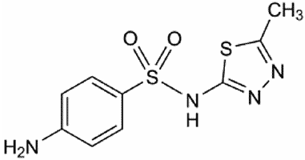
Sulfa drugs are most commonly used today in the treatment of urinary tract infections.
The drugs are usually taken by mouth, but other forms include creams that can be applied to burn wounds to SULFA^{W10}
prevent infection and ointments and drops used for eye infections.

Development of penicillin as an antibiotic
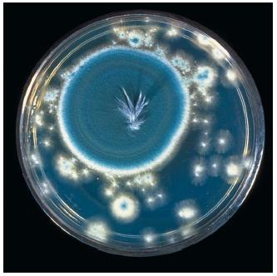
In 1928, British bacteriologist Alexander Fleming (1881–1955) discovered the bacteria-killing property of penicillin. Fleming noticed that a mold that had accidentally fallen into a bacterial culture in his laboratory had killed the bacteria. Having identified the mold as the fungus Penicillium notatum, Fleming made a juice with it that he named penicillin.
After giving it to laboratory mice, he discovered it killed bacteria in the mice without harming healthy body cells. Although Fleming had made an incredible discovery, he was unable to A penicillin culture^{w30} produce penicillin in a form useful to doctors.
Who is Alexander Fleming
Fleming was born on 6 August 1881 at Lochfield^{w31}, he went to Louden Moor School and Darvel School, and then for two years to Kilmarnock Academy.
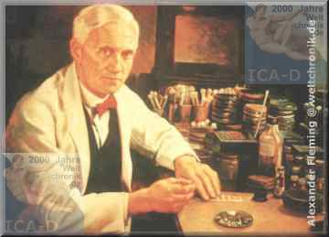
He qualified for the school with distinction in 1906 and had the option of becoming a surgeon. On 23 December 1915, Fleming married a trained nurse, Sarah Marion McElroy of Killala, Ireland.
Fleming served throughout World War I as a captain in the Army Medical Corps, and was mentioned in dispatches. He and many of his colleagues worked in battlefield hospitals at the Western Front in France. Fleming
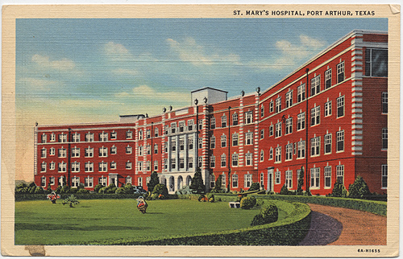
In 1918 he returned to St. Mary's Hospital, which was a teaching hospital. He was elected Professor of Bacteriology in 1928. After the war, Fleming filed actively searched for anti-bacterial agents, having witnessed the death of many soldiers from septicemia resulting from infected wounds. Unfortunately antiseptics killed the patients' immunological defences more effectively than they killed the invading bacteria. Mary's Hospital
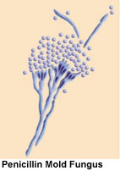
By 1928, Fleming was investigating the properties of staphylococci^{w32}. He was already well-known from his earlier work, and had developed a reputation as a brilliant researcher, but quite a careless lab technician; he often forgot cultures that he worked on, and his lab in general was usually in chaos. After returning from a long holiday, Fleming noticed that many of his culture dishes were contaminated with a fungus, and he threw the dishes in disinfectant. But subsequently, he had to show a visitor what he had been researching, and so he retrieved some of the submerged dishes that he would have otherwise discarded. He then noticed a zone around an invading fungus where the bacteria could not seem to grow. Fleming proceeded to isolate an extract from the moldy bread, correctly identified it as being from the Penicillium genus, and therefore named the agent penicillin.
penicillin^{w34}
He investigated its positive anti-bacterial effect on many organisms, and noticed that it affected bacteria such as staphylococci, and indeed all Gram-positive pathogens (scarlet fever, pneumonia, meningitis, diphtheria) but unfortunately not typhoid or paratyphoid, for which he was seeking a cure at the time. It also affected gonorrhoea, although this condition is caused by a Gram-negative pathogen.
Fleming published his discovery in 1929 in the British Journal of Experimental Pathology, but little attention was paid to his article. Fleming continued his investigations, but found that cultivating penicillium was quite difficult, and that after having grown the mould, it was even more difficult to isolate the antibiotic agent. Fleming's impression was that because of the problem of producing it in quantity, and because its action appeared to be rather slow, penicillin would not be important in treating infection. Fleming also became convinced that penicillin would not last long enough in the human body (in vivo) to kill bacteria effectively. Many clinical tests were inconclusive, probably because it had been used as a surface antiseptic. In the 1930s, Fleming’s trials occasionally showed more promise, and he continued, until 1940, to try and interest a chemist skilled enough to further refine usable penicillin.
Fleming soon abandoned penicillin, and not long after Florey and Chain took up researching and mass producing it with funds from the U.S and British governments. They started mass production after the bombing of Pearl Harbor. When D-day arrived they had made enough penicillin to treat all the wounded allied forces.
Fleming also discovered very early that bacteria developed antibiotic resistance whenever too little penicillin was used or when it was used for too short a period.
Fleming cautioned about the use of penicillin in his many speeches around the world. He cautioned not to use penicillin unless there was a properly diagnosed reason for it to be used, and that if it were used, never to use too little, or for too short a period, since these are the circumstances under which bacterial resistance to antibiotics develops.

Death and legacy
In 1955, Fleming died^{w31} suddenly at his home in London of a heart attack. He was cremated and his ashes interred in St Paul's Cathedral a week later. Alexander Fleming was Catholic.

History of Penicillin
Originally noticed by a French medical student, Ernest Duchesne, in 1896. Penicillin was re-discovered by bacteriologist Alexander Fleming working at St. Mary's Hospital in London in 1928. He observed that a plate culture of Staphylococcus had been contaminated by a blue-green mold and that colonies of bacteria adjacent to the mold were being dissolved. Curious, Alexander Fleming grew the mold in a pure culture and found that it produced a substance that killed a number of disease-causing bacteria. Naming the substance penicillin, Dr. Fleming in 1929 published the results of his investigations, noting that his discovery might have therapeutic value if it could be produced in quantity.

Man to know

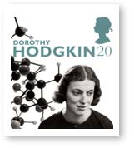
Dorothy Crowfoot Hodgkin^{w33}
Hodgkin used x-rays to find the structural layouts of atoms and the overall molecular shape of over 100 molecules including penicillin. Dorothy's discovery of the molecular layout of penicillin helped lead scientists to develop other antibiotics.
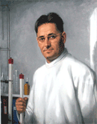
Dr. Howard Florey^{W13}
It was not until 1939 that Dr. Howard Florey, a future Nobel Laureate, and three colleagues at Oxford University began intensive research and were able to demonstrate penicillin's ability to kill infectious bacteria. As the war with Germany continued to drain industrial and government resources, the British scientists could not produce the quantities of penicillin needed for clinical trials on humans and turned to the United States for help. They were quickly referred to the Peoria Lab where scientists were already working on fermentation methods to increase the growth rate of fungal cultures. One July 9, 1941, Howard Florey and Norman Heatley, Oxford University Scientists came to the U.S. with a small but valuable package containing a small amount of penicillin to begin work.
Pumping air into deep vats containing corn steep liquor (a non-alcoholic by-product of the wet milling process) and the addition of other key ingredients was shown to produce faster growth and larger amounts of penicillin than the previous surface-growth method. Ironically, after a worldwide search, it was a strain of penicillin from a moldy cantaloupe in a Peoria market that was found and improved to produce the largest amount of penicillin when grown in the deep vat, submerged conditions.

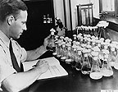
Andrew J. Moyer
By November 26, 1941, Andrew J. Moyer^{W22}, the lab's expert on the nutrition of molds, had succeeded, with the assistance of Dr. Heatley, in increasing the yields of penicillin 10 times.
In 1943, the required clinical trials were performed and penicillin was shown to be the most effective antibacterial agent to date.
Penicillin production was quickly scaled up and available in quantity to treat Allied soldiers wounded on D-Day. As production was increased, the price dropped from nearly priceless in 1940, to $20 per dose in July 1943, to $0.55 per dose by 1946.
As a result of their work, two members of the British group were awarded the Nobel Prize. Dr. Andrew J. Moyer from the Peoria Lab was inducted into the Inventors Hall of Fame and both the British and Peoria Laboratories were designated as International Historic Chemical Landmarks.

Andrew J Moyer Patent
On May 25, 1948, Andrew J Moyer was granted a patent for a method of the mass production of penicillin.
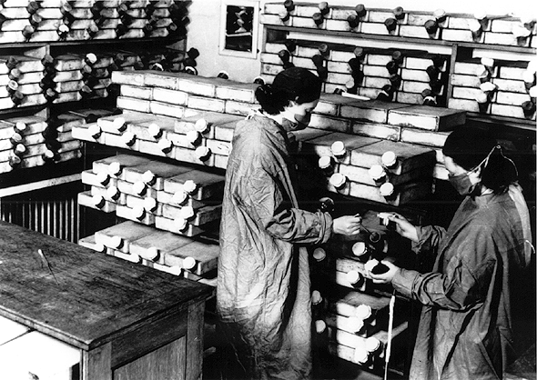
Old manufacture of Penicillin

Ernst Boris Chain
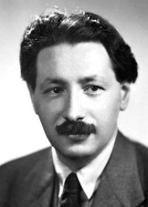
Ernst Boris Chain (19 June 1906 – 12 August 1979) was born on June 19, 1906, in Berlin. In 1935 he was invited to Oxford University where he worked in the Sir William Dunn School of Pathology, becoming, in 1936, demonstrator and lecturer in chemical pathology.
In 1939 he began, with H. W. (now Sir Howard) Florey, a systematic study of antibacterial substances produced by micro-organisms. This led to his best known work, the reinvestigation of penicillin .Later he worked on the isolation and elucidation of the chemical structure of penicillin and other natural antibiotics.
Professor Chain is author or co-author of many scientific papers and contributor to important monographs on penicillin and antibiotics.
For his part in the development of penicillin, Boris Ernst Chain was honored in 1945 by the award of the Nobel Prize in Physiology and Medicine, shared together with Alexander Fleming and Howard W.Florey.

1981 Amoxicillin
SmithKline Beecham^{w35} patented Amoxicillin or amoxicillin/clavulanate potassium tablets, and first sold the antibiotic in 1998 under the tradenames of Amoxicillin, Amoxil, and Trimox. Amoxicillin is a semisynthetic antibiotic.
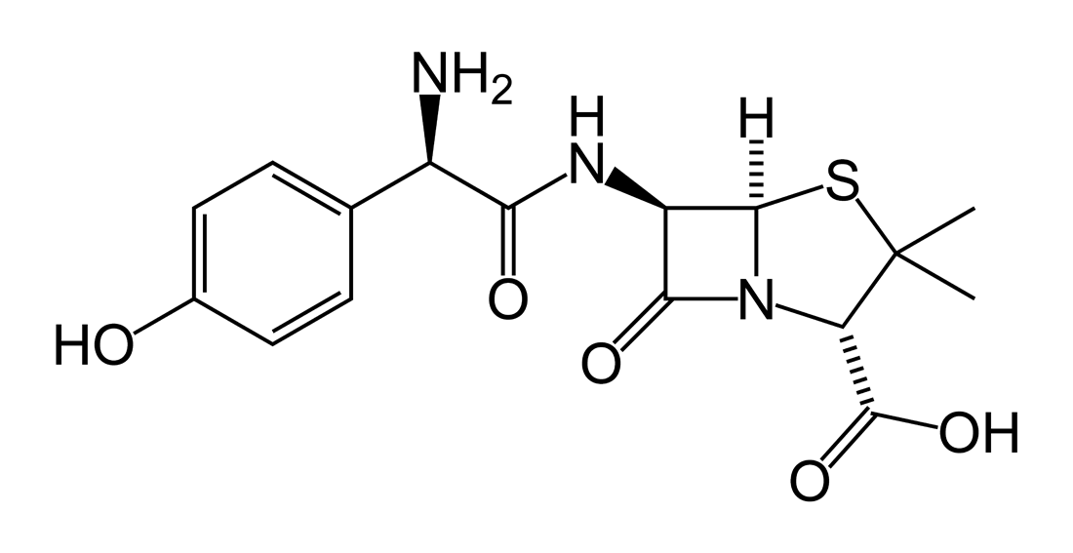
Other antibacterial drugs
Macrolides
Macrolides have been an important class of antibiotics since their discovery in 1952^{w36}. The first macrolide called erythromycin was isolated from a broth containing the microorganism Streptomyces erythreus now known as Saccharopolyspora erythraea. The basic structure of the macrolide is a large 14-member ring containing methyl and hydroxyl groups among others. An amino sugar (D-desoamine) and a neutral (L-cladinose) are noteworthy substituent's that are consistent throughout the class. During the 1950’s it was discovered that this new drug could be used for infections of the respiratory tract, the skin, the soft tissue, and the genital tract. In general, the class is very effective against gram-positive bacteria, but also shows activity against gram negative and pseudomonas.
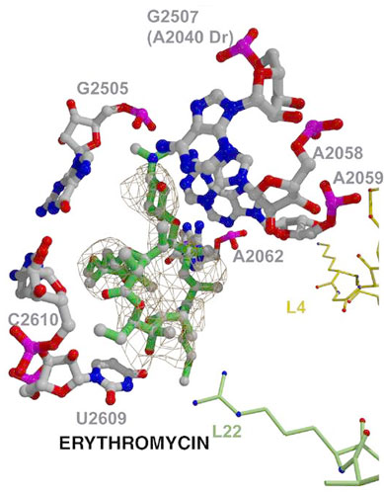 picture^{w37}
Streptomycin & Neomycin
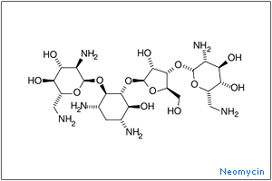
In 1939, Merck and Company provided Waksman with financial assistance to mount a search for antibiotics in soil microorganisms. In 1943, this search culminated in the isolation of streptomycin^{w3}, the first antibiotic to offer hope to patients with tuberculosis (TB). This antibiotic is still used today in the treatment of TB. 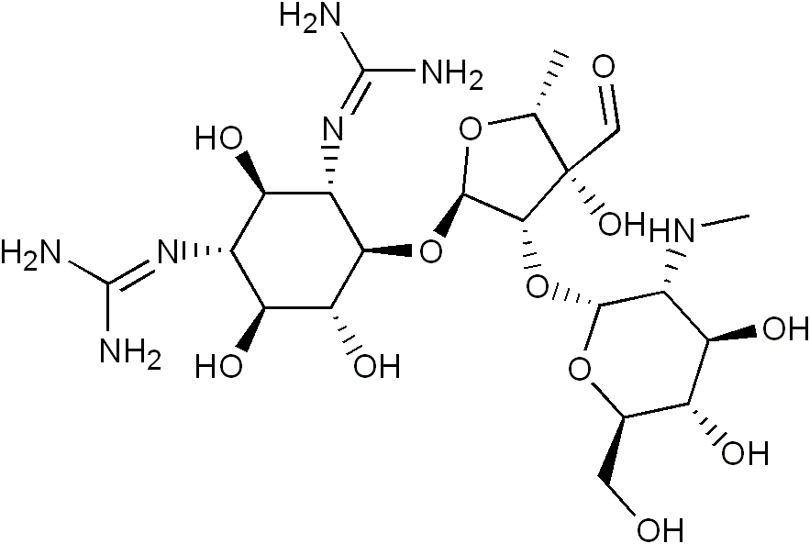
After clinical use in tuberculosis patients, it was soon realized that streptomycin caused side effects not seen with penicillin, including kidney damage and deafness. However, the main problem encountered in the use of streptomycin, and the one that restricted its effectiveness, was resistance. The speed at which bacteria were able to develop resistance to the drug was a surprise to Waksman and his coworkers. Because of this, they were prompted to search for other antibiotics. This search resulted in the development of neomycin, a drug commonly used in antibacterial ointments today. NEOMYCIN^{W21}

Chloramphenicol
David Gottlieb^{w15} (1911 – 1982), a professor of plant pathology at the University of Illinois at Urbana-Champaign (1946-1982), was a pioneer in the field of fungi physiology and antibiotics for plants.
Gottlieb is best known for isolation in the 1940s of the strain of Streptomyces from which chloramphenicol was developed, for his mentoring in the field, and for his editorial work.
In 1947, the antibiotic chloramphenicol was used in a clinical trial to treat an epidemic of typhus in Bolivia. Its success in curbing the epidemic led to its use on the other side of the world-treating scrub typhus in Malaysia.
In the Bolivian epidemic, all twenty-two patients who received chloramphenicol recovered. Of the fifty patients for whom the antibiotic was unavailable, fourteen died. The trial in Bolivia is not the only South American link with this antibiotic. Chloramphenicol was first isolated from a soil sample in Caracas, Venezuela, a discovery that was important in two ways. First, it identified a new antibiotic substance; second, as the clinical trial showed, chloramphenicol could cure previously untreatable diseases, such as typhus. Later, this same antibiotic showed remarkable results in the treatment of typhoid fever. At last scientists were finding effective substances that could treat serious infections.
The euphoria surrounding the discovery of chloramphenicol was dampened somewhat when it was shown to cause serious side effects. By 1950, many investigators had become alarmed by the mounting evidence linking it with serious blood disorders, including anemia and leukemia.
Today, the use of chloramphenicol is limited in developed countries, where more expensive but safer drugs are available. In developing countries, however, it is still widely used because it is so inexpensive to produce. It is used mainly to treat typhus, typhoid fever, meningitis, and brucellosis, but it can also be used for other infections. You may have used it yourself-in ear drops or eye drops.

Cephalosporin
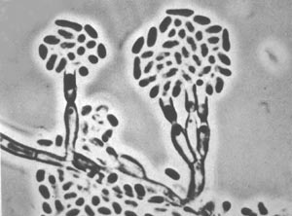
In the mid-1940s, Giuseppe Brotzu^{w3}, rector of the University of Cagliari in Sardinia, isolated an antibiotic-like substance from a mold. He conducted clinical trials with the substance (albeit in an impure form) and achieved very good results, particularly in the treatment of staphylococcal infections and in typhoid fever.
Brotzu published his results in 1948, and his work came to the attention of Florey's research group in Oxford. When they obtained samples of the fungus, they were able to isolate and purify several penicillin-like antibiotics. These were called cephalosporins. The cephalosporins are very effective in treating a wide range of bacterial infections. They destroy bacteria in a manner similar to penicillin and are valuable alternatives, especially where resistance to penicillin is a problem. The added advantage is that they have very low toxicity, although allergic reactions develop in about 5 percent of patients.
Modifications of the basic cephalosporin chemical structure led to the development of a whole range of these antibiotics for clinical use. Research into the development of new cephalosporins continues today. the first agent cephalothin (cefalotin) was launched by Eli Lilly in 1964.

Cephalosporium acremonium^{W26}

Giuseppe Brotzu
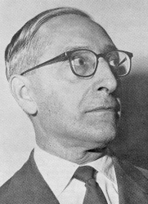
Giuseppe Brotzu^{W19} (1895-1976), for over thirthy years Professor of Hygiene in the Medical Faculty and Rector
(1936-1945) of the University of Cagliari, was also superintendent of Public Health during the campaign for the eradication of malaria in Sardinia. As a scientist, his fame is due to the discovery of cephalosporins that he made in Cagliari, at the end of the"2nd World War.
For his discoveries Brotzu was awarded in 1971 the honorary degree in Science by Oxford University.

Giuseppe Brotzu ^{W18}
Tetracycline
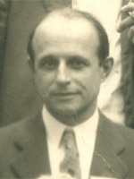
In 1947, chlortetracycline^{W30} was isolated from a Missouri River mud sample by Benjamin M. Duggar. Chlortetracycline was the first tetracycline, but Duggar's discovery has led to the isolation and subsequent development of a large number of very powerful antibiotics, which now rank second only to the penicillins in their use worldwide.
Because they are active against a broad range of bacteria and are relatively inexpensive to produce, the tetracyclines quickly gained favor and are now used to treat a long list of infections.
Benjamin M. Duggar^{w38}
The extensive research done on the tetracyclines has shown them to be effective. However, they are also known to cause a number of toxic side effects. The tetracyclines form calcium complexes in growing bone, which may lead to lifelong discoloration and enamel defects in teeth, as well as reduced bone growth. Tetracyclines also cross the placenta and have a greater toxicity in the fetus. As a result of these side effects, they are prohibited in the treatment of infections in pregnant women and in children below the age of seven, as they may inhibit small children's growth.
Other toxic effects include overgrowth of the Candida spp. and Staphylococcus spp. bacteria in the bowel, leading to chronic infections with these organisms. Liver and kidney damage may also occur in some patients, as may allergic reactions such as hives, skin rash, asthma, and contact dermatitis.
Methicillin

Further research took place during the 1960s, which led to the development of the second generation of antibiotics by Beecham. Among these was methicillin, a semi-synthetic derivative of penicillin produced specifically to overcome the problem of penicillin resistance. Methicillin was hailed as a major breakthrough in the fight against bacterial resistance to penicillin, and scientists
believed that they could now win this battle. Unfortunately, bacteria had the last word, Beecham^{W17} and we now have bacteria that are resistant to methicillin.
Beecham was a British pharmaceutical company.

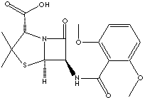

methicillin

Fluoroquinolone
The fluoroquinolone family is a relatively new group of antibiotics. They^{w6} were first introduced in 1986, but they are really modified quinolones. The parent of the group is nalidixic acid, the discovery of nalidixic acid in 1962, and its introduction for clinical use in 1967. The majority of quinolones belong to a subgroup called fluoroquinolones, which have a fluoro group attached the central ring system. Both terms are used to describe antibiotics in this class.
The fluoroquinolones are classified into generations based on their antibacterial spectrum, with earlier generation quinolones more effective against Gram-negative bacteria and the spectrum of activity expanding to include more Gram-positive bacteria with the later generations.
The first-generation agents ("quinolones") had poor distribution into the body tissues and limited activity. They were used mainly for treatment of urinary tract infections. The early quinolones include: cinoxacin, nalidixic acid and oxolinic acid.
Second-generation fluoroquinolones have significantly increased antibacterial activity. These antibacterial agents have increased gram-negative activity, as well as some gram-positive and atypical pathogen activity. Compared with earlier quinolones, these drugs have broader clinical use in the treatment of complicated urinary tract infections and pyelonephritis, sexually transmitted diseases, pneumonias and skin infections.
Ciprofloxacin and ofloxacin are the most widely used second-generation fluoroquinolones because of their availability in oral and intravenous formulations and their broad set of FDA-approved indications.
The third-generation fluoroquinolones (levofloxacin, gatifloxacin, moxifloxacin, sparfloxacin, trovafloxacin) have expanded activity against gram-positive bacteria and atypical pathogens, such as Mycoplasma pneumonia and Chlamydia pneumonia. Third-generation antibiotics are widely used in the treatment of community-acquired pneumonia, acute sinusitis and acute exacerbations of chronic bronchitis.
The fourth-generation fluoroquinolones (e.g. garenoxacin, gemifloxacin, trovafloxacin) add significant antimicrobial activity against anaerobes while maintaining the gram-positive and gram-negative activity of the third-generation antibiotics.
Metronidazole

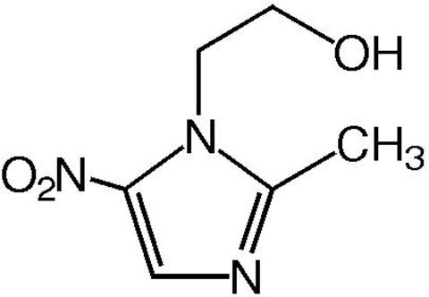
Metronidazole^{W20} is one of the rare examples of a drug developed against a parasite which has since gained broad use as an antibacterial agent. Briefly, at Rhone-Poulenc labs in France, extracts of Streptomyces spp. were screened for activity against Trichomonas vaginalis, a cause of vaginal itching. Azomycin, a nitroimidazole, was identified, and metronidazole, a synthetic derivative, was used to treat chronic trichomonad infections, beginning in 1959. Metronidazole was shown to be efficacious against Entamoeba histolytica, the cause of amebic dysentery and liver abscess, in 1966. Giardia lamblia (also known as G. duodenalis) was treated with metronidazole after Metronidazole this luminal parasite was recognized as a cause of malabsorption and epigastric pain in the 1970s.
The antibacterial activity of metronidazole was discovered by accident in 1962 when metronidazole cured a patient of both trichomonad vaginitis and bacterial gingivitis. However, it was not until the 1970s that metronidazole was popularized for treatment of infections caused by gram-negative anaerobes such as bacteroides or gram-positive anaerobes such as clostridia. Presently, metronidazole, which is inexpensive, has good tissue penetration, and produces relatively mild side effects, is on the formulary at most hospitals for prophylaxis against anaerobic infection after bowel surgery, for treatment of wound abscess, and for treatment of antibiotic-associated colitis caused by Clostridium difficile. Metronidazole is an important part of combination therapy against Helicobacter pylori, a major cause of gastritis and a risk factor for stomach cancer.

Antifungal agents
Until two to three decades ago^{w39}, only a few drugs were available for the treatment of fungal infections. The status of antifungal therapy changed dramatically in the late 1960s with the introduction of newer broader spectrum agents, such as the iodinated trichlorophenols and the imidazoles, that acted by disruption of the fungal cell membrane. Some of the more recently developed broad-spectrum antifungal drugs include the triazoles terconazole, itraconazole, and fluconazole and the dimethylmorpholine amorolfine. The allylamines represent one of the newest classes of compounds shown to be effective in the management of fungal disorders. The two members of this unique chemical class that have been studied clinically, naftifine and terbinafine, are effective against a wide spectrum of fungal organisms. Terbinafine has the added advantage of both topical and oral activity
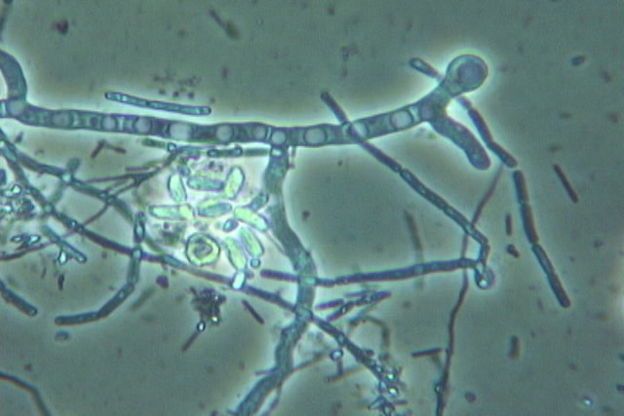

.

fungal hyphae1^{w2}

Nystatin
This drug patented in 1957 was used to cure many disfiguring and disabling fungal infections^{w40}.
As researchers for the New York Department of Health, Elizabeth Lee Hazen and Rachel Fuller Brown combined their efforts to develop the anti-fungal antibiotic drug nystatin. The drug, patented in 1957 was used to cure many disfiguring, disabling fungal infections as well as to balance the effect of many antibacterial drugs. In addition to human ailments, the drug has been used to treat such problems as Dutch Elm’s disease and to restore water-damaged artwork from the effects of mold.
The two scientists donated the royalties from their invention, over $13 million dollars, to the nonprofit Research Corporation for the advancement of academic scientific study. Elizabeth Lee Hazen and Rachel Fuller Brown were inducted into the National Inventors Hall of Fame in 1994.
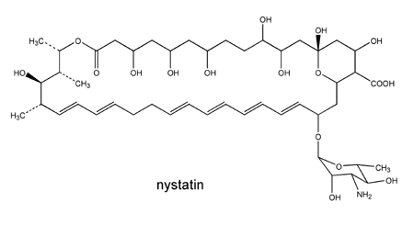
NYSTATIN^{w24}

Antiviral drugs

For it's important we'll gave it a large place , to speak about .
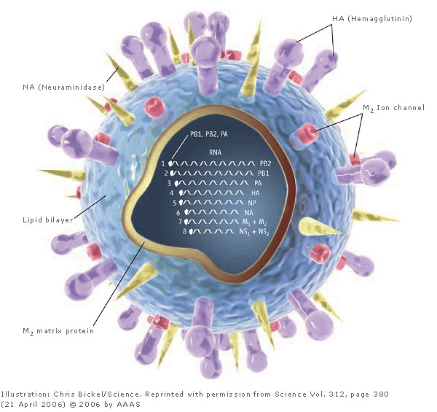
influenza virus^{w40}

The concept of specific antiviral therapy
and a false dawn^{w42}

The 1946 edition of van Rooyen and Rhodes’ Virus Diseases of Man introduced the concept of specific therapy for a number of virus infections, including mumps and smallpox. This early work focused on the use of the current bacterial antibiotics, including sulphonamides.
The futility of these early attempts led to the dogma that viruses are not susceptible to ‘antibiotics’ and for two decades virologists were taught that selective toxicity for these obligate intracellular parasites was unattainable. Mumps virus^{W8}

Several lines of research were to overturn this idée fixe. In 1957 came the famous first description by Isaacs and Lindenmann of interferon. Human interferons were subsequently developed for the treatment of particular
virus infections, i.e. hepatitis B and, more recently, hepatitis C virus infections, as pegylated interferon ,combined with ribavirin. However, the discovery of the interferons in the late 1950s was something of a false dawn.

Idoxuridine: the first useful antiviral
nucleoside analogue

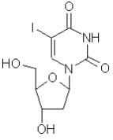
Many in the antiviral field recognize as a most important early milestone the description of 5-iodo-2′-deoxyuridine (idoxuridine, IDU) by Dr Bill Prusoff in 1959 and the realization of its antiviral properties. The first publications on this and similar nucleoside analogues appeared in cancer journals and it is clear that the aim was to develop molecules to interfere with DNA synthesis in order to produce cytotoxic drugs for the treatment of neoplastic disease. However, an important by-product of this work was the Idoxuridine discovery that IDU was a specific inhibitor of certain large DNA viruses,
most notably herpes simplex virus (HSV).
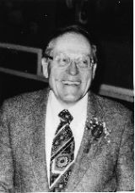
The compound is cytotoxic and was therefore only suitable for topical application, for which it remains in use to the present day. The development of IDU from laboratory inhibitor to useful antiviral drug was driven by several notable pioneers, especially the ophthalmologist Dr Herbert Kaufman who proved its clinical value in 1962 and, subsequently, that of trifluorothymidine (TFT) in 1964.
The first description of the antiviral activity of adenine arabinoside (vidarabine, ara-A) by M. Privat de Garilhe and J. De Rudder also dates from the avant-garde year 1964. Ara-A was the Dr Herbert Kaufman first of the nucleoside analogues to be sufficiently non-toxic to be given systemically and the
work of Dr Richard Whitley proved beyond doubt the clinical value of this compound, showing for the first time that, providing treatment was commenced early in the disease, it was possible to curtail herpes zoster in the immune suppressed and reverse the potentially lethal progression of herpes encephalitis and the overwhelming herpes infections that occasionally occur in the newborn.
Poliomyelitis, smallpox: important early
antiviral targets
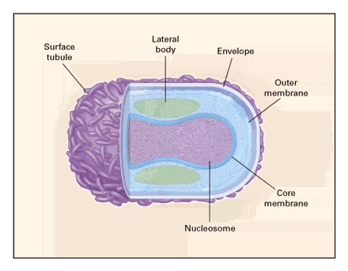
We will return to herpes antivirals, but first we should remember the origins of several other lines of antiviral research and the early pioneers. Poliomyelitis was still a serious threat in the developed world when guanidine and 2-(α-hydroxybenzyl) benzimidazole (HBB) were shown to be specific inhibitors of this small, positive strand picorna virus and other picorna viruses (i.e. Coxsackie and Echo) as early as 1961 by J.G. Barrera-Oroand Joe Melnick, and Igor Tamm and Hans Eggers ,respectively. The latter promoted the smallpox^{w44} concept of specific antiviral therapy for polio and their lectures and writing much influenced the field in the 1960s, although, in the event, polio was eventually controlled by vaccination rather than chemotherapy. Another important virus threat was that of smallpox caused by variola virus, which is among the largest of all viruses with a double stranded DNA genome comprising more than 200 genes.
The compound β-thiosemicarbazone was first reported to be an inhibitor of a related poxvirus, vaccinia virus, in 1951 by D. Hamre, K.A. Brownlee and R. Donovick. Dr John Bauer at the then Wellcome Foundation Laboratories in Beckenham, UK, led the team which developed the drug marboran, a β-thiosemicarbazone derivative. Marboran was shown in several trials to have some clinical efficacy both for the treatment of smallpox and the complications of vaccinia following vaccination. Furthermore, it was shown that marboran was a highly effective agent for chemoprophylaxis in the management of smallpox contacts. Smallpox was shortly to be eradicated by means of the WHO vaccination scheme and work on marboran ceased. However, recently there has been renewed interest in antipoxvirus agents as a result of the threat of smallpox being reintroduced by an act of terrorism.

Treatments for influenza virus infections

Influenza was also an early antiviral target, and in 1964 it was reported by C.E. Hoffmann and co-workers that amantadine was a specific inhibitor of the negative RNA strand virus, influenza A. Amantadine and its sister compound, rimantadine , were later shown to act by interaction with the viral M2 protein which forms an ion channel during the early stages of virus replication. As for almost all other specific antiviral agents, resistant
mutants were obtained by passage of virus at sub inhibitory concentrations of the inhibitor and in this case these mutations mapped to the M2 and haemagglutinin (HA) genes. Furthermore, when the compounds were used clinically, resistance developed quickly in patients and this was one of the factors which argued against their widespread clinical use. Rimantadine was, however, widely used clinically in Eastern Europe during the cold-war years, although the data relating to its use in man were not so easily forthcoming. However, the work on amantadine and rimantadine provided a platform for the development of the next generation of anti-influenza drugs that resulted from a programme of rational drug design. The crystal structures of the influenza envelope
proteins – HA and neuraminidase (NA) – were solved. Influenza NA was known to interact with sialic acid residues on host-cell plasma membranes and the first of several sialic acid analogues, Neu5Ac2en, designed by M. von Itzstein and his colleagues in 1993, based on the crystal structure of influenza NA, led to the development of 4-guanidino-Neu5Ac2en (relenza), the first NA inhibitor, to be marketed by Glaxo. A difficulty with this compound is its poor oral bioavailability, necessitating its application by means of inhalation. Other NA inhibitors tailored on the sialic acid residue followed, including the successful oseltamivir (developed at Gilead sciences and first reported by C.U. Kim et al. in 1997) in which a cyclohexene ring was introduced and a polar glycerol replaced with a more lipophilic side-chain. Furthermore, oseltamivir is an ethyl ester that is orally bioavailable and readily converted to the active carboxylate by esterases in the liver, a prodrug approach first used for the antiherpetic compound famciclovir.

The first broad-spectrum antiviral after
interferon
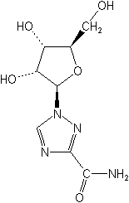
Ribavirin was reported in 1972 by Robert Sidwell , R.K. Robins and their colleagues as a broad-spectrum antiviral acting against many different virus families, notably the negative RNA strand virus, respiratory syncytial virus. It was noted that virus resistance to ribavirin was not detected for any of the susceptible virus families. This may be related to the fact that ribavirin primarily targets a host-cell protein, and, indeed ribavirin (5′-monophosphate) has been found to inhibit IMP dehydrogenase, the enzyme responsible for the conversion of IMP to XMP. Another discovery in the 1970s was the anti herpes virus activity of the pyrophosphate analogue phosphonoformic acid (phosphonoformate PFA) following the earlier discovery of the lead compound, Ribavirin phosphonoacetic acid (PAA). PFA, described by B. Öberg and developed at the Swedish pharmaceutical company, Astra, suffers from toxicity problems, including nephrotoxicity. However, PFA continues to have a role in managing HSV infections in immunocompromised patients who are resistant to the classical antiherpetic compounds (e.g. acyclovir).

The advent of acyclovir
No history of the origins of antivirals would be complete without acknowledging the enormous impact of the compound acyclovir. Like IDU, acyclovir was the result of a drug development programme not primarily aimed at antivirals. The names of Dr Gertrude (Trudy) Elion
and Dr Howard Schaeffer (Burroughs Wellcome, USA) are inextricably linked to this compound, although its potent antiviral properties were first uncovered by Drs Peter Collins and John Bauer at the Wellcome Laboratories (UK) where the compound had been sent for antiviral activity evaluation.
Dr Bauer coined the term acycloguanosine , although this was subsequently dropped in favour of the generic term acyclovir (aciclovir). Dr Elion and her colleagues produced a definitive mechanism of action and the thoroughness of this work and the associated pharmacological data were crucial to the early acceptance of the compound. Acyclovir was shown to be a substrate for the HSV-encoded deoxyribopyrimidine kinase, usually called thymidine kinase (TK). Acyclovir monophosphate is then further phosphorylated by cellular kinases and the resulting acyclovir triphosphate is a potent suicide inhibitor of the herpes specified DNA polymerase. The fact that a (deoxy)- guanosine analogue serves as a substrate for the virus deoxyribopyrimidine kinase was Acyclovir (aciclovir) a major stumbling block in elucidating the mechanism of action, but eventually this was resolved. Acyclovir has become recognized as one of the safest drugs of all times with almost no adverse affects described during 21/2 decades of use (apart from those related to low aqueous solubility of the compound), including individuals who have used the compound for 20 years to suppress recurrent HSV.
Acyclovir was the very first highly selective antiviral compound, and it was the prototype described as a ‘second generation’ nucleoside analogue. It eventually became available as an over-the-counter drug in the UK, an unthinkable development even a few years previously.

HIV – a new virus threat
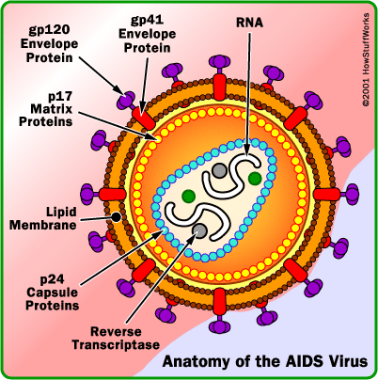
The science of antiviral research was well advanced when HIV/AIDS appeared as a major new virus disease in the early 1980s. The first effective antiviral compound (AZT, azidothymidine) was already among the library of compounds screened by Burroughs Wellcome and the National Cancer Institute (USA), and was promptly reported in 1985 to be a specific inhibitor of retroviruses, including HIV. The mechanism of action of AZT is based upon phosphorylation of the drug by cellular enzymes to AZT triphosphate, which then interacts at the substrate binding site of the HIV reverse transcriptase, thereby acting as a chain terminator. The discovery of AZT was followed by several other dideoxynucleoside (ddN) analogues (ddI, ddC, d4T, 3TC, ABC, (–)FTC) so that at the time of writing seven ddN analogues, also referred to as NRTIs (i.e. nucleoside reverse transcriptase inhibitors) are formally licensed for the treatment of HIV infections. All these NRTIs act in a similar fashion: after their phosphorylation to the triphosphate, they interact as ‘chain terminators’ of the HIV reverse transcriptase, thus preventing the formation of the proviral DNA that otherwise would AIDS^{W9} eternalize the infectious state (following integration of the proviral DNA into the host-cell genome). In 1990 it came as a surprise that the HIV reverse transcriptase revealed a second target for interaction of HIV RT inhibitors, namely at an allosteric site, distinct where the NRTIs interact. This site was originally dubbed the TIBO-binding site, as TIBO, together with HEPT analogues, were the first compounds found (by E. De Clercq and his colleagues) to interact in this way. Later, a succession of structurally different compounds, now termed NNRTIs (non-nucleoside reverse transcriptase inhibitors) were shown to interact in a manner similar to that of TIBO and HEPT, and of these NNRTIs, three, namely nevirapine, delavirdine and efavirenz, have been currently licensed for clinical use in the treatment of HIV infections. The elucidation of the HIV genome revealed at an early stage the existence of the virus-specified protease and this was the declared target for several of the leading pharmaceutical companies. The team of chemists and molecular virologists at Roche led by Drs Joe Martin and Noel Roberts achieved the synthesis of saquinavir, the first peptide-based transition state mimetic. Saquinavir was shown to be active at nanomolar concentrations and was among the most potent antiviral substances yet described. Saquinavir was soon joined by several other similar compounds produced by competing companies. At present, seven protease inhibitors have been licensed for the treatment of HIV infections: saquinavir, ritonavir, indinavir, nelfinavir, amprenavir, lopinavir and atazanavir. 2003 witnessed the advent of the first ‘HIV fusion’ inhibitor, enfuvirtide (previously called ‘T20’), which blocks viral entry by targeting the viral glycoprotein gp41 which is responsible for the fusion of the viral and cellular membranes. A problem with this compound is that, unlike all other anti-HIV drugs, which can be
administered orally, enfuvirtide has to be given subcutaneously by injection twice daily. It should be mentioned that virus drug resistance has not been a problem with herpes virus chemotherapy (except in immune compromised patients). However, resistance to antiviral drugs has emerged as one of the most important barriers to efficacy in the treatment of chronic infections, including HIV. In this case the key was to be found in history – the treatment of tuberculosis where cocktails of drugs were found to be necessary for the successful eradication of the mycobacteria over several months. There has been considerable opposition to the possibilities of drug combinations in the antiviral field (probably born from their inherent reputation for toxicity); therefore, the introduction and subsequent recognition of the value of drug combinations for the treatment of HIV infections were not instantaneous, but are now taken for granted.
The acyclic nucleoside phosphonates

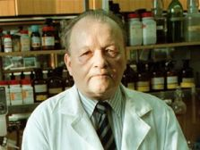
The discovery in 1986 of HPMPA or (S)-9-(3-hydroxy- 2 phosphonylmethoxypropyl)adenine, by Antonin Holy and Erik De Clercq, heralded a totally new concept in the antiviral therapy era, that of the acyclic nucleoside phosphonates. These nucleotide analogues can be viewed as a kind of hybrid between acyclic nucleoside analogues (a class of molecules to which acyclovir, ganciclovir and penciclovir belong) and pyrophosphate analogues (phosphonoacetic acid and phosphonoformic acid), thus combining the assets of both approaches. In this sense HPMPA could be considered a hybrid of Antonin Holy⁴³ PAA (phosphonoacetic acid) with DHPA (2,3-dihydroxypropyladenine), a molecule discovered in 1978 by De Clercq and Holy as a broad-spectrum antiviral agent, but at that time overshadowed by acyclovir. As the first ‘nucleotide’ analogue, to be endowed with antiviral properties, HPMPA would subsequently give rise to numerous derivatives, three of which would eventually gain formal acceptance for the treatment of a wide variety of virus infections: cidofovir for the treatment of herpes virus infections (CMV in AIDS patients), adefovir for the treatment of chronic hepatitis B and tenofovir for the treatment of HIV (AIDS), the latter two in the form of their oral pro drugs, adefovir dipivoxil and tenofovir disoproxil, respectively. Cidofovir, in addition to theindication for which it has been licensed (CMV retinitis in AIDS patients), also offers great potential for the treatment of papilloma-, adeno-, herpes- (other than CMV) and poxvirus infections (i.e. vaccinia, variola, monkeypox, molluscum contagiosum, orf). This is gratifying knowledge, as cidofovir may be useful in the prophylaxis and/or therapy of variola virus infections (smallpox) and complications (such as disseminated or progressive vaccinia) following vaccination with the smallpox vaccine vaccinia in immunocompromised patients.

Selected milestones in antiviral drug
Development

Date | Drug | How's Discovery
1951 | Thiosemicarbazone | Hamre et al
1957 | Ribavirin | Isaacs & Lindenmann
1959 | IDU | Prusoff
1961 | Hydroxybenzylbenzimidazole | Tamm & Eggers
1961 | Guanidine | Barrera-Oro & Melnick
1962 | IDU (clinical effectiveness) | Kaufman
1963 | Marboran (clinical effectiveness) | Bauer et al.
1964 | TFT (clinical effectiveness) | Kaufman
1964 | Amantadine | Bauer et al.
1964 | Amantadine | Kaufman
1964 | Ara-A | Davies, Hoffmann et al.
1972 | Ribavirin | Privat de Garilhe & De Rudder
1976 | Ara-A (clinical effectiveness) | Sidwell, Robins et al.
1977 | Acyclovir | Whitley
1978 | DHPA | Elion, Schaeffer, Collins & Bauer
1979 | Phosphonoformic acid (PFA) | De Clercq & Holy
1979 | BVDU | Helgstrand & Öberg
1982 | Ganciclovir | De Clercq et al.
1985 | Azidothymidine (AZT) | Verheyden & J.C. Martin
1986 | ddI, ddC, … | Mitsuya, Broder et al
1986 | Adefovir (PMEA) | Mitsuya & Broder
1987 | Cidofovir (HPMPC) | De Clercq, Holy et al.
1989 | Famciclovir (oral prodrug strategy) | De Clercq, Holy et al.
1989  1990 | HEPT/TIBO | De Clercq, Baba, Pauwels & Janssen
1990 | Saquinavir | J.A. Martin, Roberts et al.
1991 | 3TC | Belleau et al.
1993 | Tenofovir (PMPA) | Balzarini, De Clercq & Holy
1993 | Relenza | von Itzstein et al.
1997 | Oseltamivir | Kim et al.

Abstract
The antibiotic evolution passed many stage :
- from old use of herbal and honey ,which we saw in Egyptians around 1550 BC .
- to Arab who treat eye infection ,and prescript the treatment of windows by ointment using many herbals.
- Modern use of antibiotics and their classes :
- Antibacterial drug .
- Antifungal drug.
- Antiviral drug .

The huge discovery happened in last century , and main antibacterial drug were developed in this period .
Alexander Fleming who discovery the penicillin ,was great scientist .
The whole world now use the penicillin and it's derivatives widely, and the work still to develop a new antibiotics .

Antiviral drug now very important , because the danger of virus attack .
Hiv is the main danger in this time , and all work to fight it .
Cidofovir, Ribavirin, and Amantadine are antiviral drug , use to treat many virus infection .
We should thanks all scientist which we speak about them above .

References
I - Books and Essays:
- Avicenna. Alkanon . electronic edition.
http://www.shamela.ws/
- Razi . Alhawe. electronic edition.
http:// www.almeshkat.net /
II - Web Sites:
W1 http://e-ducation.net/philosophers/razes_1.jpg
W2http://www.microbeorganics.com/Fungal%20Hyphae%20barn%20compost%20w%20mol.JPG
W3 http://www.herbs2000.com/medica/2_antibioticsH.htm earliest evidence of humans using plants
W4 http://alanany1.googlepages.com/ebn-sena.jpg/ebn-sena-full.jpg
W5 http://www.vedicsciences.net/design/bacteria5.jpg
W6 http://jac.oxfordjournals.org/cgi/content/abstract/51/suppl_1/13 (qulinon)
W7 http://www.dutly.ch/domagk/mikro.jpg
W8 http://wwwdelivery.superstock.com/WI/223/824/PreviewComp/ SuperStock_824-710.jpg
W9 http://www.roshanpakistan.com/web-magzine/Health/imgs/aids-hiv-anatomy.gif
W10 http://www.itmonline.org/image/sulfa1.gif
W11http://www.chemheritage.org/classroom/chemach/images/smfotos/07pharma/hodgkin2.jpg
W12http://mcgovern.library.tmc.edu/data/www/html/texascoll/post/N-S/port_08.jpg
W13http://www.florey.edu.au/uploads/pics/Howard_Florey.GIF
W14http://www.botany.org/images/officers/Duggar-vp-1912.jpg
W15 http://en.wikipedia.org/wiki/David_Gottlieb
W16 http://www.essortment.com/all/whatisthehist_rgic.htm history of antn
W17 http://www.menloeng.com/images/whale/whale1_lg.jpg
W18 http://www.atlaswords.com/IMAGES%20126/brotzu.gif
W19 http://www.zbmed.de/fileadmin/pdf_dateien/EAHIL_2002/orru.pdf
W20 http://www.pubmedcentral.nih.gov/articlerender.fcgi?artid=89320
W21 http://www.onlinepharmacycatalog.com/drugs-medications/antibiotics/neomycin/neomycin.jpg
W22 http://www.ars.usda.gov/IS/timeline/jpgsgifs/penicillin-2h.jpg
W23 http://www.sciencedirect.com/ fung
W24 http://www.doctorfungus.org/thedrugs/images/fig_nystatin.gif
W25 http://www.ncbi.nlm.nih.gov/pubmed/2229521fung
W26 http://www.angelfire.com/wizard/kimbrough/ Textbook/04_17copy.jpg W27 www.udel.edu/chem
W28 http://inventors.about.com/library/inventors/bltetracycline.htm
W29 http://www.scienceclarified.com/Al-As/Antibiotics.html
W30 http://www.scienceclarified.com/images/uesc_01_img0045.jpg
W31 http://en.wikipedia.org/wiki/Alexander_Fleming
W32 http://www.answers.com/topic/alexander-fleming
W33 http://inventors.about.com/od/hstartinventors/a/Hodgkin.htm
W34 http://inventors.about.com/od/pstartinventions/a/Penicillin.htm
W35 http://inventors.about.com/od/pstartinventions/a/Penicillin_2.htm
W36 http://sitemaker.umich.edu/medchemgroup10/macrolides_-_introduction&config=UPTe87n55RCtEZ4kmOZbGg
W37 http://www.molgen.mpg.de/~ag_ribo/ag_fucini/ffhistory/ery_3d.jpg
W38 http://www.botany.org/images/officers/Duggar-vp-1912.jpg
w39 http://www.ncbi.nlm.nih.gov/pubmed/2229521
w40 http://inventors.about.com/library/inventors/blnystatin.htm
w41 http://www.ifpma.org/Influenza/content/images/diagram_virus.jpg
w42 http://www.sgm.acuk
w43 http://i.lidovky.cz/07/103/lncl/FHO1e9300_Holy.jpg
w44 http://students.usm.maine.edu/kathryn.kennie/virus.bmp

* Chairman, History of Medicine Department, Institute for the History of Arabic Science, Aleppo University, Aleppo-Syria The President of ISHIM (www.ishim.net) P.O. Box: 7581, Aleppo, Syria e-mail: a.kaadan@scs-net.org Phone 963 944 300030, Fax 963 21 2236526 ** Master stage student, Institute for the History of Arabic Science, Aleppo University
*

